Introduction

About six billion people currently inhabit the world (F.A.O., 1996), and by the year 2050, it is predicted the world’s population will double (Figure 1). Malthusian analysts have predicted that agricultural production will be insufficient to provide an adequate diet for future generations (McCouch and Xiao, 1998; Sakamoto and Matsuoka, 2004). However, despite a dramatic population growth in the last century, grain production has more than doubled since the 1950’s, averting large-scale famine (Borlaug, 1968; Rusell, 1974; Sakamoto and Matsuoka, 2004). Mechanization and cultural practices have played a key role in the rapid improvement of yield during this “Green Revolution”. Most of the agricultural success achieved, however, can be attributed to the development of higher yielding, disease resistant crop varieties (Reinhardt and Kuhlemeier, 2002; Sakamoto and Matsuoka, 2004). The fundamental mission of plant breeders is to predict plant phenotype during crop improvement in order to increase the yield and quality characteristics of future varieties. Recent advances in plant genetic analysis and biotechnology, when used in conjunction with classical genetic analysis, offer breeders an opportunity to realize a second green revolution (McCouch and Xiao, 1998; Sakamoto and Matsuoka, 2004).

Qualitative genetics
Gregor Mendel, the father of genetics, developed the single locus theory of genetics to explain observations of plant phenotype (Mendel, 1866). Mendel’s systematic approach is now known as Mendelian Genetics. The qualitative trait variation described by Mendel is conditioned by relatively few genes (1-2) that are largely unaffected by the environment. Hence, the phenotype of qualitatively inherited traits is typically directly related to the genotype, which can be divided unambiguously into distinct classes. This unambiguous phenotypic classification allows for the use of genetic test ratios to define the genetic control of qualitatively inherited traits (Stern and Sherwood, 1966).

Quantitative genetics
After the rediscovery of Mendel’s studies by de Vries, Correns, and Tschermark in 1900 (Sturtevant, 1965), Pearson and Weldon (Biometricians) realized that segregations for many characters could not be adequately explained utilizing Mendelian theory because it was not possible to classify the observed variation into discrete classes (Lynch and Walsh, 1998). These traits are known as complex, metric or quantitative traits, and the phenotypic distribution of F₂ progeny segregation of such traits typically forms a bell shaped distribution. The examination of quantitative variation resulted in the development of the multiple-factor hypothesis (East, 1916; Johannsen, 1909; Nilsson-Ehle, 1909). This hypothesis states that several (or many) environmentally influenced Mendelianly inherited genes with relatively small effects contribute to quantitative trait values to form a continuous distribution.

Simple phenotypic assessment cannot provide for an unequivocal genotyping of quantitative traits, thus, statistical inference is necessary to estimate gene action and the genetic control of such traits. In 1918, Fisher proposed analysis of variance (ANOVA) for the study of complex traits (Fisher, 1918). This type of analysis allowed for the partitioning of the phenotypic variation into its genetic and environmental components. Fisher (1918), Wright (1921a, 1921b), and Haldane (1919) described the principles and statistical tools of quantitative analysis, which allow the prediction of selection response based on phenotype and genetic relationships among individuals.

CLASSICAL ANALYSIS OF QUANTITATIVE TRAITS. Quantitative traits are classified based on the numbers and magnitudes of segregating genetic factors or quantitative trait loci (QTL) affecting trait variability (Beavis, 1998). Oligogenic traits are controlled by few QTL with relatively large effects, and polygenic traits are conditioned by many QTL having small effects. Most traits of economic importance are polygenetic, and thus their study has been difficult (Lande and Thompson, 1990). Traditionally, the study of quantitative traits has been accomplished by estimating the average properties of genes or QTLs, instead of their individual dissection (Kearsey and Pooni, 1996).

The estimation of average properties of genes usually requires the use of relatively complex statistical analyses and breeding designs (Allard, 1960; Falconer and Mackay, 1996; Fehr, 1987; Kearsey and Pooni, 1996; Hallauer and Miranda, 1988; Lynch and Walsh, 1998; Mather and Jinks, 1982). The North Carolina Designs I, II, III, (Comstock and Robinson, 1948, 1952) and diallel analysis (Eberhart and Gardner, 1966; Gardner and Eberhart, 1966; Griffing, 1956) have been proposed and utilized for quantitative trait analyses. These methods allow for the comparison of phenotypes with known degrees of genetic similarity. Various descriptive statistics such as means, variances, covariances, and correlations can be calculated, and the estimation of gene action, variance components, genetics x environment interactions (G x E), heritabilities, and numbers of least effective factors are possible from the covariance between relatives (Allard, 1960; Cockerham, 1954, 1986; Comstock, 1978; Dudley and Moll, 1969; Eberhart et al., 1966; Falconer and Mackay, 1996; Fehr, 1987; Lande, 1981; Lynch and Walsh, 1998; Wright, 1968).

GENERATION MEANS ANALYSIS. Generation means analysis (GMA) involves the use of means and variances calculated from the phenotype of homozygous lines (e.g., P₁ and P₂) and their progeny (F₁, F₂, BC₁P₁ and BC₁P₂) to study metric traits (Mather, 1949; Mather and Jinks, 1971, 1977, 1982). The phenotypic differences among these six basic generations (i.e., parents and their progeny) are due to genotypic factors and environmental influences. These differences are used to estimate average additive, dominant, and epistatic gene effects, and variance components, trait heritabilities, and least number of effective factors (Castle, 1921; Mather and Jinks, 1971, 1977, 1982; Wright, 1968). However, GMA is relatively inefficient for estimating variances components and least number of effective factors, and thus resulting estimates should be considered preliminary in nature (Allard, 1960; Hallauer and Miranda, 1988; Kearsey and Pooni, 1996).

VARIANCE COMPONENT ANALYSIS. The genetics of metric traits have also been studied using ANOVA techniques as proposed by Fisher (1918). Variance component analysis typically employs large populations such as F₃ families (Hallauer and Miranda, 1988; Kearsey and Pooni, 1996), and has proven efficient for the characterization of the average properties of complex traits (Allard, 1960; Falconer and Mackay, 1996; Fehr, 1987; Hallauer and Miranda, 1988; Kearsey and Pooni, 1996; Lynch and Walsh, 1998). The goal of variance component analysis is to estimate the relative importance and magnitude of the different sources of variation among genotypes (i.e., additive, dominant, and environmental variance components). Heritability estimates express the degree of correspondence between the phenotypic and genotypic values in the broad- and narrow-sense. Heritability in the broad-sense measures the proportion of the phenotypic variance that can be attributed to genetic effects. In contrast, heritability in the narrow-sense measures the fraction of phenotypic variation due to additive genetic effects, which can be passed on from parent to offspring. Due to its predictive function during selection, narrow-sense heritability is one of the most important genetic parameters available to plant breeders (Allard, 1960; Falconer and Mackay, 1996; Fehr, 1987; Hallauer and Miranda, 1988; Kearsey and Pooni, 1996; Lynch and Walsh, 1998).

Utility of molecular markers in genetic analysis
Sax (1923) proposed that metric traits could be studied indirectly using discrete Mendelian factors that are linked to QTLs. The validity of this approach was demonstrated using seed color in beans as a morphological marker for studying seed weight segregation. The potential usefulness of markers linked to QTLs has spurred the search and development of molecular markers for genetic analysis. The first molecular markers used in genetic analysis were protein variants known as isozymes (Laemmli, 1970; Markert et al., 1959). These protein markers proved useful for the study of genetic variation and in the breeding of important crop species (Delourme and Eber, 1992; Knerr et al., 1989; Knerr and Staub, 1992; Meglic and Staub, 1996; Pooler and Simon, 1993; Stuber et al., 1982; Stuber and Moll, 1972; Tanksley et al., 1981; Tanksley and Rick, 1980; Osborn et al., 1988). However, the use of both morphological and protein markers systems for genetic analysis is limited by the paucity of their variation (Burrow and Blake, 1998; Staub et al., 1996a).

Heritable, coding and non-coding, sequence differences in DNA provide unlimited variation at the molecular level (Lynch and Walsh, 1998). Consequently, DNA-based markers have become widely used in genetic analysis (Burrow and Blake, 1998). In contrast to morphological and protein markers, DNA markers segregate as Mendelianly inherited factors and are usually not influenced by the environment (Burrow and Blake, 1998; Staub et al., 1996a). Restriction fragment length polymorphisms (RFLP) were the first DNA-based markers applied to genetic analysis (Botstein et al., 1980; Beckmann and Soller, 1983; Nienhuis et al., 1987; Soller and Beckmann, 1983). More recently, random amplified polymorphic DNAs (RAPD), sequenced characterized amplified regions (SCARs), allele specific associated primers (ASAPs), single primer amplification reactions (SPAR), amplified fragment length polymorphisms (AFLPs), simple-sequence repeats (SSRs), cleaved amplified polymorphic sequences (CAPs), and single nucleotide polymorphisms (SNPs) have been employed in genetic analyses (Burrow and Blake, 1998; Staub et al., 1996a). The most widely used polymerase chain reaction (PCR)-based markers are RAPDs, AFLPs, and SSRs (Staub et al., 1996a). PCR-based marker systems are especially desirable for genetic analyses because of the small amounts of DNA required and their amendedability to high throughput analysis (Burrow and Blake, 1998; Staub et al., 1996a). Examination of variation at RAPD, AFLP, and SSR loci was used in the genetic analyses described herein and are briefly described below.

RANDOM AMPLIFIED POLYMORPHIC DNA. The RAPD PCR reaction (Williams et al., 1990) is performed using primers generated from single, short (10 bp) arbitrary sequences. The RAPD primers anneal randomly at binding sites located throughout the genome. However, for PCR amplification of DNA to occur, two primers must anneal at closely situated binding sites along sister chromatids of least one homologous chromosome. A single RAPD PCR reaction often results in the amplification of several (5-15) DNA fragments (300- 2000 bp long) that can be separated by agarose gel eletrophoresis and visualized as distinct DNA bands by ethidium bromide staining (Burrow and Blake, 1998; Rafalski and Tingey, 1993; Staub et al., 1996a). When several individuals of a population are assayed with a particular RAPD primer sequence, a specific band may be absent in some individuals and present in others. These differential banding patterns are known as dominant polymorphisms (Staub et al., 1996a). Dominant polymorphisms originate from the inability of primers to anneal at primer-binding sites on homologous chromosomes. It is possible to detect codominant RAPD polymorphisms when the primer binding sites are at slightly different positions on each homologous chromosome (Burrow and Blake, 1998; Rafalski and Tingey, 1993).

RAPD analysis is the simplest and least inexpensive method to amplify many potentially polymorphic loci (Burrow and Blake, 1998; Rafalski and Tingey, 1993; Staub et al., 1996a). However, two major disadvantages of this assay are the lack of primer specificity and the dominant nature of its markers (Staub et al., 1996a, 1996b). Nevertheless, RAPD markers have been successfully used in the genetic analysis of many plant species (Barau et al., 1993; Haley et al., 1994; Jung et al., 2003; Horejsi and Staub, 1999; Horejsi et al., 2000; Kennard et al., 1994; Martin et al., 1991; Mohan et al., 1994; Paran et al., 1991; Reiter et al., 1992; Wang and Goldman, 1999).

AMPLIFIED FRAGMENT LENGTH POLYMORPHISMS. AFLP analysis (Vos et al., 1995) involves using restriction enzymes to cut DNA into fragments. The restriction enzymes cut genomic DNA anywhere specific restriction sites are located. The ends of these fragments are ligated to synthetic linkers or adapters with complementary overhangs. Then, the ligated fragments are PCR pre-amplified using primers (16-17 bp long) homologous to the linkers, but carrying an additional arbitrary base at the 3’ end. Subsequently, a selective amplification step is performed using an isotope or fluorescent labeled primer and a non-label primer each carrying two additional selective bases at the 3’ end (Burrow and Blake, 1998; Staub et al., 1996a). Amplification products are usually separated using polyacrylamide or DNA sequencing gels, and are visualized by their incorporated fluorescence labeled bases. Numerous (50-100) bands (100 to 1000 bp long) of random genomic origin are typically produced for each individual sampled (Burrow and Blake, 1998; Staub et al., 1996a). AFLP markers are usually dominant polymorphisms defined as a presence or absence of a particular band.

Since numerous bands are produced in a single gel, AFLP analysis is time and cost efficient. Moreover, pre-amplification reactions may be assayed using 256 possible combinations of selective nucleotides allowing for the examination of additional bands in different subsets depending on the nucleotide combinations employed (Burrow and Blake, 1998; Staub et al., 1996a). The use of longer primers makes the AFLP assay more specific than the RAPD assay. However, the technique involves several steps (digestion, ligation, and multiple amplification cycles) with a level of technical difficulty that introduces the possibility of errors during the analysis (Burrow and Blake, 1998; Staub et al., 1996a). Nevertheless, AFLPs have been used for genetic analyses in several crop species (Ballvora et al., 1995; Ipek et al., 2003; Mackill et al., 1996; Maughan et al., 1996; Park et al., 2000; Santos and Simon, 2002a, 2004; Vuylsteke et al., 1999).

SIMPLE SEQUENCE REPEATS. Most eukaryote genomes contain repetitive DNA sequences referred as microsatellites or simple sequence repeats (SSR) (Jeffreys et al., 1985; Litt and Luty, 1989). Microsatellites are tandem repeats with a basic motif of less than six base pairs (Burrow and Blake, 1998; Rafalski and Tingey, 1993; Staub et al., 1996a). Plants contain numerous tandem repeat sequences that are randomly dispersed throughout their genome. SSR sequences are unique and variable in length depending on the number of repeat units that they contain (14-30 bp). Primers can be designed using these sequences to amplify specific segments of DNA using two different and highly specific primer sequences in PCR. The SSR PCR reaction gives rise to variable length polymorphisms (100- 500 bp) specific to their flanking tandem micosatellite repeat primer arrays. SSRs are codominant, and thus heterozygote genotypes can be identified by the presence of two length polymorphisms while homozygotes possess only one band morphotype.

The primary disadvantage of SSR technology is the considerable cost of primer development. However, once primers have been developed, SSR analysis is a straightforward procedure that allows the detection of highly informative and locus-specific markers. Therefore, SSRs have been widely used in the genetic study of plants (Akkaya et al., 1995; Bell and Ecker, 1994; Donini et al., 1998; Fazio et al., 2002; Jarret et al., 1997; Senior and Heun, 1993; Wu and Tanksley, 1993; Yu et al., 1999; Zietkiewitch et al., 1994).

Molecular mapping
Sturtevant (1913) developed a method to order morphological markers of Drosophila melanogaster L. (fruit fly) in a linear arrangement, and to calculate the genetic distances between them. The linear arrangement of markers along linkage groups (or chromosomes) is known as a molecular or linkage map. Linkage maps have been developed for a variety of crop species (Bell and Ecker, 1994; Beavis and Grant, 1991; Brouwer and Osborn, 1999; Camargo and Osborn, 1996; Cause et al., 1994; Fazio et al., 2003a; Galmarini et al., 2001; Xu et al., 1994).

Linkage mapping is based on the idea that offspring of a biparental cross have different marker genotype combinations due to recombination or crossover events between non-sister chromatids of homologous chromosomes during prophase I of meiosis. These crossovers provide variation that can be translated into recombination frequencies or fractions (r) that allow the statistical estimation of the linkage relationships between genetic markers (Liu, 1998a, 1998b). Recombination fractions estimate the probability of recombination events and provide a measure of the distance between marker loci.

Currently, recombination frequencies (r < 0.5) and the logarithm of odds (LOD) score threshold values (> 2.5) are used to assign markers into linkage groups (Allard, 1956; Lander and Green, 1987). The recombination between linked markers is then calculated by multi-point analysis in order to resolve their linear order and estimate map distance within chromosomes or linkage groups (Lander and Green, 1987). Often, the number of linkage groups is greater than the expected number of chromosomes. In such cases, increasing the experimental population size and/or map saturation (markers at < 10 cM) can reduce sample variance, detect rare recombination events, and increase saturation of the genome (Liu, 1998a, 1998b).

Linkage map construction employs mapping functions that linearize marker order and relate genetic distances to the number of crossovers, rather than to recombination frequencies (Kearsey and Pooni, 1996; Staub et al., 1996a). Mapping functions are necessary since recombination frequencies used for map distance estimations are underestimated when single crossover events are not independent and when interference occurs as a result of double crossovers (Kearsey and Pooni, 1996; Staub et al., 1996a). The two most commonly used mapping functions were developed by Haldane (1919) and Kosambi (1944). The Haldane mapping function assumes no interference (i.e., the crossover events occur independently in adjacent intervals), and the Kosambi mapping function assumes a moderate amount of interference (Kosambi, 1944).

The development of computerized algorithms capable of handling complex analyses have allowed for the use of molecular markers in the genetic map construction of many organisms (Liu, 1998a, 1998b). The most widely used mapping programs include MapMaker/EXP (Lander et al., 1987), JoinMap (Van Ooijen and Voorrips, 2001), and PGRI (Lu and Liu, 1995).

QTL mapping
Classical quantitative techniques describe the average properties of genes controlling quantitative traits, but they are unable to dissect individual gene effects (Kearsey and Pooni, 1996). Genetic markers, molecular maps, and the identification of marker-trait associations have allowed for the dissection of complex traits, and the estimation of the numbers, magnitudes and distributions of individual QTLs (Beavis, 1998). The feasibility of dissecting QTL using linked marker loci has long been recognized (Sax, 1923; Rasmusson, 1933; Thoday, 1961). The dissection of QTL parameters requires the use statistical models to obtain information from experimental data (phenotypic data, marker genotypes, and linkage relationships among the markers). Various models have been developed to dissect and characterize QTL effects. The most commonly used models include single marker analysis (Soller et al., 1976), interval mapping (Lander and Bostein, 1989), composite interval mapping (Jansen, 1993; Zeng, 1993, 1994), and multiple interval mapping (Kao et al., 1999) analyses. QTL-markers associations can be identified using computerized algorithms that use different statistical approaches, such as single marker t-tests, ANOVA, regressions, least squares, maximum likelihood and mixed linear models (Liu, 1998a, 1998b). Although, these computerized QTL mapping programs are available in versions for PC, Macintosh, and UNIX systems, most use command-driven interfaces and are not particularly user friendly (Liu, 1998a, 1998b). Currently, the most widely used QTL mapping programs include Mapmaker/QTL (Lander et al., 1987), QTLSTAT (Liu and Knapp, 1992), QTL Cartographer (Basten et al., 1994; Wang et al., 2001-2004), PGRI (Lu and Liu, 1995), MAPQTL (Van Ooijen and Maliepaard, 1996), Map Manager QTL (Manly et al., 1996), and R/qtl package (Broman et al., 2003).

SINGLE-MARKER ANALYSIS. Single-marker analysis is the simplest method used for the detection of QTL-marker associations (Soller et al., 1976). This method aims to identify a QTL linked to a single-marker by making comparisons among the phenotypic means of the different marker classes (Liu, 1998a). Marker-trait association tests are performed separately and independently for each marker. Therefore, single-marker analysis can only detect QTLs and not their positions and effects. An advantage of single-marker analysis is that it can be conducted in the absence of a linkage map (Liu, 1998a, 1998b).

INTERVAL MAPPING. Lander and Botstein (1986, 1989) used an interval mapping (IM) approach to estimate the numbers, positions, and effects of QTL using maximum likelihood approximations (Weller, 1996). This IM procedure detects QTLs by performing a likelihood ratio test at every position within an interval between two adjacent markers. The primary difference between single-marker and IM analyses is the ability of IM to use linkage-mapping information for the localization and estimation of QTL effects. However, the ability of IM methods to estimate QTL parameters can be seriously biased when two or more QTLs are in close proximity (Knott and Haley, 1992; Martinez and Curnow, 1992).

COMPOSITE INTERVAL MAPPING. Zeng (1993, 1994), Jansen (1993), and Rodolphe and Lefort (1993) independently proposed a method known as composite interval mapping (CIM). The precision and accuracy of QTL detection is improved over IM methodologies since CIM employs interval mapping, maximum likelihood, and multiple regression analysis for QTL characterization (Beavis, 1998). CIM uses regression analyses to remove the genetic effects of QTLs that reside outside a test interval by using additional markers as cofactors. Although estimates of QTL positions and their effects are improved using CIM (Beavis, 1998), such estimates may be biased since CIM modeling assumes the absence of epistatic interactions among QTLs.

MULTIPLE INTERVAL MAPPING. More recently, Kao et al. (1999) proposed a multiple interval mapping (MIM) approach for linkage analysis. This method seeks to simultaneously fit multiple QTLs in different intervals and has the ability to identify epistatic interactions, and thus has the potential of improving the power, precision, and accuracy of QTL mapping studies. However, the detection of these interactions requires large population sizes atypical of most QTL experiments.

Mapping populations
The most effective mapping populations maximize linkage disequilibrium between marker loci and a target QTL (Mackay, 2001; Tanksley, 1993). Segregating progeny from crosses between completely inbred lines are ideal for linkage map construction and QTL detection (Beavis, 1998). Typically, the segregating progeny are genotyped using multiple marker loci and phenotypically evaluated for one or more quantitative traits. Then, a linkage map is constructed from the genotypic data, and QTL parameters are estimated using statistical marker-trait associations. This “experimental paradigm” (Beavis, 1998) is based on maximizing linkage disequilibrium in experimental populations by selecting inbred parents with the greatest genetic differences. Although hybrid individuals from these initial crosses will be genetically identical (i.e., have the same linkage phase), their progeny (e.g., F₂ and BC) are expected to be fully informative, since theoretically all loci differing between the initial inbred parents are predicted to segregate in the progeny (Mackay, 2001). These progenies supply the required variability for linkage map construction and the estimation of QTL numbers, magnitudes, and distributions (Beavis, 1998; Mackay, 2001).

Several mapping populations derived from biparental crosses have been proposed for linkage mapping and QTL detection (Mackay, 2001). These mapping populations include F₂, F_{2:3}, backcross (BC), doubled haploid (DH), and recombinant inbred line (RIL) populations. The choice of a mapping population largely depends on the reproductive biology of the organism being studied, the magnitude of linkage disequilibrium, the relative heterozygosity and size of the mapping population, the type of marker systems being employed (dominant or codominant), the heritability of the trait being studied, and the extent of phenotypic assessment required to account for G x E interactions (Beavis, 1998; Mackay, 2001; Tanksley, 1993).

RECOMBINANT INBRED LINES. Recombinant inbred line populations are homozygous (> F₆), F₂-derived lines produced by a selfing or sib mating without selection (i.e., single-seed descent). Theoretically, RILs possess a random combination of alleles inherited from the two initial inbred parents (Mackay, 2001; Staub et al., 1996a). Since RIL populations are homozygous progenies, they are fully informative, using both dominant and codominant markers, and are useful for the estimation of additive effects (Staub et al., 1996a). However, dominant gene effects cannot be estimated using such highly homozygous progenies (Perin et al., 2000), and the time and effort necessary for RIL development is considerable (Mackay, 2001; Perin et al., 2000; Staub et al., 1996a).

Precise localization of both marker loci and QTL along linkage groups depends primarily upon the frequency of recombination events that have occurred in the experimental population (Mackay, 2001). RIL populations undergo a greater number of meioses than do other possible types of biparental cross-progenies (e.g., F₂ and BC), thus allowing comparatively more recombination. Recombination in RILs permits the shuffling of unlinked loci while maintaining linkage disequilibrium among tightly linked loci resulting in higher mapping resolution. One disadvantage of using RILs is that the greater number of recombination events between QTLs and marker loci in these populations reduce linkage disequilibrium, which is important for the identification of QTL-marker associations. However, the effects of reduced linkage disequilibrium in RILs can be solved by increasing map saturation (Beavis, 1998; Mackay, 2001; Tanksley, 1993).

RIL populations are essentially “immortalized” (Perin et al., 2000), and allow for phenotypic assessment over multiple locations and years, which is critical for obtaining valid phenotypic measurements of metric traits (Mackay, 2001; Perin et al., 2000; Staub et al., 1996a). Experimental replication is particularly important when studying traits with low heritabilities and large G x E interactions (Beavis, 1998; Mackay, 2001). The availability of abundant RILs seed allows extensive genotyping, the study of a wide spectrum of traits, and the use of increased population sizes (as additional RIL lines become available) (Mackay, 2001; Perin et al., 2000; Staub et al., 1996a). Thus, RIL populations have been extensively used for molecular map development and QTL analysis (Austin and Lee, 1996; Burr et al., 1988; Carrillo et al., 1990; Cowen, 1988; Fazio, 2001; Goldman et al., 1995; Kole et al., 1997; Mansur et al., 1993, 1996; Paran et al., 1997; Park et al., 2000).

Considerations for QTL mapping and applications
Technical advances such as the development of DNA-based markers, computer algorithms for linkage and QTL mapping, and the continued refinement of statistical models for QTL detection have allowed plant breeders to infer the numbers, magnitudes and distributions QTLs controlling economically important traits (Beavis, 1998). Numerous studies have been conducted to detect and map QTLs in crop species (Dijkhuizen and Staub, 2003; Goldman et al., 1993; Fazio et al., 2003a; Fulton et al., 1997; Havey et al., 2004; Krakowsky et al., 2003; Marquez-Cedillo et al., 2000; Quijada et al., 2004; Santos and Simon, 2002b; Serquen et al., 1997b). However, reliable characterization of QTLs depends on the type of population used and its size, type of gene action, gene numbers and the magnitude of their effects, and the heritability of the trait (Beavis, 1998). Therefore, validation experiments may be necessary to detect inconsistencies in QTL studies (i.e., numbers and positions and effects of QTLs) (Melchinger et al., 1998; Utz et al., 2000).

The potential use of marker-QTL associations for marker-assisted selection (MAS) in breeding has been a primary motivation for QTL characterization studies. Several reports have described the theoretical basis of MAS and the potential benefits of applying and/or combining MAS with conventional breeding methods (Eathington et al., 1997; Edwards and Page, 1994; Gimelfarb and Lande, 1994, 1995; Gupta et al., 1999; Hospital et al., 1992, 1997; Hospital and Charcosset, 1997; Knapp, 1998; Lande, 1992; Lande and Thompson, 1990; Lee, 1995; Mohan et al., 1997; Moreau et al., 2000; Staub and Horejsi, 1998). However, few studies exist which assess the feasibility of MAS (Causse et al., 2001; Fazio et al., 2003b; Flint-Garcia, 2003; Romagosa et al., 1999; Schneider et al., 1997; Willcox et al., 2002; Yousef and Juvik, 2001).

Melon origin
The origin of Cucumis melo L. (2n = 2x =24), which encompasses wild, feral (i.e., having become wild after domestication), and cultivated populations, has been much debated. Both Africa (de Candolle, 1886) and Asia (Naudin, 1859a; Pagalo, 1929; Vavilov, 1926) have been proposed as the origin site for melon. Historical accounts concerning the domestication process of C. melo, which began at least 3000 years ago, provide information as to its origin (Kerje and Grum, 2000; Pitrat et al., 2000; Stepansky et al., 1999).

The prevalent current theory proposes that seeds from a few (i.e., select) wild C. melo accessions were introduced from Africa into Asia along commerce routes between 2000-1500 B.C. (Karchi, 2000; Kerje and Grum, 2000). Furthermore, the most ancient accounts of cultivated C. melo appear in Egyptian paintings (Pagalo, 1929). The bible (Numbers 11:5) identifies melons, “qishu’im” (probably a non-sweet C. melo), as being eaten by the Israelites during their captivity in Egypt (Karchi, 2000; Stepansky et al., 1999). By approximately 2000 B.C., melons were extensively cultivated in Egypt, Mesopotamia, Iran, China, and by 1000 B.C. in India (Pitrat et al., 2000; Stepansky et al., 1999). Greek and Roman accounts of non-sweet melons date more recently from the first century A.D. (Pagalo, 1929).

Melon domestication events are believed to have occurred independently in Africa and Asia (Esquinas-Alcazar and Gulik, 1983; Jeffrey, 1980; Stepansky et al., 1999). However, it is likely that most of the domestication of C. melo occurred mainly in Asia since uninterrupted centers of melon production developed within the major ancient Middle Eastern and Asian cultural centers (Karchi, 2000). Moreover, the comparatively higher frequency of edible, sweet wild/or feral melons found in Asia supports the hypothesis that more extensive domestication occurred in Asia after their introduction from Africa (Kirkbride, 1993; Jeffrey, 1980). Thus, the current general consensus is that the primary center of origin for C. melo is Africa (Karchi, 2000; Kirkbride, 1993; Pitrat et al., 2000).

The African origin of C. melo is supported by genetic studies employing molecular markers which indicate that African wild/or feral populations are genetically more diverse than Asian populations (Kerje and Grum, 2000; Lopez-Sese et al., 2002, 2003; Mliki et al., 2001; Stepansky et al., 1999). Secondary centers of diversity have been identified in the Middle East, China, Russia, India (Kerje and Grum, 2000; Robinson and Decker-Walters, 1997), and the Iberian Peninsula (Lopez-Sese, et al., 2002; Mliki et al., 2001). These secondary centers of diversity probably developed after the initial C. melo domestication events because variability was captured in Asia as morphologically unique (e.g., shape and color) melon types (Karchi, 2000; Kerje and Grum, 2000). The comparatively narrow genetic diversity in Asian wild/or feral populations is likely due to the intensive selection for horticultural traits resulting in population bottlenecks (Kerje and Grum, 2000).

THE ORIGIN OF MELON POPULATIONS IN THE AMERICAS. In 1859, Naudin obtained a wild accession from Texas, which he considered distinct from Old World populations, and named it C. melo var. texanus Naud. (Naudin, 1859b). Since C. melo originated in the Old World, wild populations in America have traditionally been considered escapes from cultivation (Decker-Walters et al., 2002). Wild, free-living populations of C. melo have been reported throughout the Americas from the southern United States, Mexico, Central America, and South America (Decker-Walters et al., 2002). Decker-Walters et al. (2002) studied the origin and genetic affinities of cultivated melon cultivars and wild melon populations (Old World and wild North America populations) using molecular markers (RAPDs and SSRs) and quantitative and qualitative characters. The study concluded that wild North American melon populations are uniform, but distinct from the Old World accessions and cultivated cultivars examined. However, the North American melon accessions examined possessed greater genetic affinities with East Asian melons. Thus, it was concluded that the wild or domesticated progenitors of C. melo were likely introduced to the New World from Eastern Asia by humans in post-Columbian times.

Melon classification
Because of its great morphological variation (e.g., fruit size, shape, color, texture, and taste), C. melo is considered a highly diverse species in the Cucurbitaceae family (Jeffrey, 1980; Kirkbride, 1993; Stepansky et al., 1999). Wild and feral C. melo populations are found in Africa, America, Asia, Australia, Europe, and the Pacific Islands (Jeffrey, 1980; Kirkbride, 1993). The extensive morphological variation found in C. melo has led botanists to propose numerous infraspecific taxonomic classifications during the last 150 years (Pitrat et al., 2000; Stepansky et al., 1999). In 1753, Linnaeus coined the genus name, Cucumis, and classified five cultivated melons as independent species (Stepansky et al., 1999). Subsequently, Naudin (1859a) made the first detailed classification of C. melo, and divided it into nine tribes of cultivated melons and one tribe consisting of wild forms.

Classifications of C. melo were subsequently performed mainly by Russian researchers at the Vavilov Institute (Pitrat et al., 2000; Stepansky et al., 1999). Between 1928 and 1958, Pagalo proposed a complex classification that included four C. melo sections, two series (species and subspecies for wild, feral, and cultivated) and several infraspecific subdivisions (Pitrat et al., 2000). Between 1953 and 1986, Grebenscikov simplified Pagalo’s taxonomy into 11 “convarietas” (groupings) belonging to subspecies (ssp.) melo (cultivated) and ssp. agrestis (wild) taxons (Pitrat et al., 2000; Stepansky et al., 1999).

More recently, Jeffrey (1980) classified C. melo according to the flower ovary hairiness. Typically, ssp. melo (cultivated) has lanate ovaries while ssp. agrestis (wild) has sericeous ovaries. However, lanate-wild populations and sericious-cultivated melons exist that can be assigned to either subspecies, creating conflicts in taxonomic classification (Decker-Walters et al., 2002). Nevertheless, according to ovary morphology, Munger and Robinson (1991) subdivided C. melo L. into ssp. agrestis (Naud.) Pangalo and ssp. melo. Based on their classification, ssp. melo is currently further subdivided into six cultivar groups including Cantalupensis, Inodorous, Flexuosus, Conomon, Chito-Dudaim, and Momordica.

Melons in the United States
Melon is an economically important, cross-pollinated, vegetable species. Worldwide, more than 18 million metric tons of melons were produced in 1999, with China, Turkey, Iran the United States, and Spain being the major producers (F.A.O., 1997; F.A.O., 1999). The Cantalupensis and Inodorus groups are of particular commercial importance in the United States and Asia (McCreight et al., 1993). In the U.S., the Western Shipping and Eastern market types of the Cantalupensis Group are commercially the most important being primarily grown in Arizona, California, Texas, Georgia, and Indiana (N.A.S.S., 2003). In 2003, U.S. farmers grew more than 37,000 hectares (90,000 acres) of cantaloupes for a total production in excess of one million tons and having a market value of almost 400 million U.S. dollars (NASS, 2003). Cantaloupe yield has increased from 7.5 tons/acre in 1992 to 11.5 tons/acre in 2003 (Figure 2). Most of the yield improvement can be credited to cultural practices, breeding for relatively simple traits such as resistance to diseases and pests, and the use of hybrids created from sparingly few elite lines (McCreight et al., 1993; Robinson and Decker-Walters, 1997). Continued yield increases in melon, as in the case of other crop species (e.g., corn), will depend on the preservation, availability and use of genetic variability (e.g., exotic germplasm), and breeding for quantitative traits that are directly related to fruit yield (Dudley and Moll, 1969; Falconer and Mackay, 1996).

A limited number of cantaloupe lines (or their derivatives) have been used in U.S. breeding programs, and most cantaloupes in production today are related to these lines (Robinson and Decker-Walters, 1997). For example, powdery mildew resistant, PMR 45 (developed from PI 179376) has been used in the development of leading cantaloupe commercial varieties since its original introduction in 1936 by the U.S. Department of Agriculture (USDA) and the University of California. Also, “Top-Mark” (Table 1, Figures 3 to 5, Appendixes 2, 3, and 4), which is tolerant to environmental conditions such as salt, ozone, boron, and sulphur has been widely used in the development of important cultivars (Robinson and Decker-Walters, 1997). Another extensively used breeding line, MR-1, was developed from PI 124111 by the USDA, Charleston, South Carolina, and is resistant to downy mildew, powdery mildew, fusarium wilt, and alternaria leaf blight (Thomas, 1986).

Genetics of sex expression, fruit quality, and yield in melon
Breeding for resistance to diseases (i.e., bacterial, fungal, and viral) and pests (e.g., aphids, beetles, and white flies) as well as for excellent quality melons (e.g., high sugar content, acceptable shape, and size) have been priorities in melon improvement programs, and thus most research in melon has been conducted to elucidate the genetics of genes controlling these traits (Robinson and Decker-Walters, 1997; Rubatzky and Yamaguchi, 1997). Studies assessing the superiority of hybrids and sex expression (important in hybrid seed production) are also common, and have resulted in the current predominance of melon hybrids in cultivation (Robinson and Decker-Walters, 1997; Rubatzky and Yamaguchi, 1997). Few studies, however, have investigated the genetics of plant architecture and fruit yield (Lippert and Legg, 1972b; Lippert and Hall, 1982). The following sections review studies on the genetics of sex expression, fruit quality, and fruit yield in melon.

SEX EXPRESSION. Three flower types exist in melon: perfect, staminate, and pistillate. Different combinations and numbers of these flowers types allow for the classification of melon plants as: 1) monoecious (mostly staminate with comparatively few pistillate flowers); 2) andromonoecious (mostly staminate with comparatively few perfect flowers); 3) hermaphrodite (all perfect flowers); 4) gynomonoecious (mostly pistillate with comparatively few perfect flowers); 5) trimonoecious (a mixture of staminate, pistillate, and perfect flowers); 6) gynoecious (all pistillate); and 7) androecious (all staminate flowers ) (Poole and Grimball, 1939). Although this sexual diversity affords different opportunities for the hybrid production, most U.S. commercial cultivars are andromonoecious (Kenigsbuch and Cohen, 1990; Rosa, 1928; Rowe, 1969). To be cross-pollinated, andromonoecious cultivars must be emasculated and then hand pollinated, which is a laborious process, and the success of pollinations in melon is relatively low (24 to 40%) when compared with other crops (Rosa, 1924; Rowe, 1969). Because of the difficulty involved in hand pollination, hybrid melon production has mainly been accomplished through the use of five recessive male sterility (ms) genes (Bohn and Principe, 1964; Bohn and Whitaker, 1949; Lecouviour et al., 1990; McCreight and Elmstrom, 1984). However, gynoecious lines could also be used for hybrid production if their sex stability was accomplished (Kenigsbuch and Cohen, 1990; Rosa, 1928; Rowe, 1969).

Much research has been conducted to elucidate the inheritance of sex expression in melon. Rosa (1928) performed the earliest experiments on the inheritance of sex determination in Group Cantalupensis melons. Melon plants were classified by their female flower anatomy by dividing them into those having anthers (i.e., plants that were monoecious, gynoecious, etc.) and those lacking anthers (i.e., plants that were andromonoecious, hermaphrodite, etc.), and then controlled crosses were made. Rosa reported that pistillate flowers (lacking anthers) were dominant over perfect flowers (having anthers) by a single dominant factor (i.e., 3:1 segregation in the F₂).

Poole and Grimball (1939) studied sex expression in F₂ progeny derived from a cross between hermaphrodite (having only perfect flowers) germplasm introduced from Paotingfu, China and a monoecious cantaloupe melon. The resulting F₂ progeny plants were classified by their flower types (i.e., combinations of flower types and numbers of flowers) into six distinct sex expression classes, which corresponded to a 9:3:3:1 ratio (monoecious : andromonoecious : gynomonoecious + gynoecious + trimonoecious : hermaphrodite). In crosses between andromonoecious and hermaphrodite plants, the F₂ progeny segregated 3:1 indicating that the hermaphrodite plant sex type was double recessive to the monoecious phenotype. From these results, Poole and Grimball proposed a two-gene model to explain the four major sex classes in melon, and assigned the following symbols to the observed phenotypes: AG (monoecious); aG (andromonoecious); Ag (gynomonoecious); and ag (hermaphrodite). Since sex expression in gynoecious and trimonoecious plants was highly dependent upon environmental conditions, they also concluded that additional modifying genes operated to control sex expression in these plant sex classes (Poole and Grimball, 1939).

In subsequent experiments, Kubicki (1962), Bains and Kang (1963), and Wall (1967) independently confirmed that a single gene with complete dominance controls the presence/absence of the anthers in melon flowers. Using melons of Russian origin, Kubicki (1969) confirmed the findings of both Rosa (1928) and Poole and Grimball (1939) regarding the formation of the four basic sex types (i.e., monoecious, andromonoecious, gynomonoecious, hermaphrodite) in melon. In the model of Kubicki (1969), a dominant gene designated M (corresponding to Poole and Grimball’s symbol A) conditions the formation of pistillate flowers in monoecious plants, while its recessive allele m governs the formation of bisexual flowers in andromonoecious and hermaphroditic plants. Similarly, a dominant gene, G conditions the formation of staminate flowers in monoecious and andromonoecious plants, while the recessive allele, g conditions the absence of staminate flowers in hermaphroditic plants. Kubicki also reported that two modifier genes, designated Tr1 and Tr2, might also act to control the formation of additional melon sex expression classes (e.g., gynoecious) (Kubicki, 1969).

Rowe (1969) used gynoecious germplasm (Group Cantalupensis) in crosses among monoecious, andromonoecious and hermaphrodite lines, and concluded that modifying genes in addition to the major genes A and G (Kubicki, 1969; Rosa, 1928; Poole and Grimball, 1939) operated to control sex expression in gynoecious plants. More recently, Peterson (1983) reported that the WI-998 melon populations derived from Rowe (1969) contained sex-stable gynoecious individuals. Kenigsbuch and Cohen (1990) subsequently used crosses between andromonoecious and monoecious lines derived from the segregating WI-998 germplasm to determine the inheritance of gynoecy in that population. Their data confirmed earlier reports on the inheritance of A and G, and proposed that a third locus, M in its recessive form (mm) along with the genotypic array Aagg is required for stable gynoecy (i.e., Aaggmm). In summary, sex expression studies have revealed that three major genes, A, G, and M control sex expression in melon. However, modifier genes and environmental effects may affect the expression of such genes.

FRUIT QUALITY STUDIES. In 1914, one of the first and most complete reports on the inheritance of quality traits in melon was published (Lumsden, 1914). This study, entitled “Mendelism in melons”, characterized fruit quality characters in several cantaloupes varieties from England and France. One of the crosses involved two cultivars with different fruit and quality traits (“Delices de la Table” and “Sutton’s Superlative”), which were recognized as “pure lines suitable for Mendelian studies”. The fruit of “Delices de la Table” was described as a green, medium-sized, round, netted, and non-ribbed. Its flesh was a deep salmon color, with a relatively thick cavity, and medium-sized seeds. In contrast, the fruit of “Sutton’s Superlative” was yellow, large-sized, elliptical, non-netted, and deeply ribbed. Its flesh was light salmon colored, with a medium-sized cavity, and small seeds. It was concluded that yellow fruit was dominant to green, round fruit was dominant to elliptical, large fruit was dominant to small fruit, fruit ribbing was dominant to non-ribbing, fruit netting was dominant to non-netting, and large seeds was dominant to smalls seeds. Since this seminal study in melon, much work has been performed to elucidate the inheritance of fruit quality traits using both qualitative and quantitative genetic analyses.

Kubicki (1962), Bains and Kang (1963), Wall (1967), and Perin et al., (1999) reported that several fruit characteristics are simply inherited. Kubicki (1962) studied fruit shape (the ratio of breadth to length), color, ribbing, and taste in melons of Russian origin. All traits studied showed dominance in the F₁, and F₂ progeny segregated in the predicted 3:1 ratio, typical of a single dominant gene. Likewise, monogenic inheritance conditioning fruit shape, ribbing, rind color, and flesh color in Indian melon varieties was reported by Bains and Kang (1963). Wall (1967) subsequently described an association (correlated inheritance) between sex expression and fruit shape in Group Cantalupensis melons, and proposed that a single, incompletely dominant gene for fruit shape linked in coupling phase with a gene for sex determination were responsible for the observed correlated inheritance. Perin et al. (1999) reported the discrete segregation of nine fruit characters (flesh color, fruit abscission, spots on the rind, placenta number, mealy flesh, sour taste, empty cavity, and rind sutures) in progeny derived form crosses between French inbred line “Vedrantais”, the Korean line PI 161375, and the Indian line PI 414723.

Andrus and Bohn (1967) reported on the selection response for 18 fruit characters under mass selection in a heterogeneous Group Cantalupensis melon population. The mean values for most fruit characters increased after nine generations of mass selection without any apparent loss in genetic diversity. Furthermore, inbred lines developed from advanced mass selection cycles performed better for the selected fruit characters than inbreds developed from earlier cycles. Subsequently, Bohn and Andrus (1969) studied the pairwise correlations among fruit characters in the mass selected populations developed by Andrus and Bohn (1967), and concluded that negative and positive correlations existed among the 18 fruit characters studied.

Quantitative analysis of quality traits in melon has mainly been conducted using diallels, and North Carolina designs. Lippert and Legg (1972a) performed diallel analysis using ten Group Cantalupensis cultivars (45 F₁ hybrids) to study fruit netting, sutures, shape index (length/width), rind thickness, cavity diameter, and percent soluble solids. General combining ability (GCA), which is descriptive of the degree of additive genetic variance, accounted for a large portion of the variability among crosses, and a heterotic effect was detected only for soluble solids. Subsequently, Lippert and Hall (1982) examined nine fruit traits in a Group Cantalupensis population that had undergone mass selection. Parent offspring regression analyses allowed for the estimation of heritability, and phenotypic, genotypic and environmental correlations. Heritability for fruit appearance and quality were moderate (51-71%), except for soluble solids (16%), and correlations between characters indicated that both desirable and undesirable relationships existed among the traits examined. Moreover, the predicted responses to selection approximated realized responses for all quality traits, except soluble solids.

Kalb and Davis (1984) used a six-parent diallel analysis to study the combining ability and heterosis of fruit quality in Group Cantalupensis dwarf type melons. GCA variance exceeded specific combining ability (SCA) variance for all 12 traits examined (e.g., fruit weight, shape index, soluble solids, flesh texture, rind thickness, etc.,). Favorable heterosis (over the mid-parent value) was detected for soluble solids, net intensity, and net density. Additionally, using a North Carolina II design, Kalb and Davis (1984) found that additive variance exceeded dominance variance for all traits, except weight per fruit, shape, and vein-tract. Narrow-sense heritability estimates were moderately high, ranging from 40 to 70 %, for all traits, except for fruit weight (23 %).

More recently, Dhaliwal (1995) used line x tester analysis to study melons of Indian origin, and found that both GCA and SCA effects were important in the expression of cavity diameter and soluble solids. SCA accounted for most of the genetic variance, indicating the preponderance of non-additive gene effects conditioning these traits. Subsequently, Ching and Wu, (1998, 2002) studied fruit quality characteristics in three-way reciprocal crosses between Korean melons, and found that GCA, SCA, and heterosis were highly significant for all traits studied (soluble solids, fruit weight and shape index). In general, genetic studies indicate that, except for soluble solids, weight per fruit, and to some extent fruit shape and cavity diameter, most fruit quality traits are relatively simply inherited and conditioned by additive gene action.

YIELD STUDIES. High yield potential, and uniform fruit shape, size, and quality are pre-requisites for the release of a superior melon variety. However, few studies have been conducted to determine the inheritance of plant architecture and fruit yield in melon (e.g., days to anthesis, primary branch number, fruit number and weight per plant, average weight per fruit, and days to fruit maturity). Most research has been conducted with the goal of assessing hybrid vigor for commercial hybrid production.

In early studies, Rosa (1927) and Scott (1933) were unable to find hybrid vigor in crosses between cantaloupe inbred lines. However, Munger in (1942) reported a 30% increase in yield and uniformity in Group Cantalupensis melon hybrids as compared to their parental inbreds. Bohn and Davis (1957) subsequently found that hybrid superiority for earliness in cantaloupe could be achieved by selecting parental inbred lines for fruit maturity. Likewise, Kubicki (1962) reported heterosis for earliness, branching, primary stem growing rate, and fruit number and weight per plant in hybrid progenies derived from crosses between the Polish cultivated melon variety “Gribowski” and a C. melo ssp. agrestis Naud. accession (Kubicki, 1962). More recently, Foster (1967) encountered up to a 100% yield increase in Group Cantalupensis melon hybrids when compared to their inbred parents.

Lippert and Legg (1972b) conducted a series of diallel studies to investigate the genetics of fruit yield in Group Cantalupensis melons. Diallel crosses of ten cultivars were evaluated for several characteristics, including days to anthesis, fruit number and weight per plant, average weight per fruit, and days to fruit maturity. A multi-location assessment of 45 hybrids indicated that both additive (GCA) and non-additive (SCA) genetic effects were important for the expression of most traits. Significantly positive, heterotic effects were detected for fruit number and weight per plant. Lippert and Hall (1982) subsequently reported heritablities and correlations of fruit yield traits using parent-offspring regression analysis. Heritabilities for fruit yield and maturity traits were relatively low (5-13%), and both positive and negative correlations among characters were detected. Predicted and realized responses to selection were found to differ significantly for most fruit yield and maturity related traits.

Dhaliwal (1995) conducted an investigation to estimate combining ability effects using line x tester analysis in Indian melons with the aim of identifying superior cross combinations having potential in hybrid development. Significant GCA and SCA were detected for days to anthesis, days to harvest, and fruit number, weight per plant, and average weight per fruit. However, the hybrid SCA variance accounted for a greater part of the phenotypic variation when compared to the GCA variances in lines and testers, indicating a preponderance of non-additive effects conditioning the traits examined.

Abdalla and Aboul-Nasr (2002) reported heterosis in crosses between Egyptian open-pollinated melon varieties for yield and fruit maturity traits. Simple correlations were estimated, and total yield demonstrated a significant (p ≤ 0.01 or p ≤ 0.05), positive correlation with fruit weight per plant, average weight per fruit, and days to first fruit harvest. Total yield, however, was not correlated to fruit number per plant. Likewise, Taha et al. (2003) studied the correlations between growth and fruit yield-related characters in African melons. They detected, positive and significant (p ≤ 0.01 or p ≤ 0.05) associations between the number of primary and secondary branches (r = 0.63), and total yield and the number of primary branches (r = 0.82). It was concluded that primary branch number is a major factor affecting yield in melon. Thus, the experiments summarized in this section indicated that the inheritance of fruit yield in melon is complex and controlled by non-additive effects and environmental influences.

Plant architecture in melon
Broadly defined, plant architecture is the three dimensional structure of the plant body, which above ground includes branching pattern, and the size, shape and position of leaves and floral organs (Reinhardt and Kuhlemeier, 2002). During the Green Revolution food production increased over 200% (Borlaug, 1968; Russell, 1974), and improved crop varieties along with advances in mechanization, fertilizers, pesticides, and irrigation are credited for the yield increases (Reinhardt and Kuhlemeier, 2002; Sakamoto and Matsuoka, 2004). Notably, plant architecture manipulation has been of major agronomic importance in the development of new high yielding varieties, with uniform and early maturity (e.g., semi-dwarf wheat and rice) (Reinhardt and Kuhlemeier, 2002; Sakamoto and Matsuoka, 2004). Among the architectural characters associated with yield increases are plant height, tiller number, lateral branches, node number, internode length, shoot length, and leaf area index (Beattie et. al., 2003; de Leon and Coors, 2002; Fazio, 2001; Kobayashi et al., 2003; Okogbenin and Fregene, 2003; Satyavathi et al., 2001; Seleznyova et al., 2002; Tar'an et al., 2002; Teixeira et al., 1999; Xu et al., 2004).

The varied, growth habits in melon provide for a wide array of architectural plant types (Figure 3 and Appendix 1). These architectural types feature various combinations of vining habit, (determinate or indeterminate), internode length (standard or shortened), and branch number (unilateral or multilateral) (Knavel, 1988, 1990, 1991; Mohr and Knavel, 1966; Nerson et al., 1983; Paris et al., 1981, 1982, 1984, 1985) (Figure 3). The three primary architectural types recognized in melon include vining (Rosa, 1924; Rubatzky and Yamaguchi, 1997), dwarf (synon. short-internode or bush) (Knavel, 1988, 1991; Mohr and Knavel, 1966), and birdnest (Nerson et al., 1983; Paris et al., 1981, 1982, 1985) (Figure 3). Six genes that affect plant architecture in melon have been described including abrachiate ab (Foster and Bond, 1967), long main stem internode lmi (McCreight, 1983), short lateral branching slb (Ohara et al., 2001), and short internode si-1 (Denna, 1962), si-2 (Paris et al., 1984), and si-3 (Knavel, 1990).

VINING TYPES. Rosa (1924) first described the vining architectural type (Figures 3 to 5, Appendixes 2 and 3), which is the most common among cultivated melon varieties. For instance, Western Shipping cultivars (Group Cantalupensis) grown commercially in the U.S. are vining types (Kultur el al., 2001; Nerson et al., 1983; Paris et al., 1984; Rosa, 1924, 1928; Rubatzky and Yamaguchi, 1997). Vining melons are typically andromonoecious, indeterminate, prostrate, possess relatively few branches (2 to 5), have relatively long internodes, and set differentially maturing fruit distal to the crown (Figures 3 to 5 and Appendixes 2, to 4; Rosa, 1924, 1928; Rubatzky and Yamaguchi, 1997). Some historical and current examples U.S. vining types are PMR 45, “Top-Mark”, MR-1, “Hales Best Jumbo”, “Esteem”, and “Sol Dorado” (Figure 4 and Appendix 4).

DWARF TYPES. Denna (1962) and Mohr and Knavel (1966) first described the dwarf melon phenotype (Figure 3). Since then several dwarf cantaloupe cultivars have been developed and released by land grant institutions in California, Florida, and Minnesota (Davis et al., 1976; Halsey, 1980; Zink, 1978, 1980). The first dwarf types were reported in commercial plantings in Oklahoma and Texas, and it is believed that such phenotype arose from mutations in genes that control internode length (Mohr and Knavel, 1966). Dwarf melon types possess a compact and prostrate growth habit, relatively few branches and nodes, and short, brittle and twisted internodes (Figure 3; Knavel, 1991). The dwarf phenotype is due to a major recessive gene (si; short internote) that dictates internode length, and is affected by the action of least two modifier genes (Paris et al., 1984). Major si genes have been identified in vining (Denna, 1962), birdnest (Paris et al., 1984), and dwarf melons types (Mohr and Knavel, 1990).

BIRDNEST MELON TYPES. Paris et al. (1981) first reported the “birdnest” architectural type (Figure 3), which was initially observed in the Iranian accession “Persia 202”. Since, Birdnest type melons originated in desert or semi-desert environments, they possess the ability to germinate and develop quickly. Birdnest plants produce a relatively large biomass early in development, and their vines are compact, upright, and highly branched. The compact appearance of birdnest plants is related to their relatively short internodes and equilateral branching (Figure 3). Both dwarf and birdnest types possess short internodes (i.e., si genes), but the internodes of dwarf types are comparatively shorter (Paris et al., 1984). Although, birdnest types are capable of only one fruit-setting cycle (due to their compact growth habit), fruit set during this period is substantial and concentrated near the base of the plant (crown set), resulting in early, uniform fruit maturity (Nerson et al., 1983; Nerson and Paris, 1987; Paris et al., 1981, 1982, 1984, 1985).

A NEW ARCHITECTURAL TYPE. Horticulturally unique germplasm designated CR1 (received in 1995 from Mr. Claude Hope, Cartago, Costa Rica) is available in the USDA, Agricultural Research Service (ARS) melon breeding project, Madison, Wisconsin (Figure 3 and Appendix 1). This accession is probably a feral form of C. melo, most likely ssp. agrestis (Naud.) Pangalo. CR1 is early flowering, monoecious, fast growing, indeterminate, possesses standard size internodes, abundant branching (6 to 12 primary branches), and bears many small fruits (up to 100 fruits/plant) 3 to 6 cm in diameter (Figure 3 and Appendix 1; Staub et al., 2004; Zalapa et al., 2004). The unique nature of CR1 is characterized by its “fractal” or radiant growth habit (Mandelbrot, 1983; Prusinkiewicz and Haran, 1989; Prusinkiewicz and Lindenmayer, 1990; Smith, 1984), which is distinct from the previously described vining (Rosa, 1924), dwarf (Denna, 1962; Mohr and Knavel, 1966), and birdnest (Paris et al., 1981) plant habits (Figure 3 and Appendix 1). The fractal architecture of CR1 is a function of its internode length (standard size) and comparatively high number of primary, secondary, and tertiary branches (Figure 3 and Appendix 1). This fractal plant type when incorporated into a U.S. Western Shipping type melon background (Table 1, Figures 3 to 6, and Appendixes 1 to 4) may allow for the development of highly branched genotypes with high yielding potential and concentrated fruit-setting ability, especially suited for once-over or machine harvest (Staub et al., 2004; Zalapa et al., 2004).

BREEDING OF THE FRACTAL MELON TYPE. In order to initiate the transfer of the fractal architectural type (Figure 3 and Appendix 1) into a U. S. Western Shipping melon type (Figures 3 to 6 and Appendixes 1 to 4), CR1 plants were evaluated in 1996 for flowering date, sex expression, primary branch number and fruit setting habit at the University of Wisconsin Experimental Station, Hancock, Wisconsin. A monoecious, early flowering plant having 12 primary branches was selected, and this selection was subsequently crossed to an F₁ plant derived from a cross between USDA line FMR#8 x line SC#6. Line FMR#8 was an F₃ line derived from a “Galia” x “Qalya” mating (Israeli lines), and line SC#6 (S₅; Eastern market type) which originated from the USDA, ARS melon breeding project at Charleston, S.C. A monoecious, early flowering plant was selected from this three-way cross and self-pollinated four times to produce an S₃ inbred line designated USDA 846-1 (Figures 4 to 5 and Appendixes 2 to 4; Staub et al., 2004; Zalapa et al., 2004). The USDA 846-1 fractal architectural type is monoecious, high branching (5 to 8 primary branches) produces a concentrated fruit-set (2-5 fruits near the crown of the plant), possesses the fractal plant architectural type, produces a concentrated fruit-set (2-5 fruits near the crown of the plant), and is capable of multiple fruiting cycles at commercial spacing (0.35 m within row spacing on 2 m centers; 72,600 plants/ha) (Table 1, Figures 3 to 5, and Appendixes 2 to 4). In studies performed between 2001 and 2002, line USDA 846-1 produced more primary branches and higher concentrated yield than commercial vining types such as “Top-Mark”, “Hales Best Jumbo”, “Esteem”, and “Sol Dorado” (Table 1, Figures 3 to 5, and Appendixes 2 to 4).

INTER-RELATIONSHIP OF PLANT ARCHITECTURE AND YIELD. Rosa (1924), Kubicki (1962), and McGlasson and Pratt (1963) recognized an inter-relationship between growth habit (plant architecture) and fruiting habit in melon. Rosa (1924) observed that primary branches behave independently of each other with regards to fruit set. A developing fruit arising from a primary branch inhibits the development of additional fruit for seven to eight nodes along that branch. Thus, while competition among fruit growing on different primary branches is relatively low, competition among fruit borne on secondary branches of the same primary branch is relatively high. This developmental competition gives rise to fruiting cycles (i.e., a diffuse fruit setting pattern) that are followed by intervals of fruit set inhibition (2 to 3 weeks long). Up to three of such cycles may occur depending upon the variety, growth habit, environmental growing conditions, and length of the growing season. Therefore, typically, only one fruit develops per primary branch, and fruits in the first cycle develop simultaneously over a seven-day period. These fruit (1 to 3) are commonly known as the crown fruit set, which generally constitute the bulk of commercial harvestings (Rosa, 1924).

Kubicki (1962) studied growth rate and branching in crosses between the Polish cultivated melon variety “Gribowski” and C. melo ssp. agrestis Naud (uncultivated exotic). “Gribowski” exhibited a relatively high vegetative growth rate (‾X = 71.6 cm/average length of all shoots), limited branching (‾X = 9.6 total shoots per plant), and produced relatively few (‾X = 2.5), large (‾X = 932 g) fruits. The uncultivated melon plants exhibited low vegetative rate (38.9 cm/average length of all shoots), abundant branching (‾X = 41.7 total shoots per plant), and produced numerous (‾X = 8.4), small (‾X = 140 g) fruits. Since total yield in melon is a function of the number and size of the fruits, “Gribowski” exhibited higher total yield (‾X = 2331.5 g/per plant) when compared to the uncultivated variety (‾X = 1176.0 g/per plant). The resulting F₁ progeny displayed a relatively high growth rate (‾X = 69.3 cm/average length of all shoots), abundant branching (‾X = 48.3 total shoots per plant), and heterosis for fruit number (‾X = 5.2/per plant), weight (‾X = 1103.9 g/per plant), and total yield (‾X = 5740.3 g/per plant). Additionally, these F₁ progeny exhibited comparatively faster and increased vegetative growth (leaves and shoots) and floral organ development (male and female flowers). Kubicki (1962) concluded that the observed heterosis in yield was due to an interaction of genes (inherited from both parents) that were related to growth rate and branching capacity.

McGlasson and Pratt (1963) conducted a three-year experiment that included two plantings/year at commercial planting densities (plants were spaced at 0.3 m within rows on 2 m row centers) to investigate the relationship between vegetative growth and fruiting habit in Group Cantalupensis melons. In general, this study confirmed the observations made by Rosa (1924) regarding the cyclic fruit setting habit in melon. Moreover, under commercial planting densities, most fruits developed in the first cycle (within a period of 10-14 days), and the second fruit setting cycle produced comparatively fewer fruit. However, in some instances, a single setting cycle was observed with no evidence of subsequent fruit setting periods. Thus, it was concluded that fruit setting ability may vary in response to environmental conditions, plant vigor, and the genetics of the melon cultivar. Moreover, under ideal conditions fruit develop on branches arising near the bases of the main stem, but under less favorable conditions, fruit may not set until the primary branches have extended a considerable distance from the base of the plant.

More recently, Hughes et al. (1983) studied the role of individual melon leaves in fruit setting economy. Leaves acropetal to the developing fruit were treated with radioactively labeled CO₂ (¹⁴CO₂), and photosynthate (¹⁴C) translocation to the fruit was studied over time. Both time and leaf position affected the percentage of ¹⁴C exported (i.e., translocated) to the developing fruit. Leaves closer to the developing fruit (3 nodes acropetal) exported up to 65% of the labeled isotope in six hours. The influence of the fruit on the translocation of ¹⁴C was limited in length to a few internodes along the branch on either side of the developing fruit. Hughes et al. (1983) stated that their results provided an explanation of the melon fruit set pattern described by Rosa (1924), Kubicki (1962), and McGlasson and Pratt (1963). They suggested that fruit cycling in melon occurs because the sink (i.e., developing fruit) places a strong demand upon the carbohydrate supply of nearby leaves (i.e., source) while exacting lesser effects on more distant leaves. After the initial development of a fruit, carbohydrate demand increases and is provided by nearby leaves, thus depleting photosynthate supply in that area of a plant, which in turn inhibits the development additional fruit. As the primary shoots elongate, new leaves are produced that are not under the immediate influence (i.e., demand) of the sink, thus these leaves provide photosynthate for the next fruiting cycle.

The major factor limiting yield increase in melon, therefore, is the availability of photosynthate required for fruit development (Hughes et al., 1983; Kubicki, 1962; McGlasson and Pratt, 1963; Rosa, 1924). This conclusion is supported by studies that aimed to increase yield by increasing the number pistillate flowers in melon plants through chemical treatments (Karchi, 1970; Loy, 1971). Lippert et al. (1972) and Nerson and Paris (1987) showed that increased pistillate flower production is not necessary for concentrated fruit set or increased yield. Rather, yield in melon plants is limited by their diffuse fruit-set pattern, which is due to complex source-sink relationships. Since melon plants with various growth habits exist (Figure 3; Denna, 1962; Mohr and Knavel, 1990; Paris et al., 1984) which possess different source-sink relationships (Hughes et al., 1983), manipulation of plant architecture may lead to concentrated fruit setting ability and increased yield potential (Table 1, Figures 3 to 6, and Appendixes 1 to 4; Knavel, 1988, 1991; Mohr and Knavel, 1966; Nerson et al., 1983; Paris et al., 1981, 1982, 1984, 1985; Staub et al., 2004; Zalapa et al., 2004).

THE RELATIONSHIP OF PRIMARY BRANCH NUMBER AND YIELD. Primary branch number in melon likely affects net photosynthetic capacity (due to increased leaf area, Figures 3 to 6, and Appendixes 1 to 4) and hence source sink relationships, which determine concentrated yield (i.e., crown set in first cycle) and total yield potential (i.e., cumulative fruiting in all cycles) (Hughes et al., 1983; Kubicki, 1962; McGlasson and Pratt, 1963; Nerson, et al., 1983; Nerson and Paris, 1987; Paris et al., 1981, 1982, 1984, 1985; Rosa, 1924). This hypothesis is supported by the results of Taha et al. (2003), who reported positive and significant (p ≤ 0.01) associations between primary branches and fruit number per plant (r = 0.82) and between the number of primary branches and total yield (r = 0.73). Thus, introgression of genes that condition higher primary branch number into U.S. Western Shipping germplasm (Figure 6 and Appendixes 2 to 4) may allow for the development of high yielding melon cultivars with concentrated fruit set.

Efforts to increase yield in melon through plant architecture
In the 1970’s and 1980’s, both dwarf and birdnest types were considered to have potential for increasing melon yield in once-over or mechanized harvesting operations (Knavel, 1988, 1991; Mohr and Knavel, 1966; Nerson et al., 1983; Paris et al., 1981, 1982, 1984, 1985). Dwarf melon plant types were proposed as a means of increasing yield because their small sized vines (Figure 3) could be planted at higher densities (e.g., in close row spacing with staggered double rows), and each dwarf plant would theoretically support a single fruit. It was believed that higher yield would be achieved by the increased number plants and that fruit development would be synchronized across the field, thus making once-over or mechanical harvesting practical (Knavel, 1988, 1991). However, the initial breeding efforts of dwarf cultivars in the U.S. proved difficult and required over 10 years to complete (Davis et al., 1976; Halsey, 1980; Mohr and Knavel, 1966; Zink, 1978, 1980). Furthermore, such breeding efforts did not result in superior yielding cultivars and their fruit were often unacceptably small for commercial purposes (Nerson and Paris, 1987). The deficiencies of the dwarf types are probably related to their relatively small total stem and leaf area (Figure 3), which adversely affect net photosynthetic capacity and efficiency (Knavel, 1988, 1991).

Both vining and dwarf plant types are often less productive than highly branched genotypes (Figure 3; Nerson and Paris, 1987; Nerson et al., 1983; Paris et al., 1983, 1985). Therefore, birdnest plant types (Figure 3) were proposed for increasing yield in melon, specifically concentrated, early maturing yield for once-over or mechanized harvesting operations (Nerson et al., 1983; Nerson and Paris, 1987; Paris et al., 1981, 1982, 1984, 1985). Initially, breeding efforts concentrated on transferring the birdnest plant type from Persia 202 into Israeli cultivars such as “Galia”. Paris et al. (1983) and Nerson et al. (1985) compared the fruit setting ability and yield of Persia 202 and D48 (a “Galia” birdnest prototype) to vining and dwarf cultivars. In general, the birdnest melon types produced higher yield and concentrated fruit set than the dwarf and vining plant types examined. However, both Persia 202 and D48 produced fruits of lower quality (e.g., small fruit size and low soluble solids) when compared to their dwarf and vining counterparts. The development of Israeli birdnest types with acceptable commercial quality was described as a laborious process that could take up to 10 years (Nerson et al., 1983; Nerson and Paris, 1987; Paris et al., 1985). Therefore, U.S. public and private breeding programs have been reluctant to invest in the development of such melon types, and to date no cantaloupe commercial birdnest cultivars are available.

Molecular technology applications in melon
The first melon gene list was published in 1979, and has been updated every four years since 1986 (Pitrat, 2002). Initially, this list included genes for simply inherited traits such as disease resistance, and leaf, stem, flower, and fruit characters (Pitrat, 1990). The most recent melon gene list, however, contains a total of 162 genes (47 mapped unto linkage groups as phenotypic markers), and also includes seven QTLs for disease resistance, 43 QTLs for fruit quality traits, and 46 cloned genes with complete sequences (Pitrat, 2002).

DIVERSITY ANALYSIS AND TAXONOMIC CLASSIFICATION. Molecular markers including isozymes (Akashi et al., 2002; Esquinas- Alcazar, 1981; Perl-Treves et al., 1985; Staub et al., 1987; 1997), RFLPs (Neuhausen, 1992; Silberstein et al., 1999), RAPDs (Garcia et al., 1998; Lopez-Sese et al., 2002, 2003; Mliki et al., 2001; Silberstein et al., 1999; Staub et al., 1997, 2000; Stepansky et al., 1999), SSRs (Danin-Poleg et al., 2001; Decker-Walters et al., 2002; Katzir et al., 1996; Lopez-Sese et al., 2002, 2003; Monforte et al., 2003; Staub et al., 2000), inter-SSR (Danin-Poleg et al., 1998a; Perl-Treves et al., 1998; Stepansky et al., 1999), and AFLPs (Garcia-Mas et al., 2000) have been used in melon for genetic diversity analysis and the elucidation of the taxonomy and domestication of melon, and assessment of market class relationships.

DISEASE AND PEST RESISTANCE MAPPING. Molecular markers (e.g., AFLPs, CAPs, ISSRs, RAPDs, RFLPs, SCARs, SNPs, and SSRs) have been used to identify and map disease and pest resistance genes in melon. Marker-trait associations have been identified for fusarium wilt (fom1 and fom2; Brotman et al., 2004; Garcia-Mas et al., 2001; Karises et al., 2000; Wang et al., 1998, 2000; Wechter et al., 1995, 1998; Zheng et al., 1999; Zheng and Wolff, 2000), zucchini yellow mosaic virus (Zym 2 and Zym 3; Danin-Poleg et al., 2000a, 2002), papaya ringspot virus (Prv; Brotman et al., 2002; 2004; Garcia-Mas et al., 2001), virus aphid transmission resistance (Vat; Brotman et al., 2002) powderly mildew (Pm; Fukino et al., 2002), and melon necrotic spot virus (Nsv; Garcia-Mas et al., 2004; Morales et al., 2004a, 2004b).

LINKAGE MAPPING IN MELON. The genome size of melon has been estimated to be 4.5-5.0 x 10⁸ bp, about three times that of Arabidopsis (Arumuganathan and Earle, 1991). Pitrat (1984) initiated a systematic characterization of the linkage relationships among phenotypic markers in melon and developed the first linkage map for this species (Pitrat, 1984, 1991). In 1994, the composite map consisted of 28 loci grouped into eight linkage groups (Pitrat, 1994). Some of these linkage groups contained genes controlling economically important traits including disease resistance (Fom-2, Nsv, Pm, Pvr, and Zym); flower characters (a and ms); and plant architecture (si and lmi). After the development of molecular markers, numerous linkage maps of melon have been published, but most are unsaturated and lack traits of economic importance. A summary of the features of the most important molecular maps in melon is presented in Table 2. The following section is a summary of molecular mapping efforts starting with the first maps followed by an account of mapping efforts in the most active research groups worldwide (i.e., the French, Spanish, and Israeli groups).

Baudracco-Arnas and Pitrat (1996) constructed the first DNA-based map using 218 F₂ individuals from a cross between “Vedrantais” x “Songwhan Charmi” (PI 161375). The 103-point map consisted of 34 RFLPs, 63 RAPDs, one isozyme, four disease resistance markers (Fom-1, Fom-2, Nsv, and Vat), and one morphological marker (p, conditioning carpel number). The total length of this map was 1,390 cM, where marker loci were evenly dispersed among 14 linkages groups at an average distance of 17.7 cM. Wang et al. (1997) constructed a 204-point map using 66 BC₁ lines derived from a cross between line MR-1 and “Anas Yokneam”. The map consisted of 14 major and six minor linkages groups composed of 197 AFLPs, six RAPDs, and one SSR marker. The map spanned 1,942 cM with an average distance between markers of 11 cM (Wang et al., 1997). Staub et al. (1998) used F₂ and BC₁ progenies originating from strategic crosses among 400 USDA plant introductions (PI’s) to construct two linkage groups consisting of 11 isozyme loci spaced at an average distance of nine cM. Liou et al. (1998) used 64 F₂ individuals (Makuna #SLK-V-052 x “Sky Rocket”) and 125 RAPD markers to construct a map consisting of 29 linkage groups spanning 1,348 cM with markers spaced at an average distance of 10.8 cM.

The French research group at the Station de Genetique et d’ Amelioration des Fruits et Legumes (INRA) has made substantial efforts to obtain a saturated melon map (Table 2). Perin et al. (1998) reported the use of 122 RILs derived from the population used by Baudracco-Arnas and Pitrat (1996), denominated Ved161, for creation of a map consisting of 354 markers (294 AFLP, 46 ISSR and 14 morphological markers). The map consisted of 12 major and five minor linkage groups that covered 1,366 cM with an average marker interval of 3.9 cM (Perin et al., 1998). Dogimont et al. (2000) subsequently constructed an improved 527-point map based on the backbone map of Perin et al. (1998). This map consisted of 12 linkage groups spanning 1,583 cM, where the average marker interval was 3 cM. Perin et al. (2000) continued this mapping effort using 120 RILS from Ved161 and 60 RILs from Ved414 (“Vedrantais” x PI 414723) to construct a composite map spanning 1,590 cM. The consensus map consisted 777 markers, including 608 AFLP, 25 RFLP, 128 ISSR, 16 RAPD and 14 morphological markers evenly dispersed in 12 linkage groups. Most recently, Perin et al. (2002c) developed a 668-point map using 163 RILs from Ved161 and 63 RILs from Ved414 RIL employing AFLP, RAPD, RFLP, SSR, and morphological markers, which were grouped into 12 linkages spanning 1654 cM (Perin et al., 2002a, 2002b, 2002c).

In 1998, Spanish researchers at the Institut de Recera i Tecnologia Agroalimentaris (IRTA) published the first of several reports that culminated in the publication of 411-point map (Oliver et al., 1998, 2000, 2001) (Table 2). This map was constructed using 93 F₂ individuals from a cross between “Songwhan Charmi” (PI 161375) x “Pinyonet Piel de Sapo” and consisted of 234 RFLP, 94 AFLP, 47 RAPD, 29 SSR, five ISSR, two isozymes, and one phenotypic marker (p). These markers were randomly distributed across 12 linkage groups that spanned 1,197 cM, where the average marker interval was 3.1 cM (Oliver et al., 2001). Gonzalo et al. (2005) recently constructed an improved map by adding 26 SSRs to the 261 marker (235 RFLPs and 26 SSRs) array used by Oliver et al. (2001). The 287-point map consisted of 12 linkage groups and spans 1,240 cM, where the average marker interval is 4.3 cM. Additionally, Gonzalo et al. (2005) mapped 173 polymorphic markers to 12 linkage groups using 77 DH lines derived from the Oliver et al. (2001) F₂ mapping population. The map spanned 1,223 cM with a mean marker interval of 7 cM and included 33 previously described SSRs (Fazio et al., 2002; Katzir et al., 1996; Danin-Poleg et al., 2001), 41 newly developed SSRs, 79 RFLPs, 16 EST-SSR, three SNPs (Morales et al., 2004), and the Nsv locus (Morales et al., 2002). The two maps were merged (Gonzalo et al., 2005), and the consensus map consists of 327 loci (226 RFLPs, 97 SSRs, 3 SNPs and the Nsv locus) distributed over 12 linkage groups spanning 1,021 cM, where the average distance between loci is 3.1 cM (Table 2).

Israeli scientists have also made significant contributions to the development of molecular markers and genetic maps in melon (Table 2). Katzir et al. (1995, 1996) and Danin-Poleg et al. (1996, 2001) developed the first SSR markers in melons. Danin-Poleg et al. (1998b, 2000b, 2002) developed three initial molecular maps using SSRs to assess the utility of this marker class for mapping and map merging. The first map was constructed from 60 F₂-derived F₃ bulks randomly chosen from the Baudracco-Arnas and Pitrat (1996) population (1998b, 2000b). The 123-point map (138 RFLPs, 65 RAPDs, one isozyme, Fom-1, Fom-2, Nsv, and Vat, and 14 SSRs) consisted of 13 linkage groups spanning 1,716 cM. The second 1,130 cM, 82-point map (including 23 SSRs) consisted of 12 linkage groups, and was constructed using 93 F₂ individuals developed by the Spanish group (“Songwhan Charmi” x “Pinyonet Piel de Sapo”; Oliver et al., 2001) (Danin-Poleg et al., 1998b, 2000). The last map (Danin-Poleg et al., 2000, 2002) was developed using 122 F₂ individuals from a cross between PI 414723 x “Dulce”, and contains 22 SSR, 46 RAPD, 2 ISSR, and four phenotypic markers (a, Fom-1, st, and pH) dispersed in 14 linkage groups, spanning 610 cM. Mapping employing the same set of SSR markers used by Danin-Poleg et al., 1998b, 2000, and 2002 enabled both marker order confirmation and synteny comparisons among these maps. More recently, Israeli researchers have developed maps (Brotman et al., 2000; Silberstein et al., 2003) based on 113 F₂ individuals derived from a cross between PI 414723 x “Top-Mark”. The consensus 179-point map was constructed using AFLPs, RAPDs, ISSRs, SSRs, RFLPs, and two phenotypic markers (vat and a), and consisted of 24 linkage groups spanning 1,421 cM (Silberstein et al., 2003).

QTL ANALYSIS AND MAP MERGING. Studies involving the molecular dissection of QTLs controlling horticulturally important traits in melon are limited. Only four QTLs studies exist in melon, including the characterization of QTL for Cucumber Mosaic Virus resistance (CMV) (Dogimont et al., 2000), ethylene production during fruit maturation (Perin et al., 2002a), and ovary and fruit shape, fruit weight, sugar content, external color, and flesh color (Monforte et al., 2004; Perin et al., 2002b).

Most melon maps have been developed using F₂ and BC₁ populations, which are not suitable for the extensive phenotypic and genotypic progeny testing required for QTL mapping (Baudracco-Arnas and Pitrat, 1996; Danin-Poleg et al., 2002; Liou et al., 1998; Oliver et al., 2001; Silberstein et al., 2003; Wang et al., 1998). Immortalized populations (e.g., DH and RIL populations) are more suitable for QTL analysis of complex traits, but saturated melon maps constructed from such populations have not been available until very recently (Gonzalo et al., 2005; Périn et al., 2002a, 2002b, 2002c). Thus, the paucity of QTLs studies in melon is in part due to the lack of moderately saturated (< 10 cM) linkage maps constructed from DH or RIL populations (Table 2).

Melon maps have been constructed mainly using dominant markers (Baudracco-Arnas and Pitrat, 1996; Danin-Poleg et al., 2002; Liou et al., 1998; Silberstein et al., 2003; Wang et al., 1998). Although the cross-identification of some linkage groups among these maps may be possible, dominant marker information is usually not transferable to other populations (Périn et al., 2002a). Conversely, codominant markers (e.g., SSRs) are often syntenic, and thus can be used in map comparison and merging experiments (Danin-Poleg et al., 2001; Gonzalo et al., 2005). Such markers will likely be important in the identification, characterization and mapping of QTLs for complex traits melon (Danin-Poleg et al., 2000, 2001, 2002; Fukino et al., 2004; Gonzalo et al., 2005; Katzir et al., 1996; Monforte et al., 2003; Oliver et al., 2001; Périn et al., 2002a, 2002b, 2002c; Silberstein et al., 2003).

Project objectives
Source-sink relationships have been shown to affect yield and fruit quality in melon (Hughes et al., 1983; Kubicki, 1962; McGlasson and Pratt, 1963; Rosa, 1924). The number of primary branches contributes to produce contrasting source-sink relationships in different melon genotypes (Table 1, Figures 3 to 6, Appendix 1, 2, and 3; Knavel, 1988, 1991; Mohr and Knavel, 1966; Nerson et al., 1983; Paris et al., 1981, 1982, 1984, 1985; Staub et al., 2004; Taha et al., 2003; Zalapa et al., 2004). Although fractal type architecture (Figures 3 to 6 and Appendixes 1 to 4) may have potential for increasing melon yield, source-sink relationships will likely complicate the development of high yielding fractal melon genotypes with commercially acceptable fruit size (weight per fruit) (Paris et al., 1985; Staub et al., 2004; Zalapa et al., 2004). The design of plant breeding strategies that maximize yield increases in fractal type melons requires a knowledge of the gene action, variance components, and heritabilities associated with plant architecture and fruit yield, and an estimation of the number of effective factors controlling these traits. Moreover, such genetic estimates when used in conjunction with QTLs mapping information (i.e., the numbers, magnitudes, and distributions of individual genes) may offer melon breeders an opportunity to maximize yield gains during selection.

The inheritance of plant architecture and fruit yield in melon has not been well studied, and QTL associated these traits have not been characterized. Therefore, a study was designed to investigate the inheritance and map QTL for days to anthesis, sex expression, primary branch number, and fruit number weight, average weight per fruit, and fruit concentration and maturity in melon. A cross between USDA 846-1 (P₁; fractal habit) and “Top-Mark” (P₂; vining habit) was made to develop suitable populations for this study (Table 1; Figures 3 to 7; Appendix 1, 2, 3, and 4), and genetic information of plant architecture and fruit yield traits was obtained by conducting generation means analysis of the six basic generations (GMA; P₁, P₂, F₁, F₂, BC₁P₁, and BC₁P₂; Chapter I), variance component analyses of F₃ families (Chapter II), and QTL analyses using RILs (Chapter III). The specific objectives (Figure 7) for this study were to: 1) investigate the importance of additive and dominance effects (H₀: additive and/or dominant effects are not important in governing plant architecture and fruit yield) (Chapter I); 2) detect epistatic effects (H₀: epistatic genetic interactions are not of consequence in the expression of plant architecture and fruit yield) (Chapter I); 3) estimate additive and dominant genetic variances (H₀: additive and/or dominant genetic variances are not significant factors affecting plant architecture and fruit yield) (Chapters I and II); 4) investigate G x E interactions (H₀: the expression of plant architecture and fruit yield is not affected by G x E interactions) (Chapters I, II, and III); 5) determine the least number of effective factors (H₀: plant architecture and fruit yield are not controlled by more than one gene) (Chapters I and II), and; 6) map QTL associated with yield (H₀: QTLs controlling plant architecture and fruit yield cannot be detected and/or mapped to defined linkage groups) (Chapter III). The ultimate goal of this study is to provide information to facilitate the development of a monoecious, early flowering, highly branched fractal melon variety with early, concentrated fruit yield. Such genotypes would be excellent for once-over and/or machine harvesting operations since they would ideally set three fruit to four fruit “simultaneously” (within a 1-2 day period of time) near the crown of the plant (i.e., concentrated setting). Knowledge of inheritance and QTL information is critical for a more complete understanding and management (i.e., accumulation and alignment) of genes associated with plant architecture and fruit yield (hereafter designated as yield components) for the development of high yielding fractal melon cultivars with potential for once-over harvesting operations.

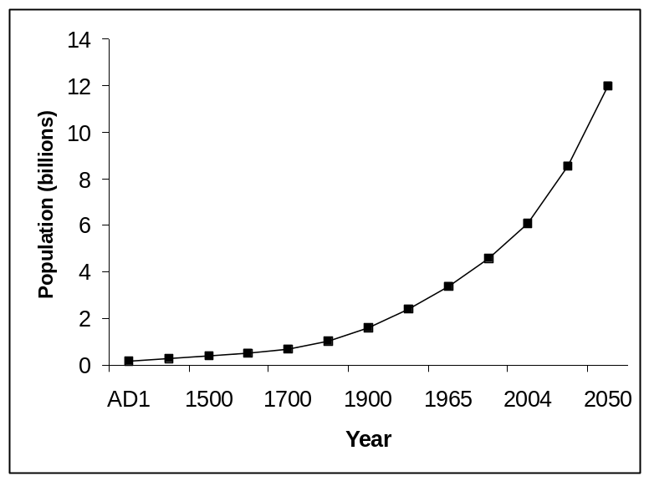
Figure 1. World population growth and projections to the year 2050 (F.A.O., 1996).

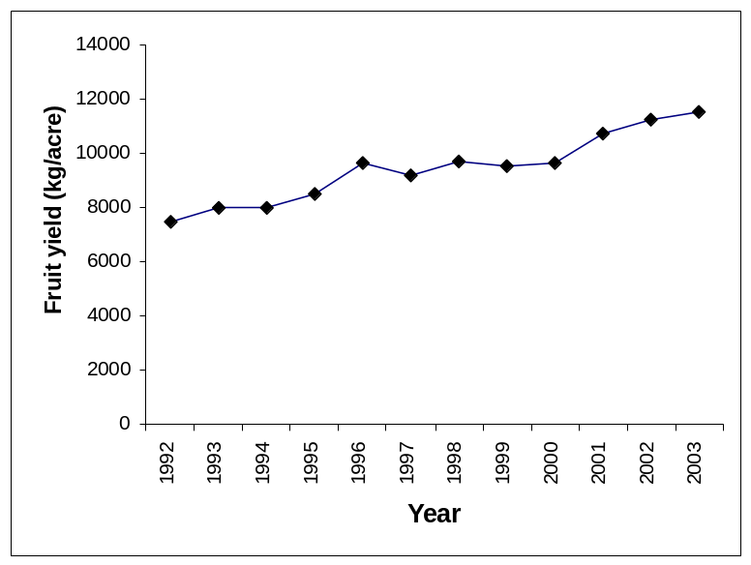
Figure 2. Average cantaloupe fruit yield in the United States between 1992 and 2003 (http://www.usda.gov/nass).

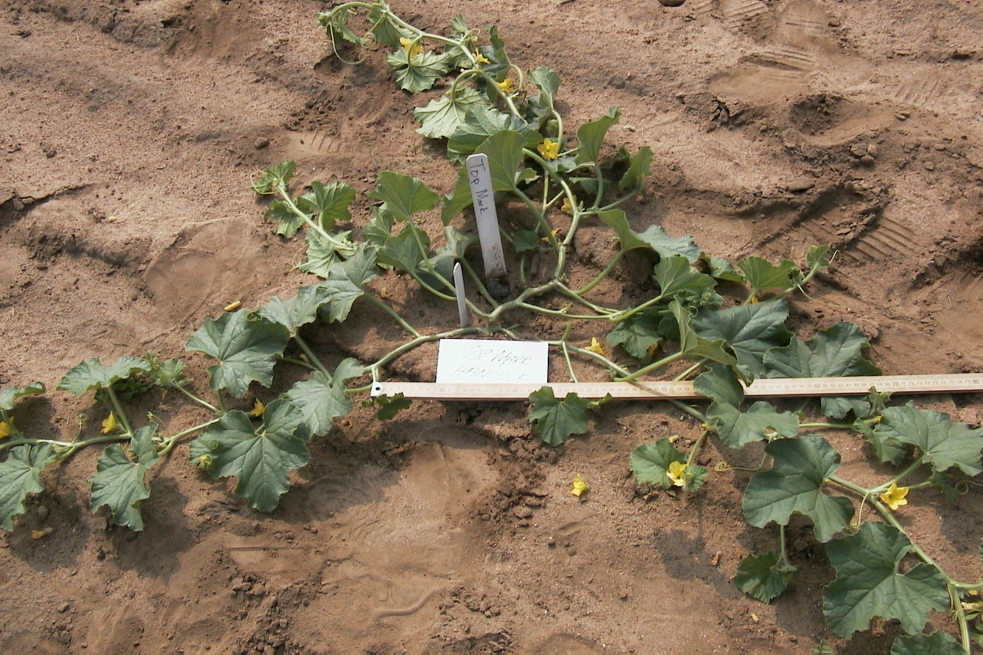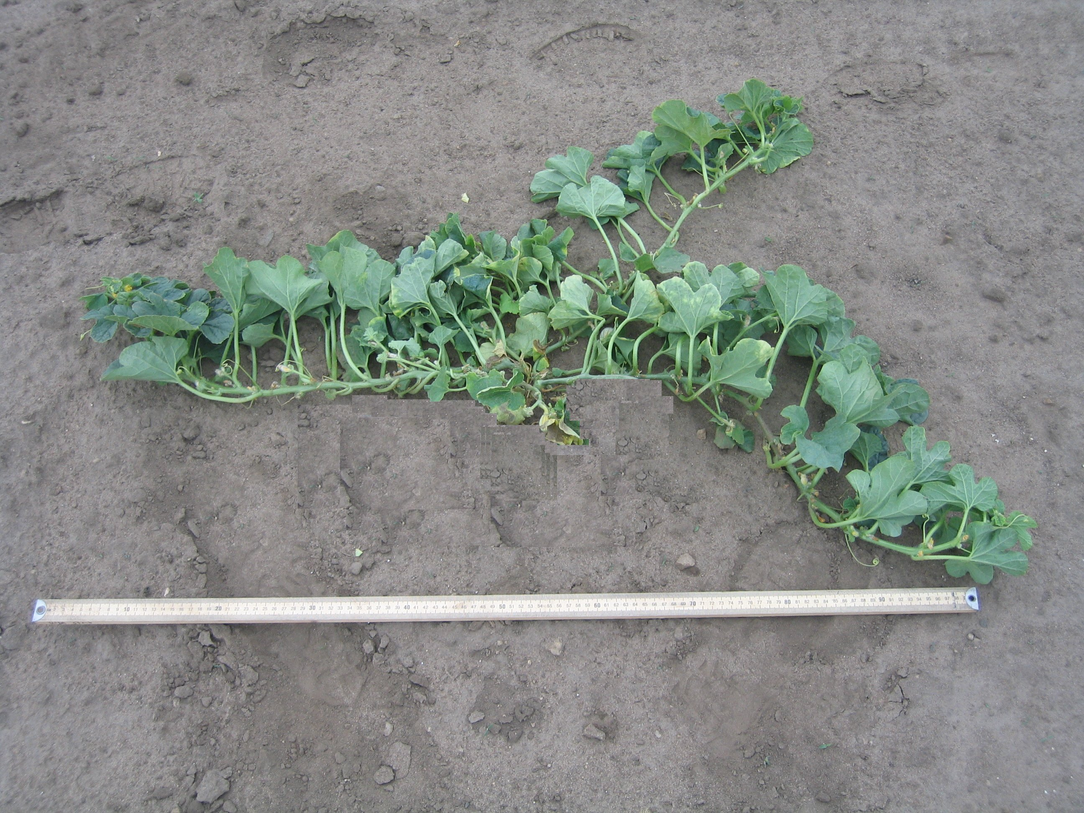
B
A

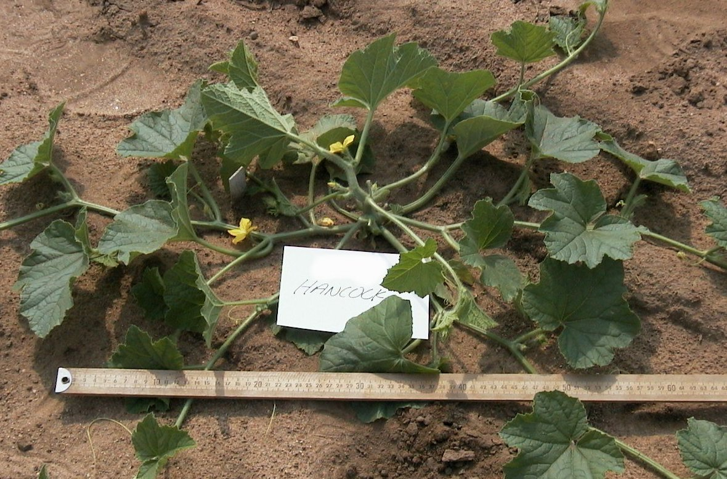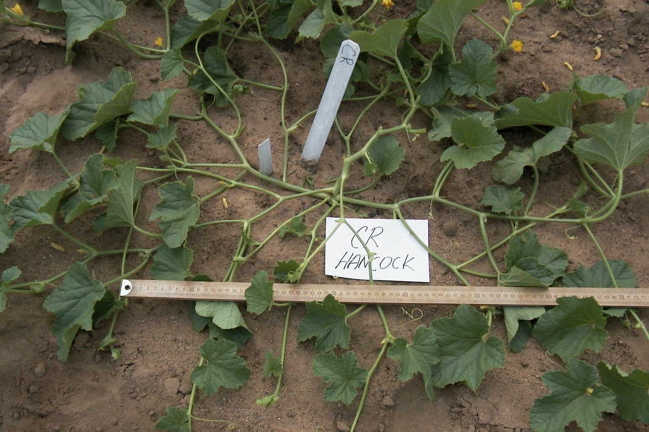
C
D

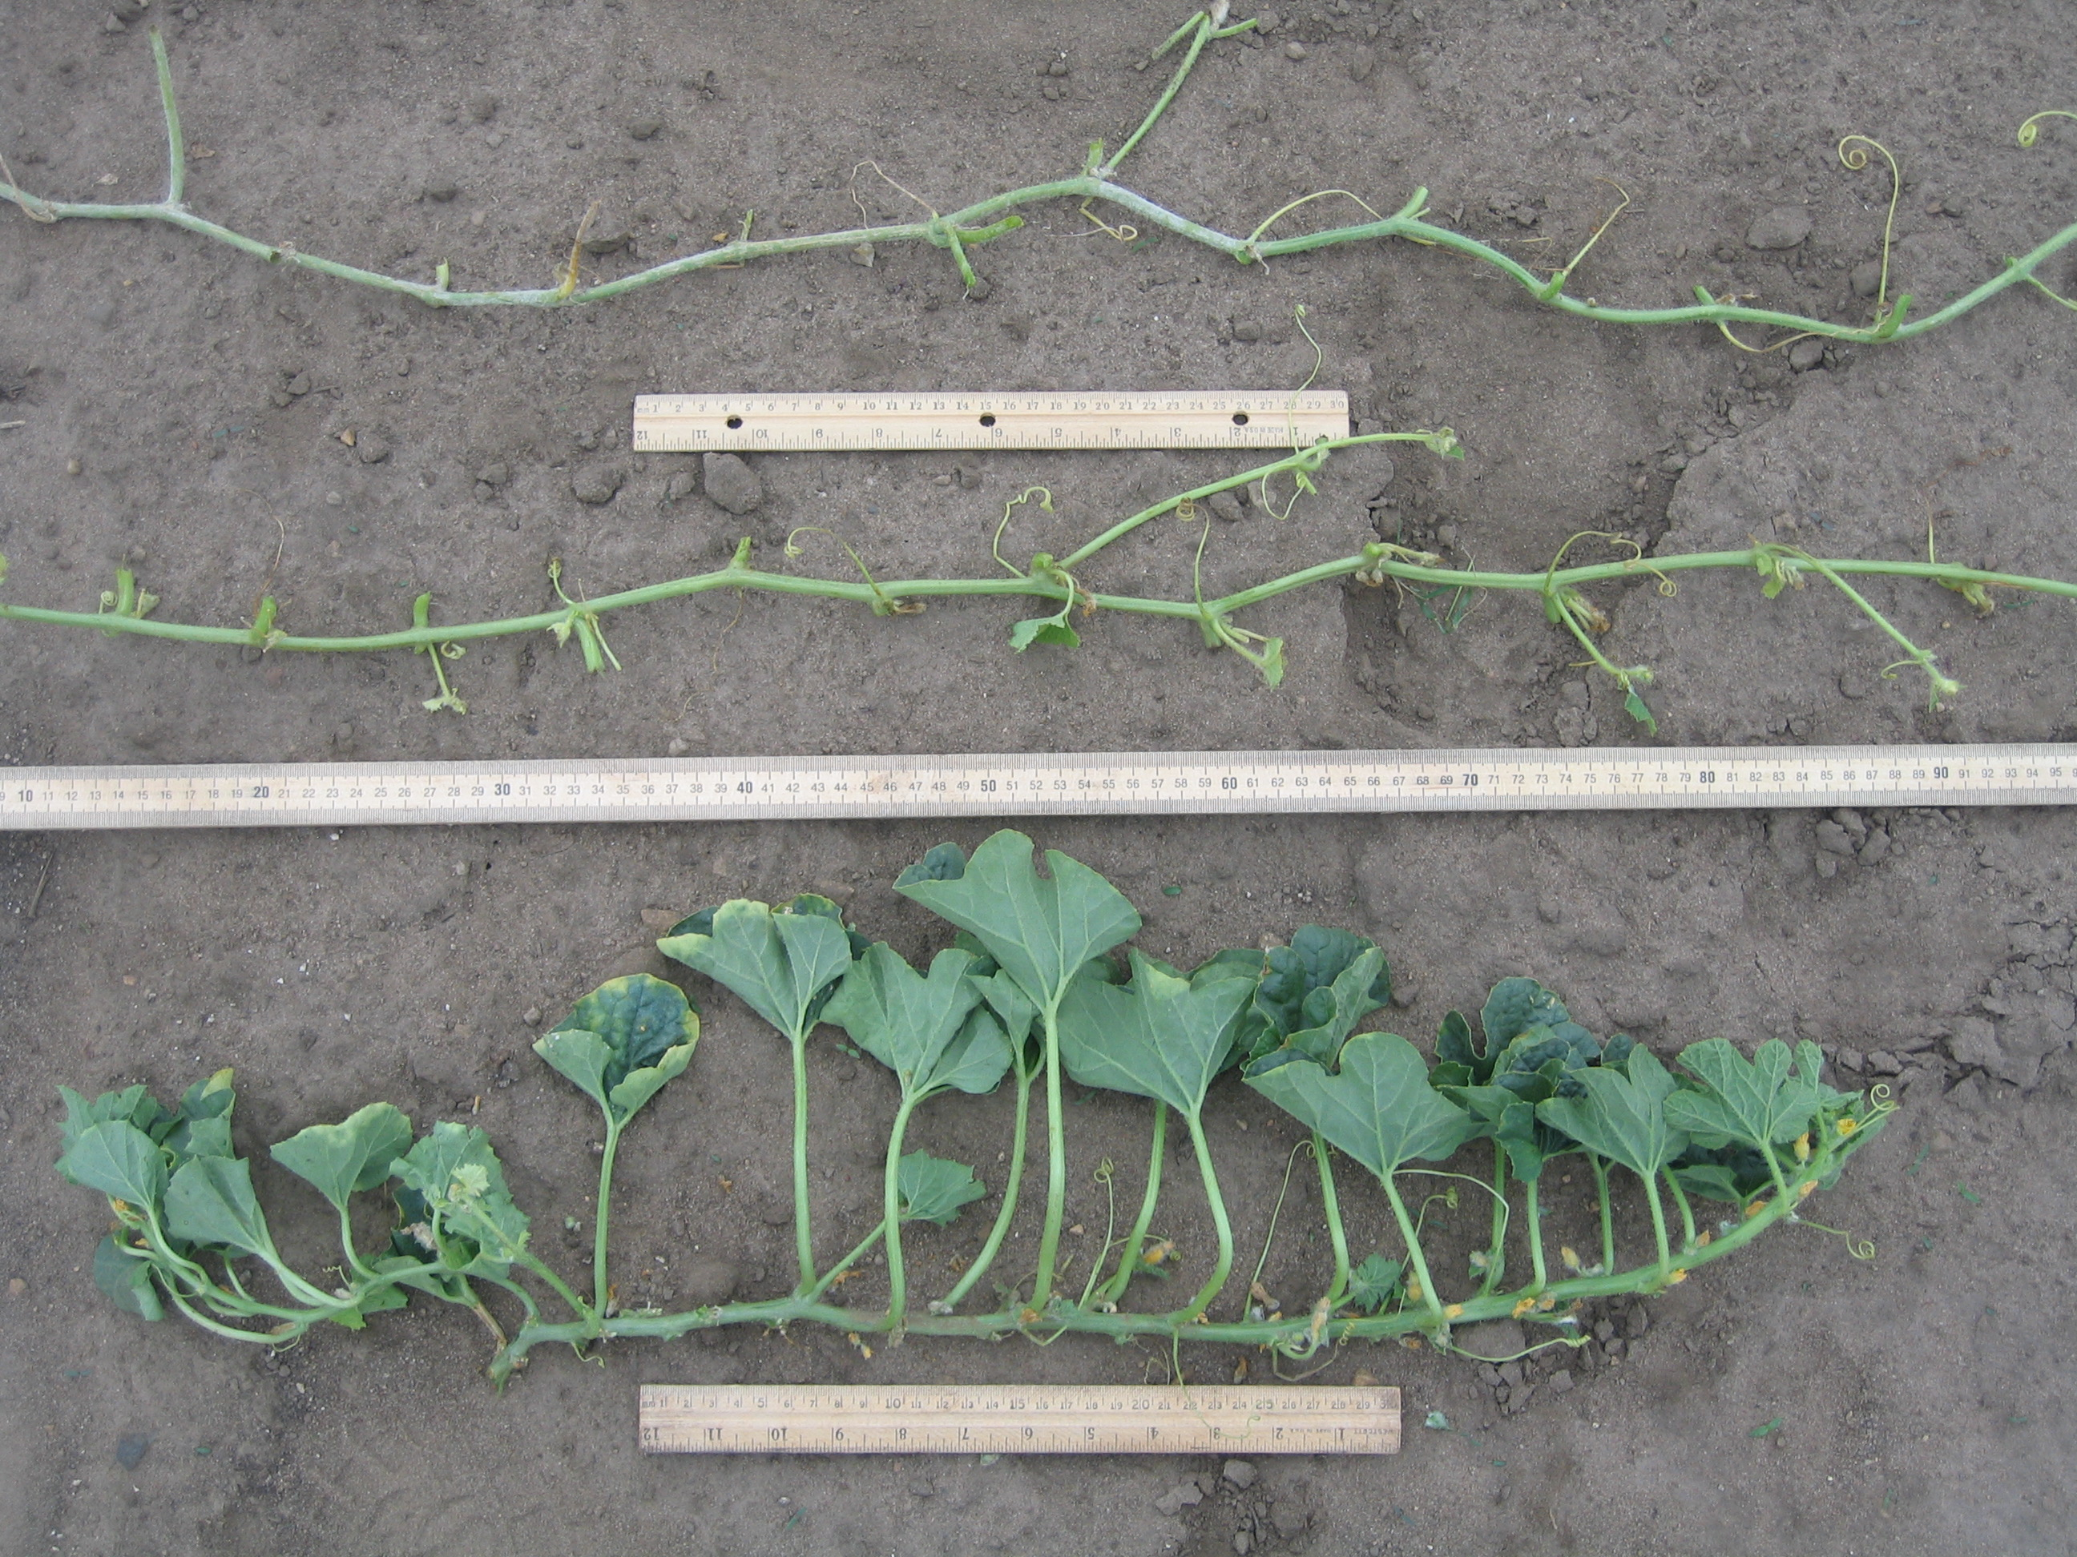
F
Vining
Fractal
Dwarf

Figure 3. Melon (Cucumis melo L.) plant architectural types; vining (panel A), dwarf (panel B), birdnest (panel C), and fractal (panel D), and internode length differences among these types (panel F).

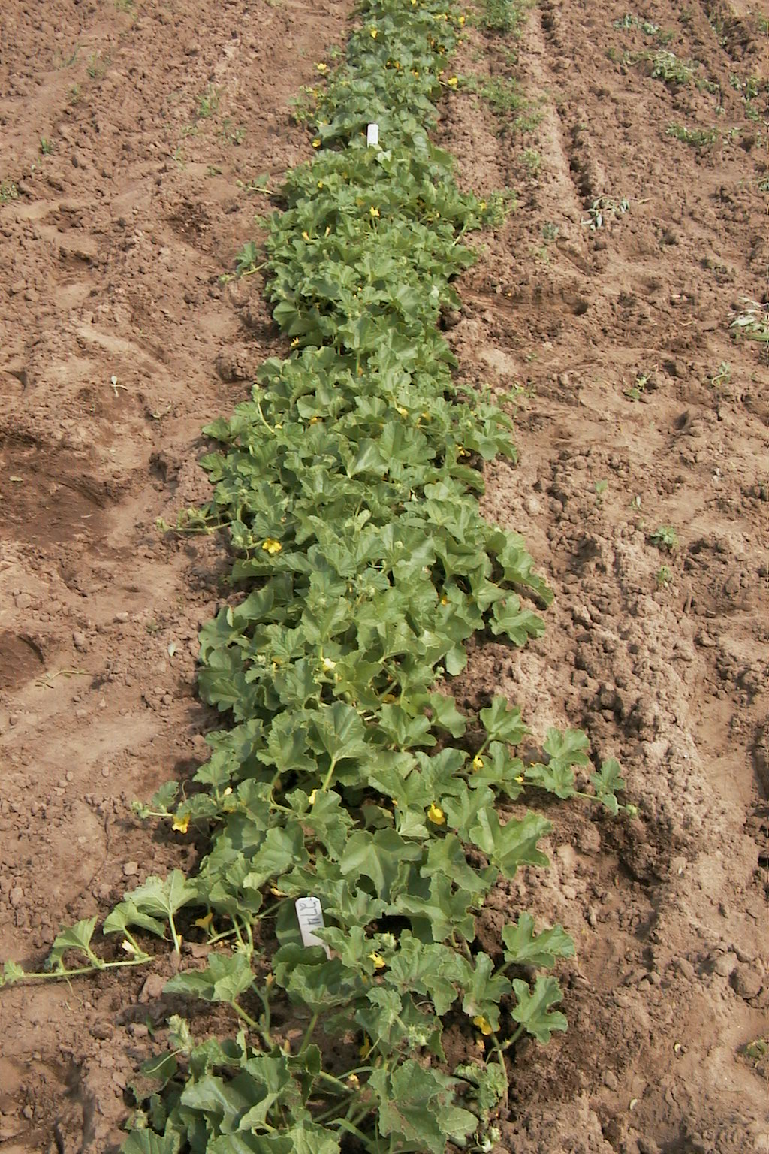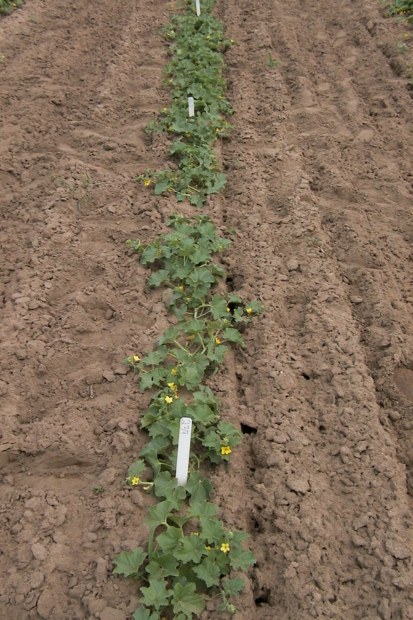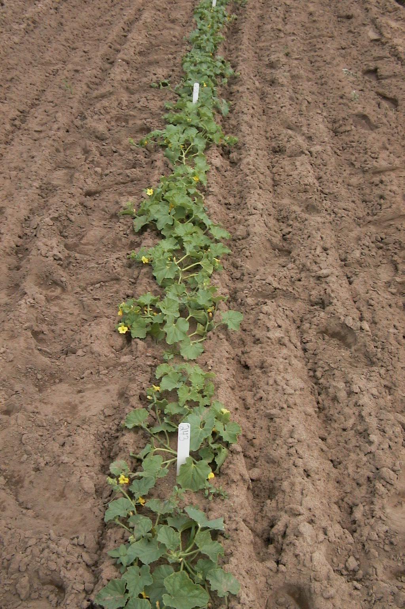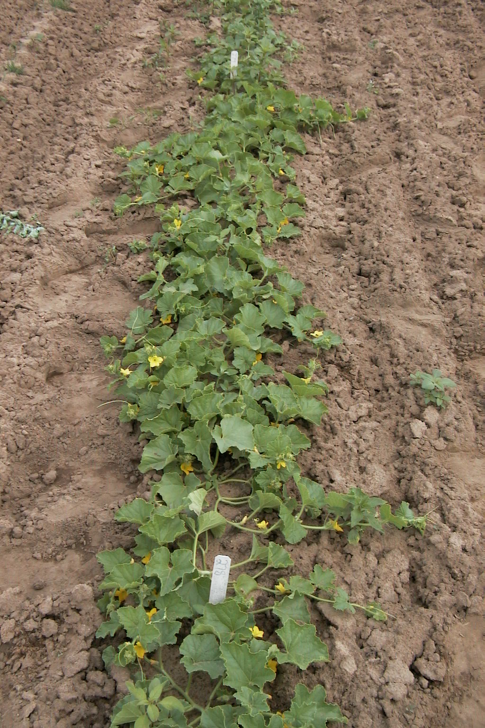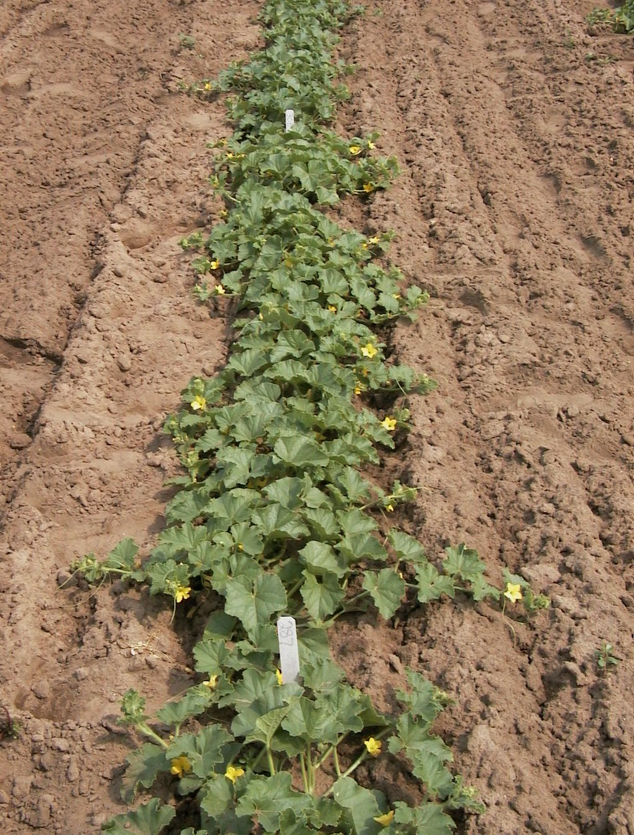

USDA 846-1
“Esteem”
“Sol Dorado”
“Hales Best Jumbo”

“Top Mark”
A

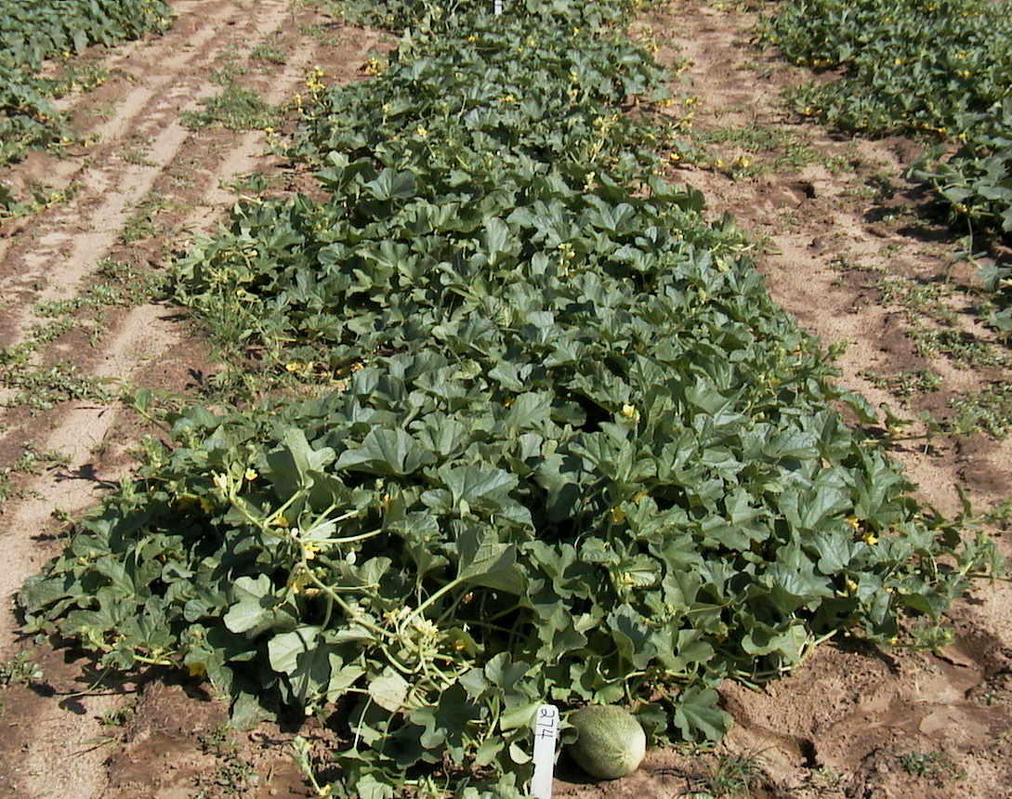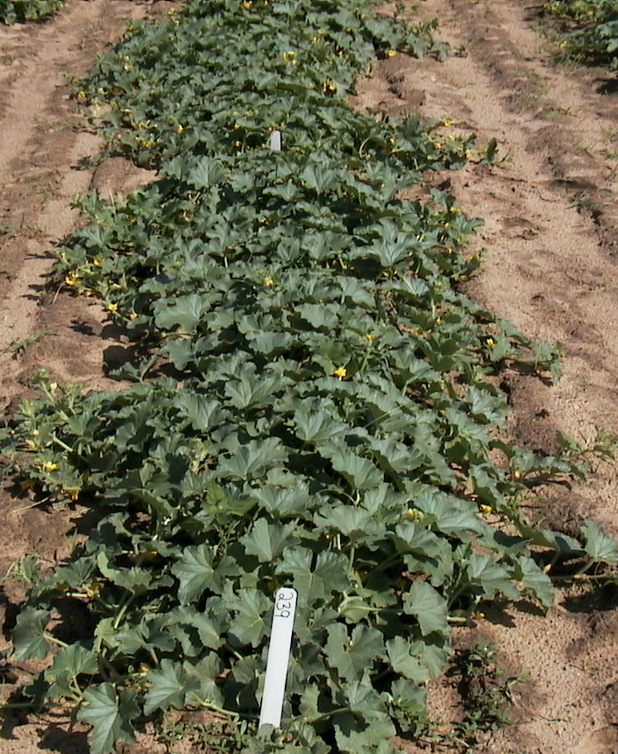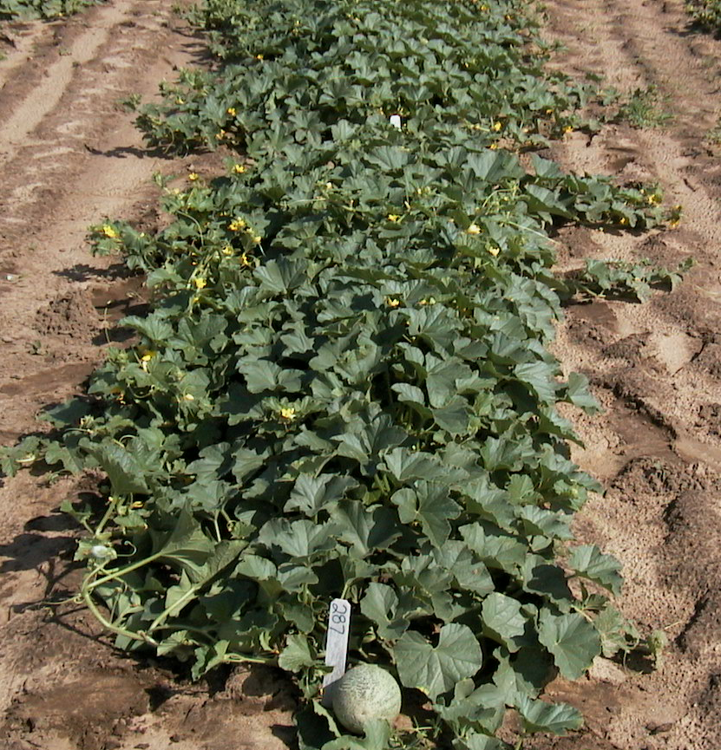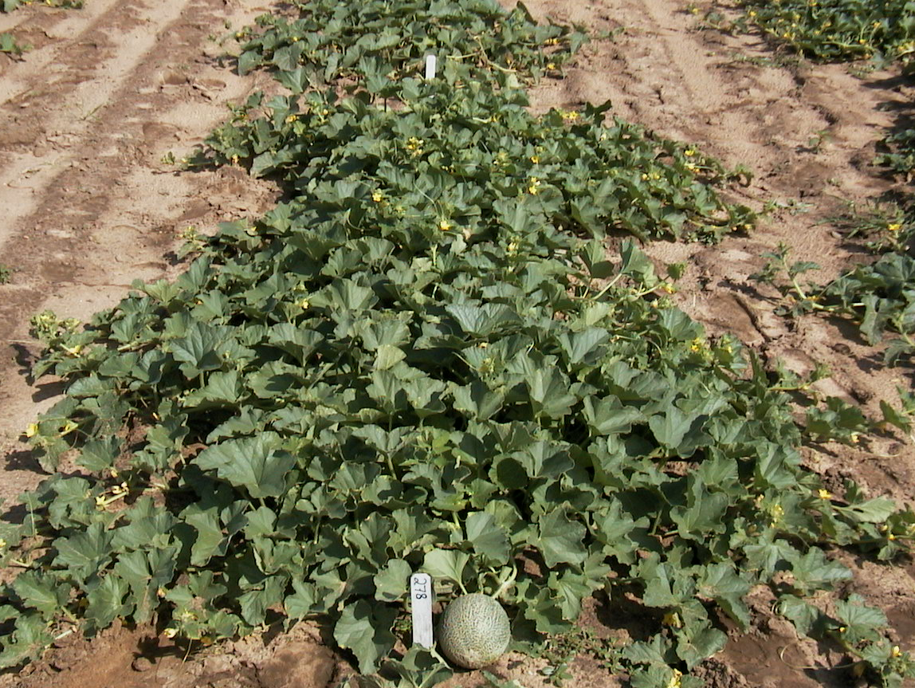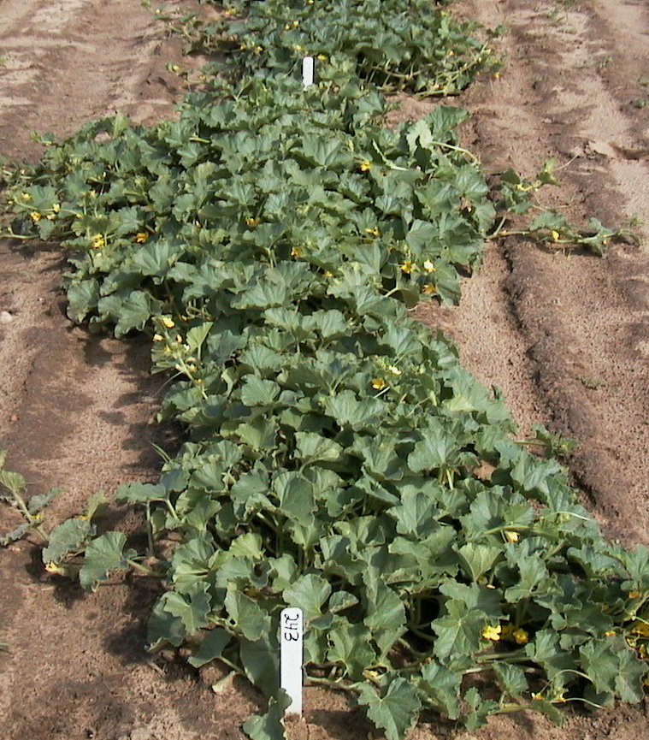
B

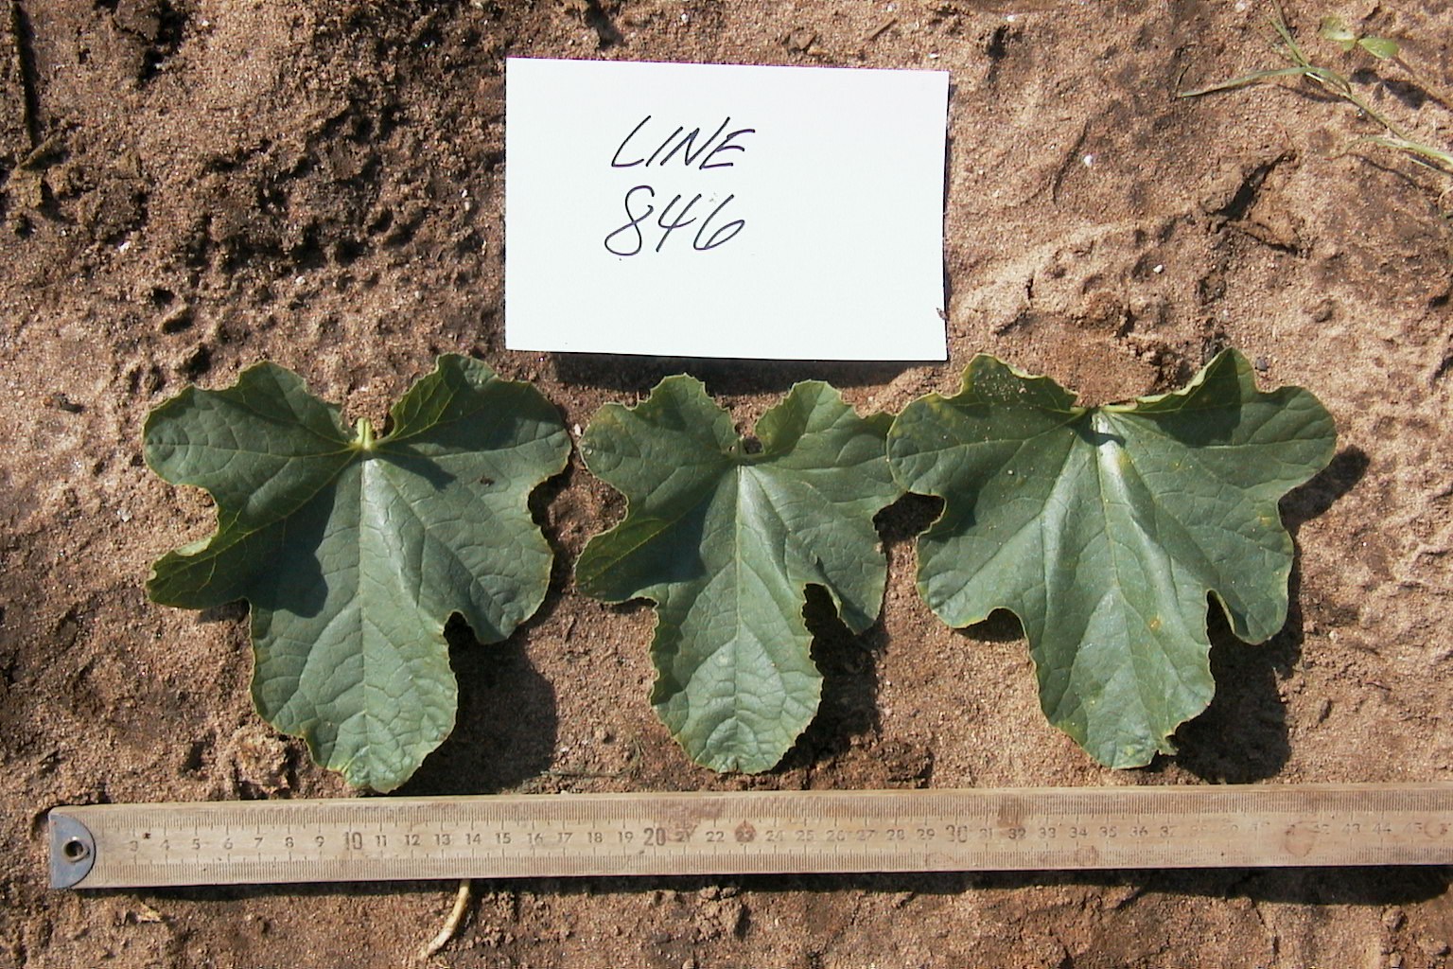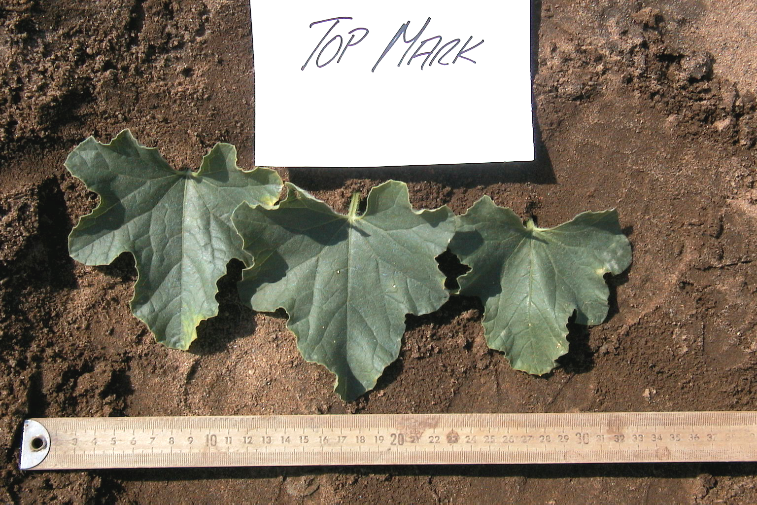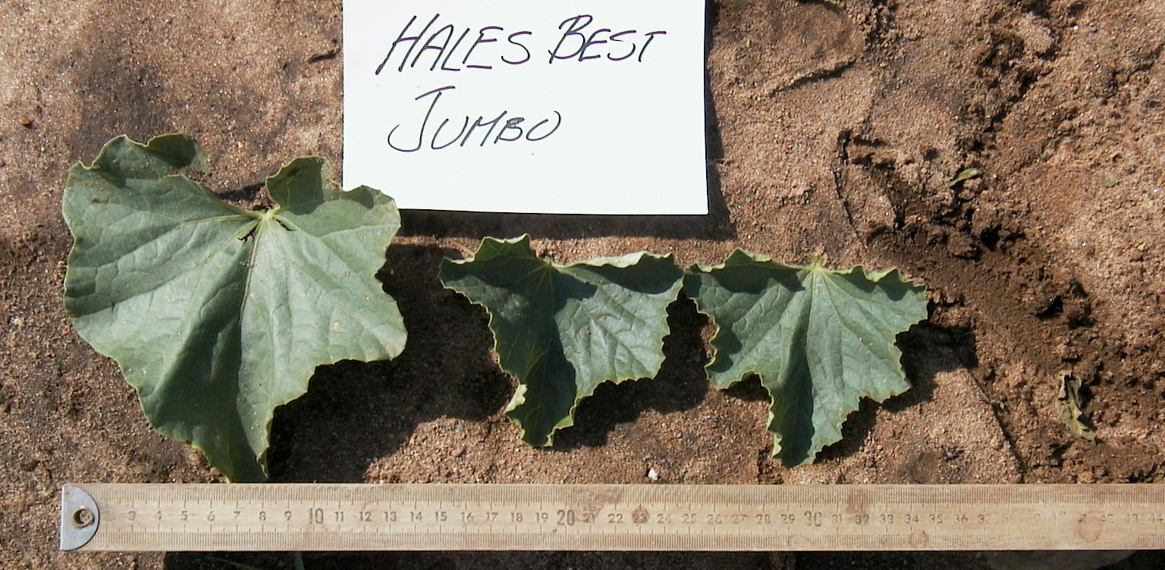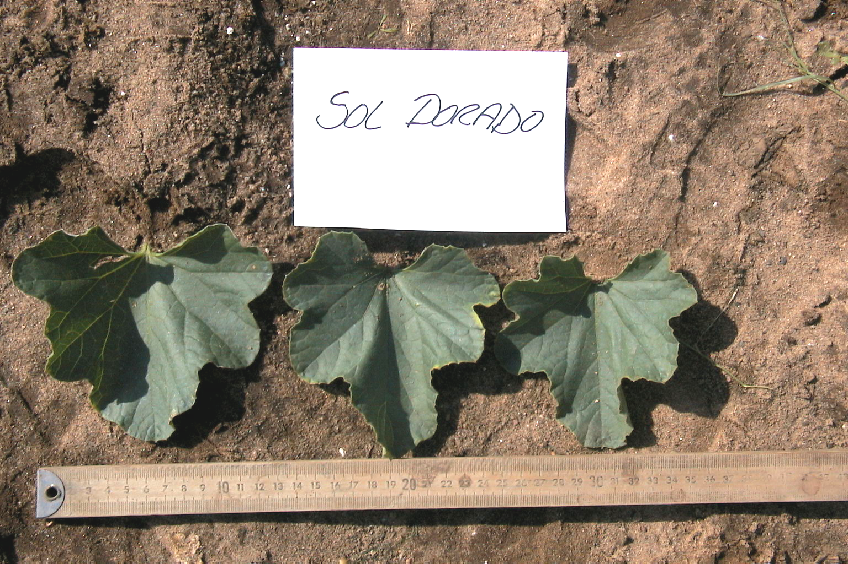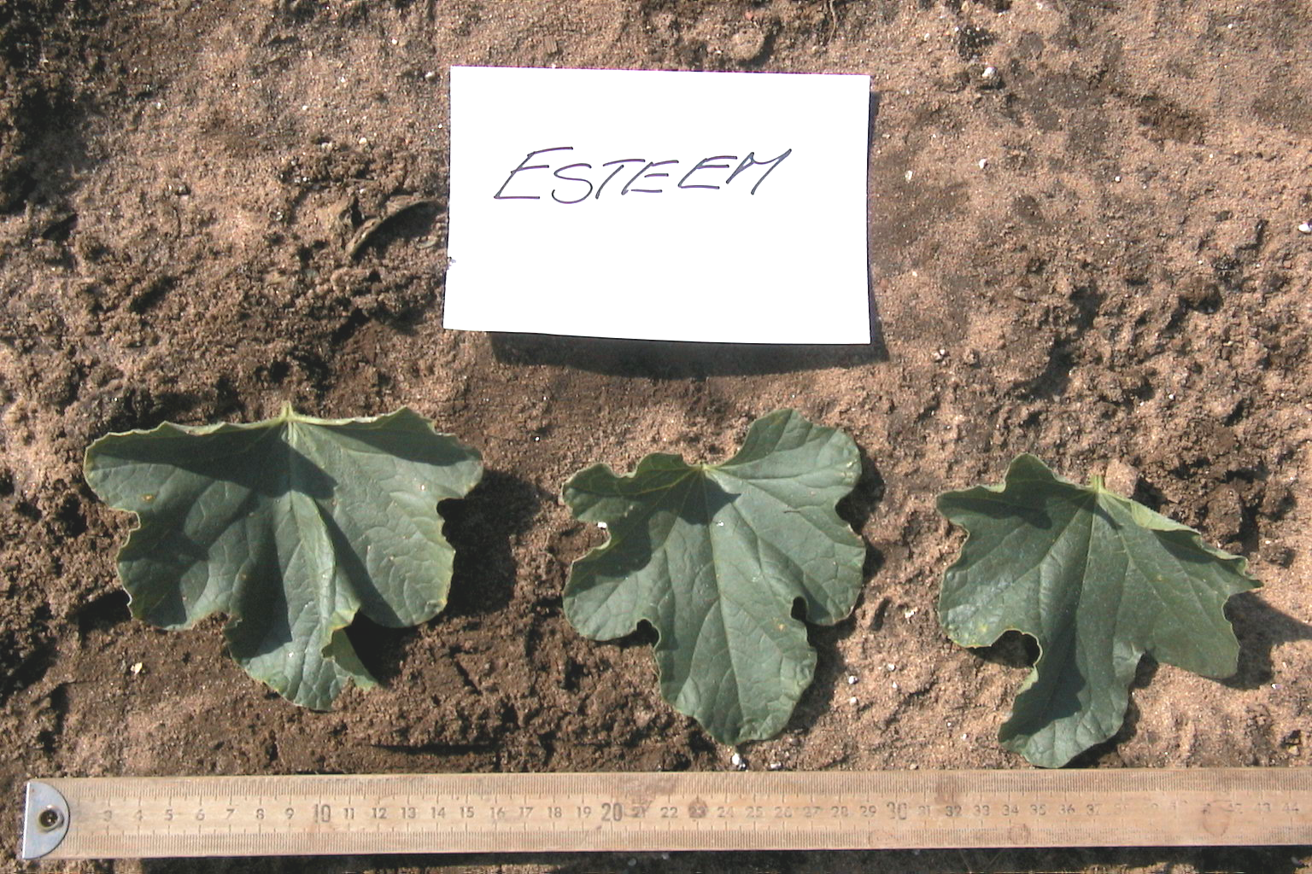
C

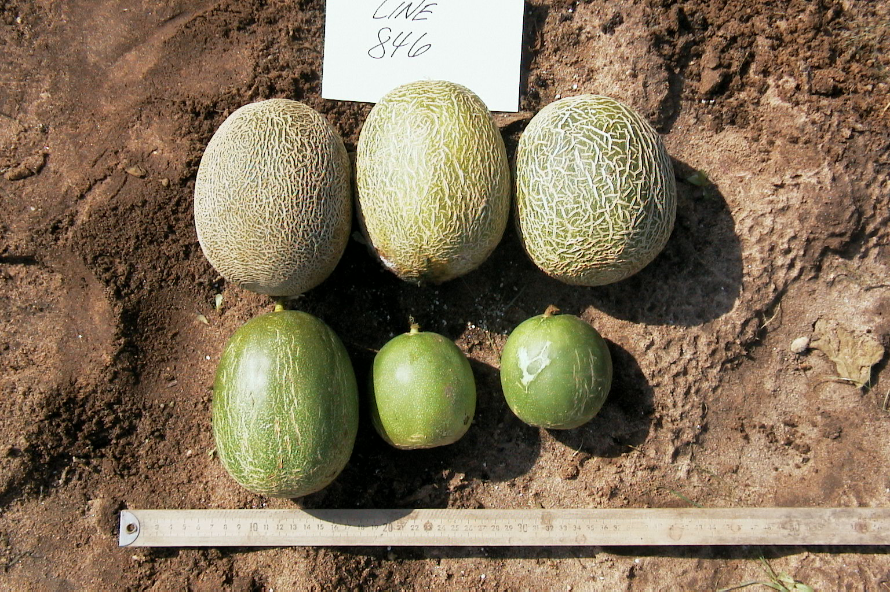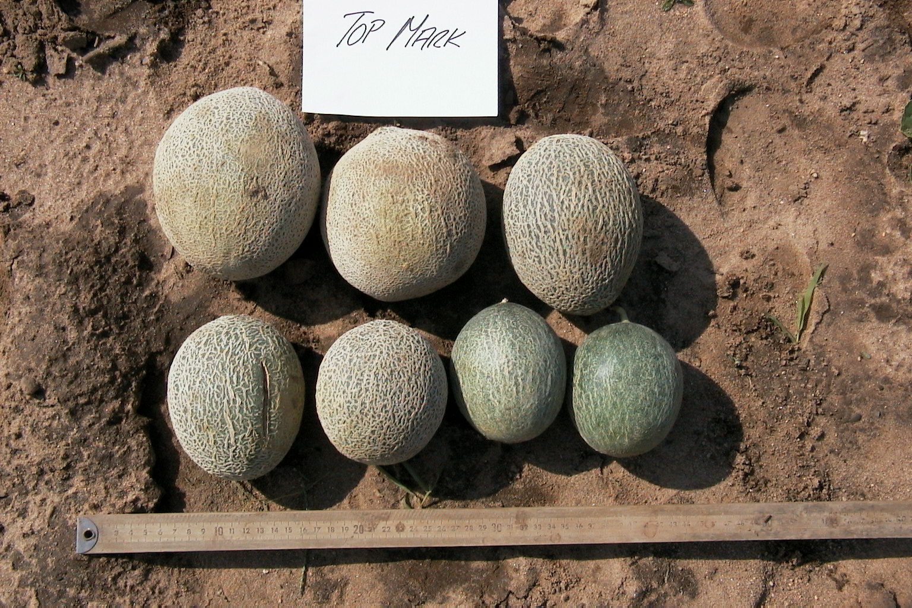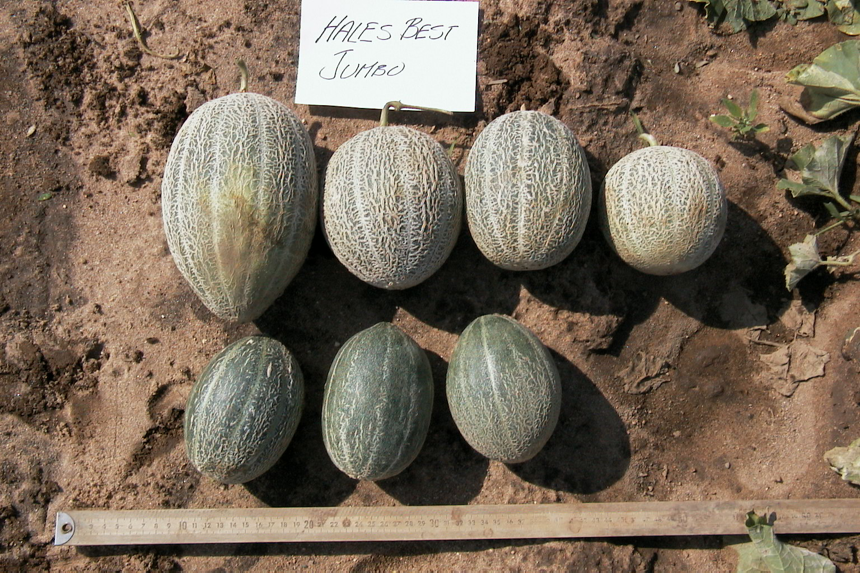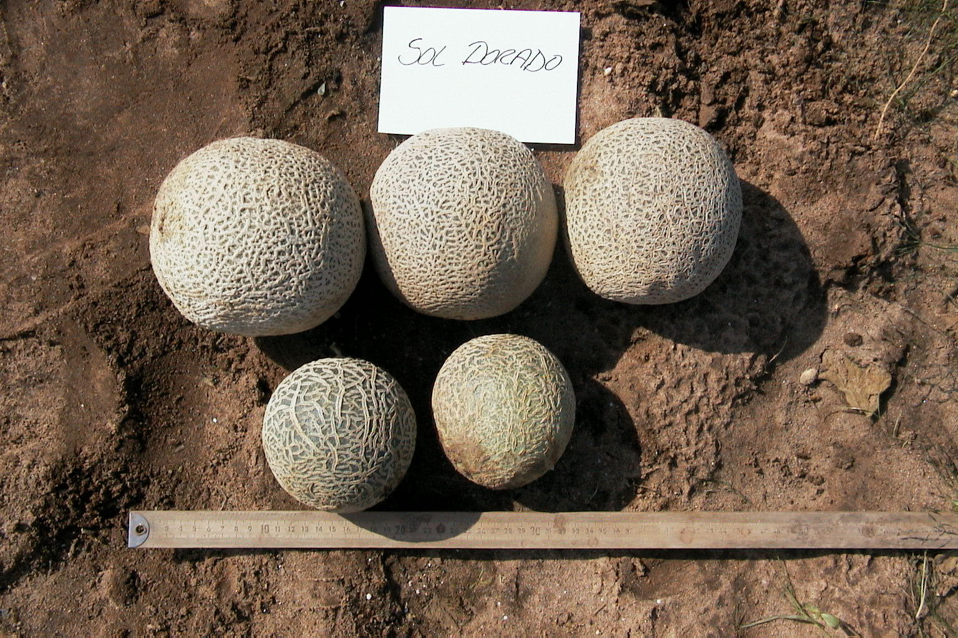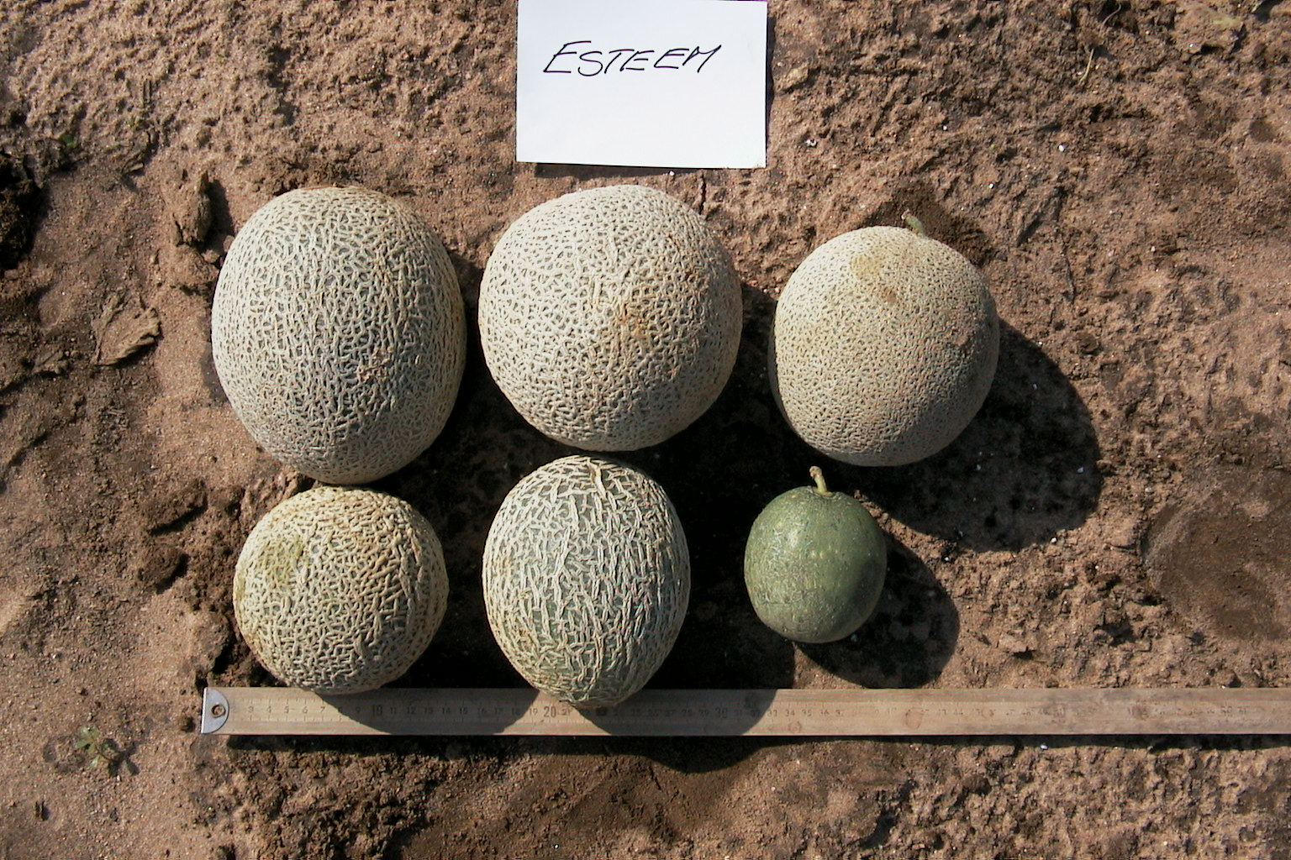
D

Figure 4. Differences in vegetative growth [at four (panel A) and eight (panel B) weeks after transplant, and leaves (panel C)], and fruit characteristics (panel D) of melon (Cucumis melo L.) germplasm (USDA 846-1, “Top Mark”, “Hales Best Jumbo”, “Sol Dorado”, and “Esteem”).
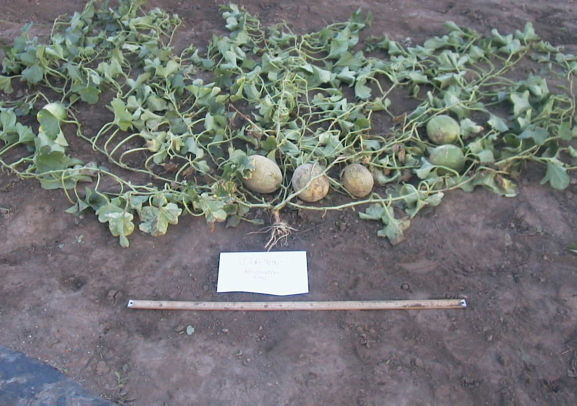
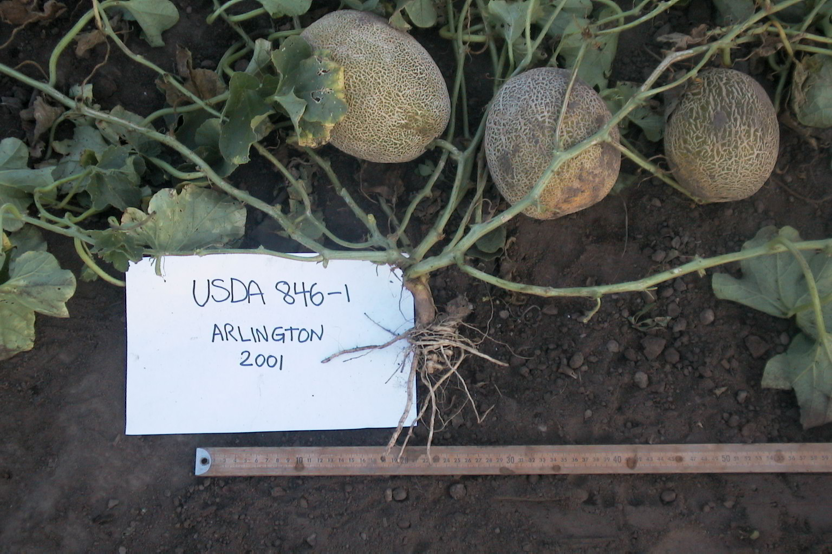
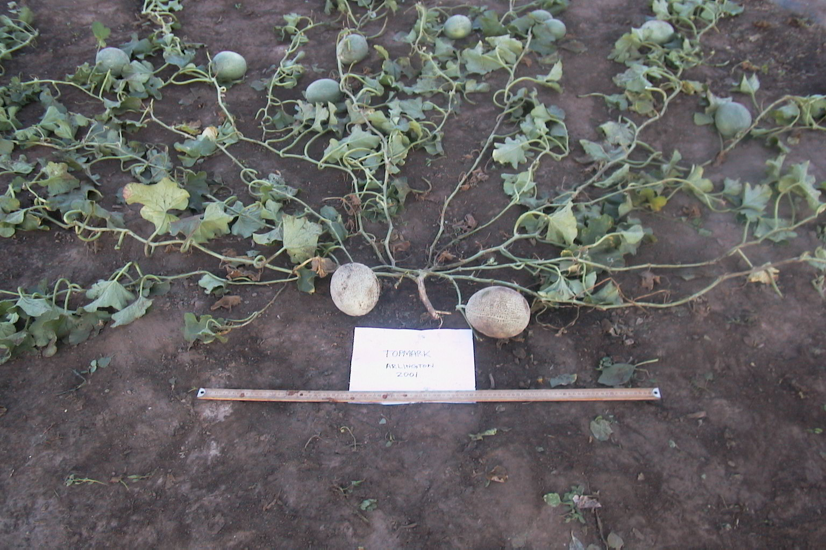
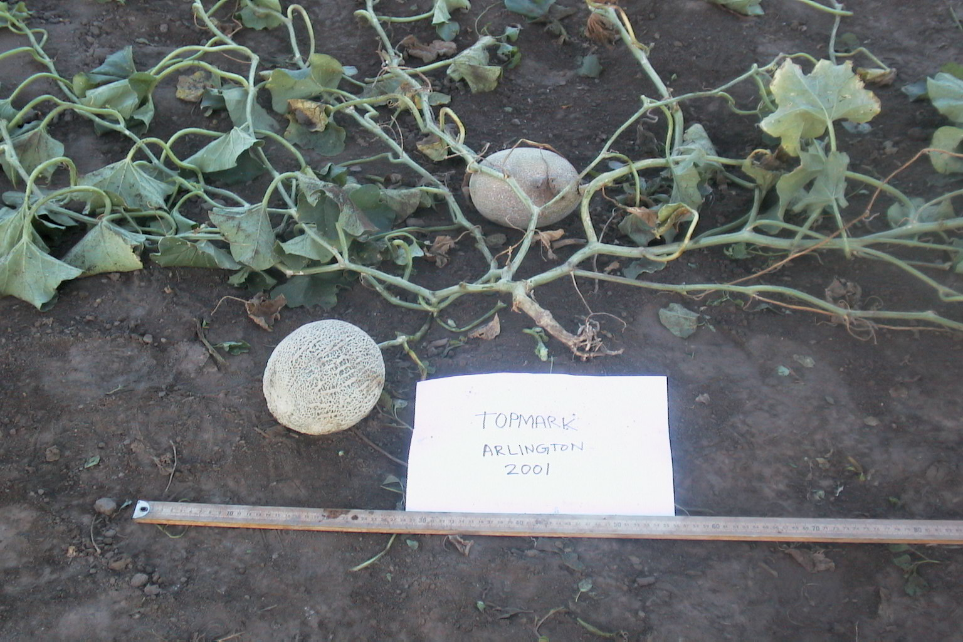
C
A
B
D
USDA 846 –1
“Top Mark”

Figure 5. Vegetative growth habit, branching, and fruiting patterns in melon (Cucumis melo L.) lines USDA 846-1 (panels A and B) and “Top Mark” (panels C and D).

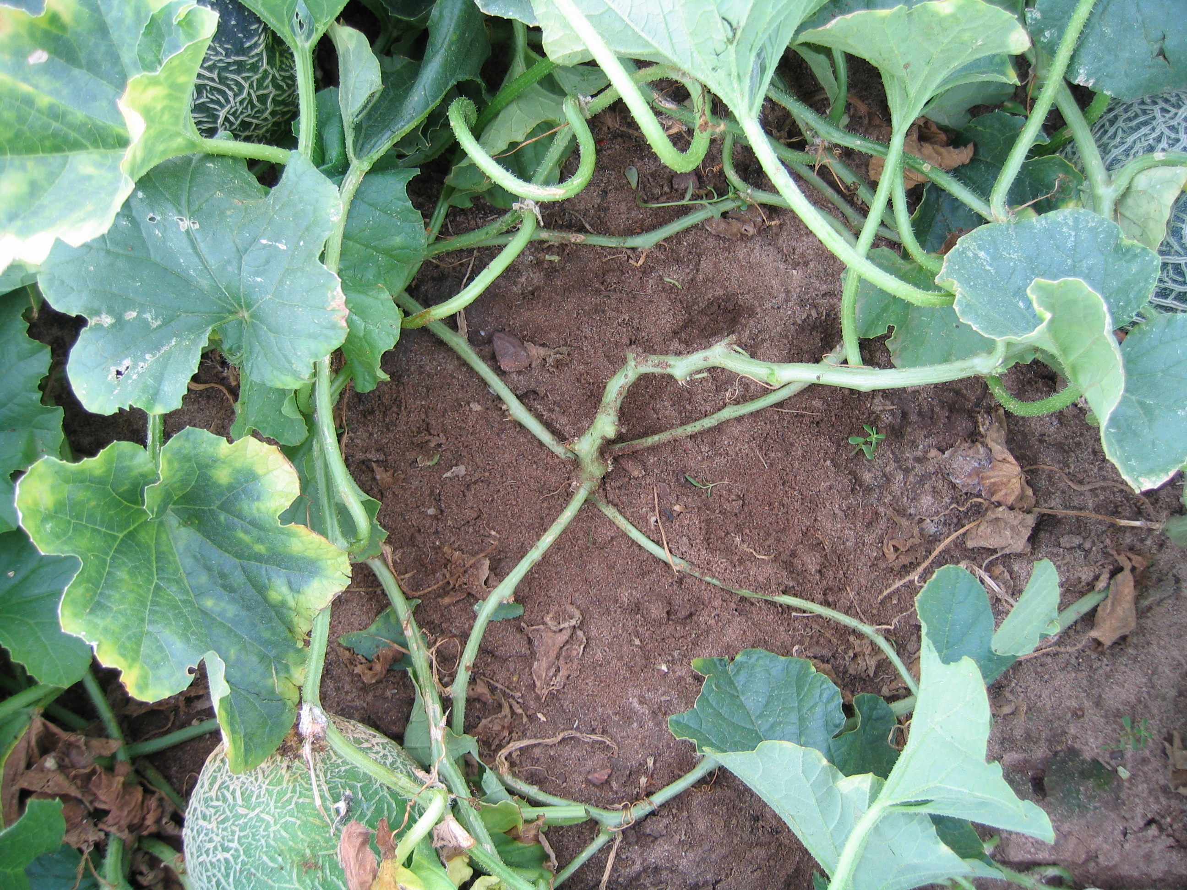
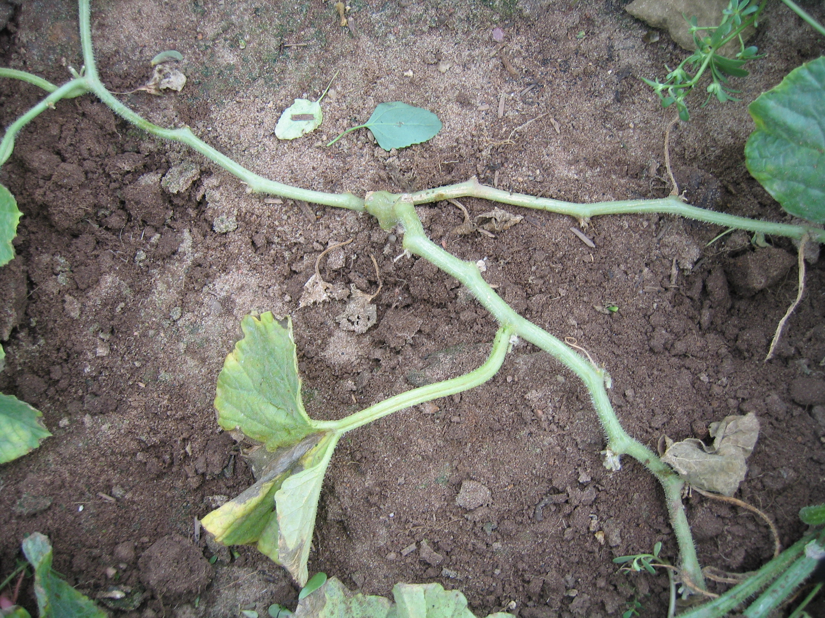
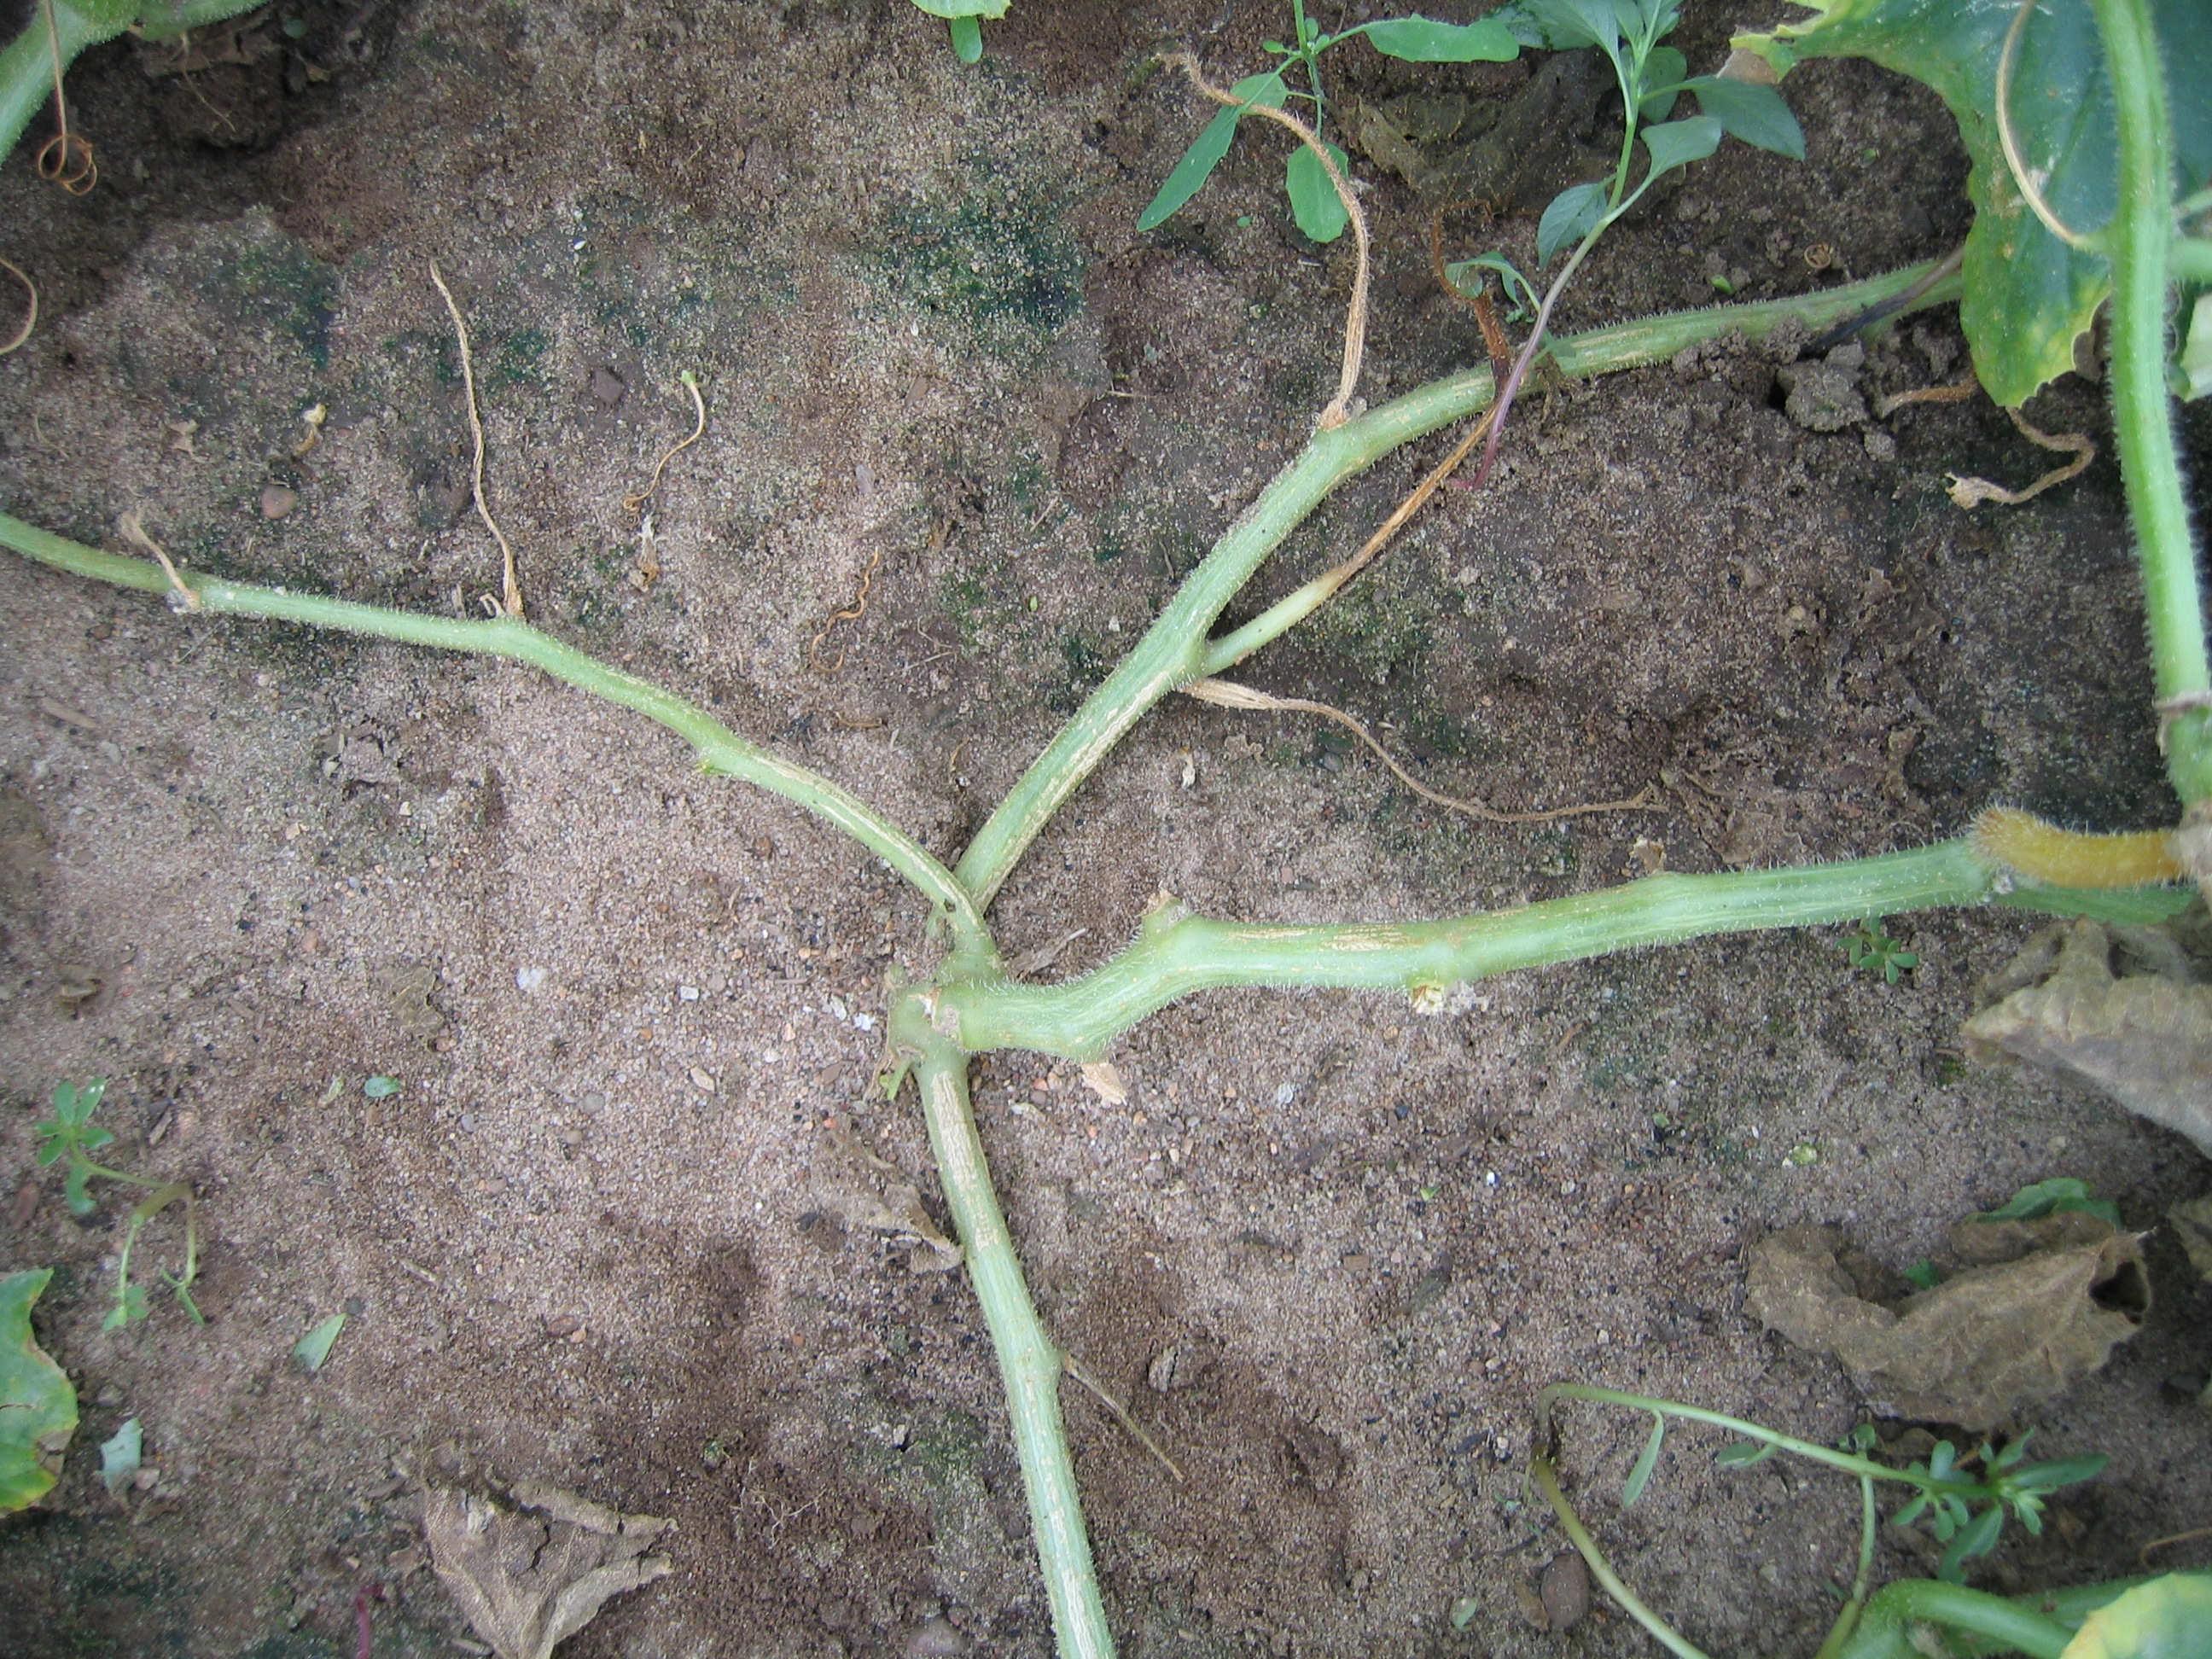

4 branches

3 branches

5 branches

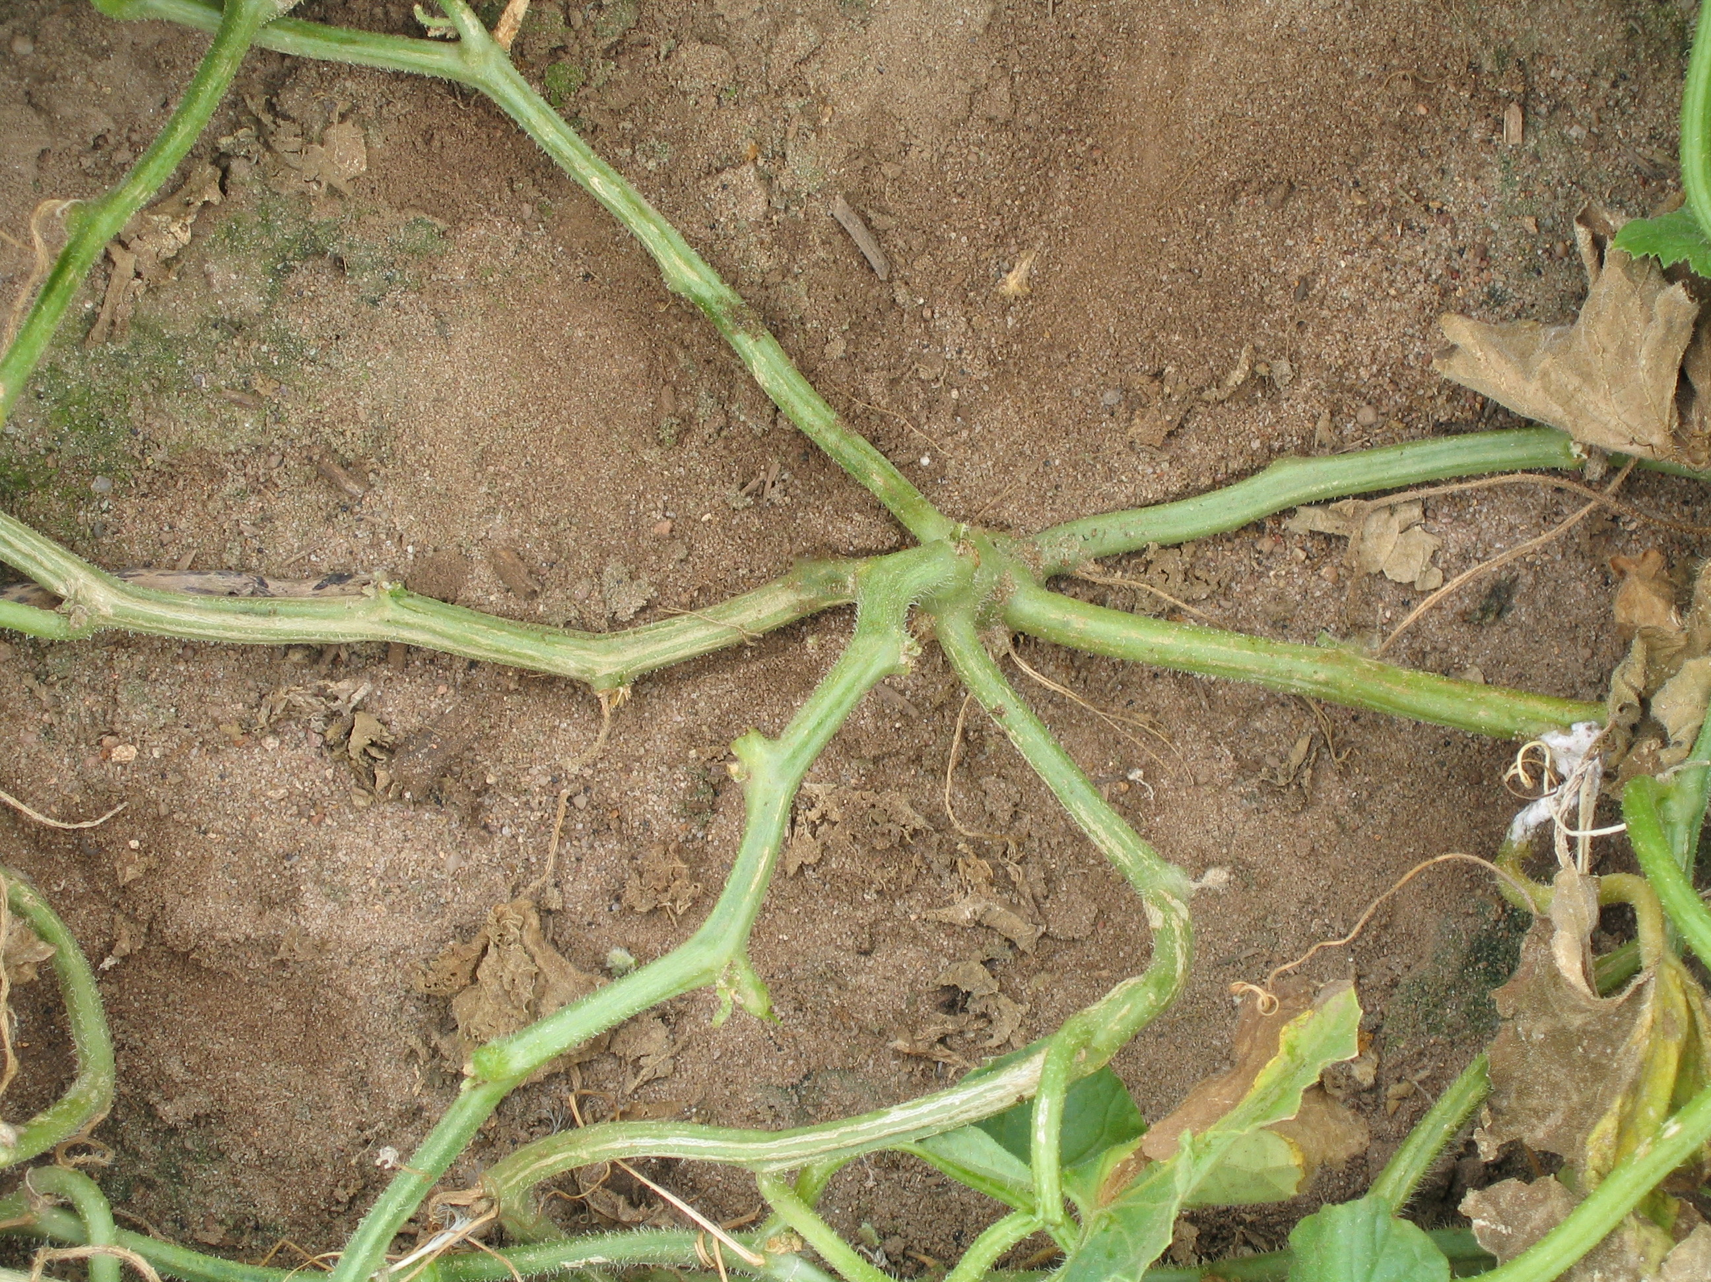
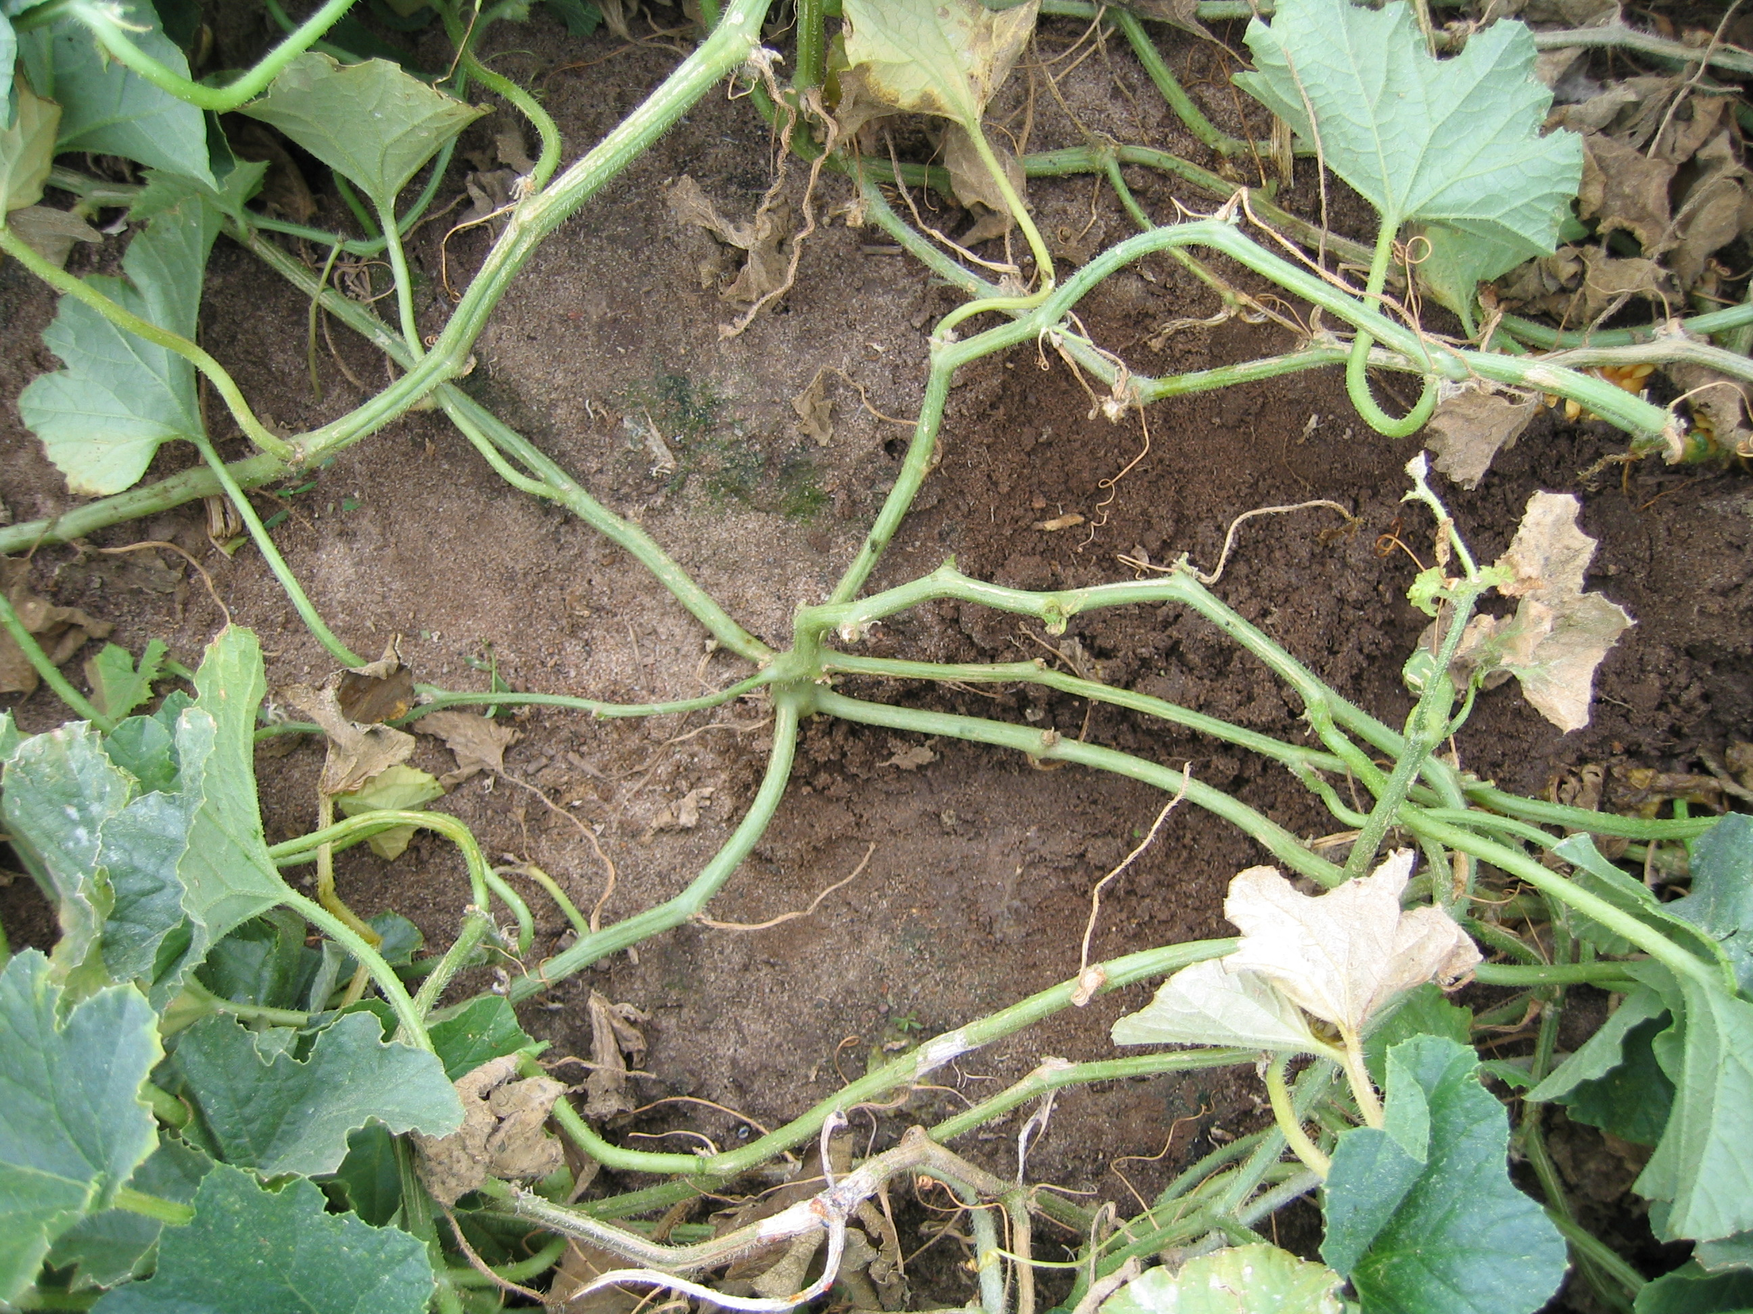
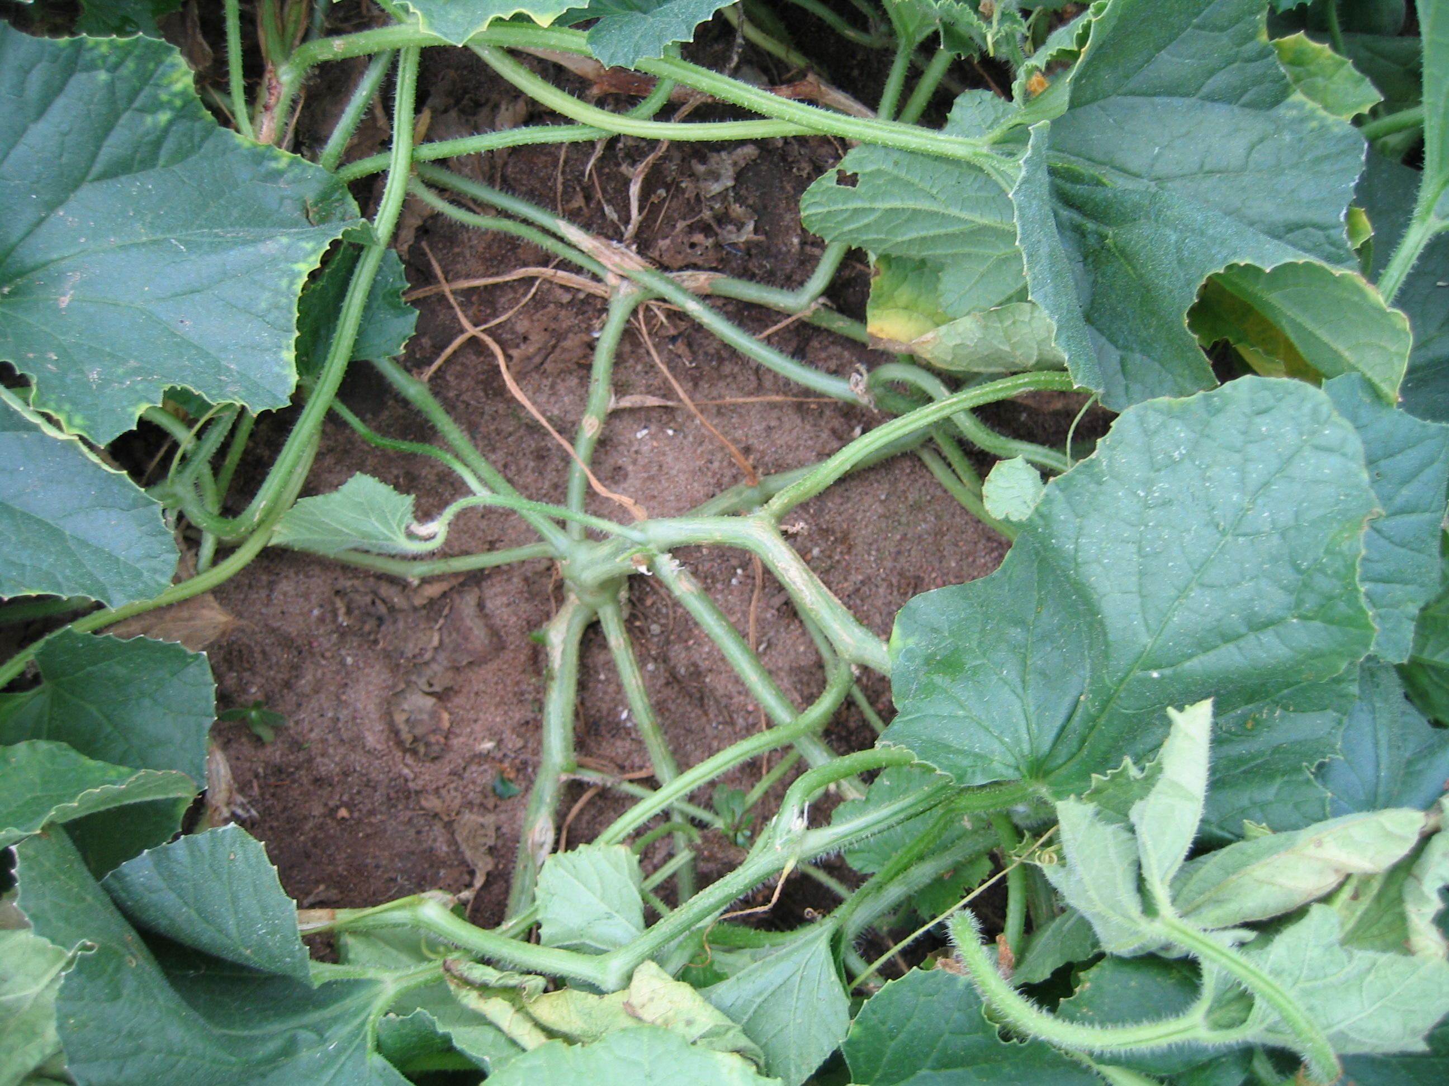

6 ranches

7 branches

8+ branches

Figure 6. Branching patterns in melon (Cucumis melo L.) progeny derived from a cross between USDA 846-1 and “Top Mark”.

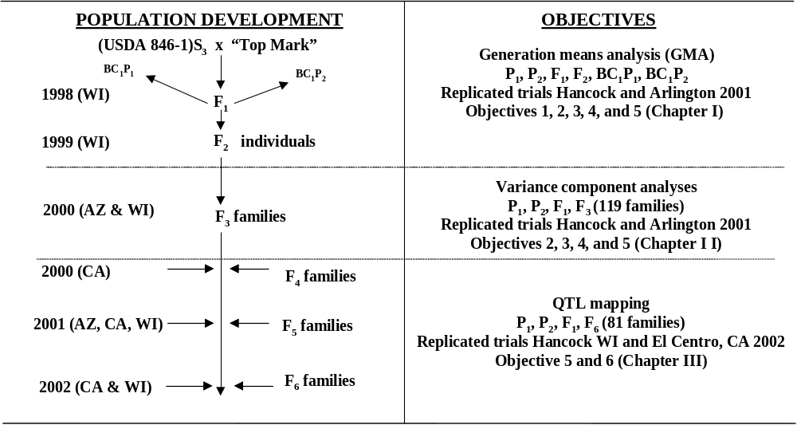
Figure 7. Timeline of objectives for determination of inheritance and QTL mapping of plant architecture and fruit yield in melon (Cucumis melo L.).

Table 1. Least square means (lsmeans) and standard errors (‾x ± S.E.) of plant architecture and fruit yield of melon (Cucumis melo L.) line USDA 846-1 (P₁), “Top-Mark” (P₂), “Hales Best Jumbo”, “Esteem”, and “ Sol Real” grown in Wisconsin and California in 2001-2002.
 | Primary  branch no. |  | Fruit no.  per plant |  | Fruit weight  per plant (kg) |  | Average fruit  weight (kg)
Cultivar |  | ‾x ± S.E |  | ‾x ± S.E |  | ‾x ± S.E |  | ‾x ± S.E
 | Arlington, WI 2001 (AR01) at 0.70 m within row spacing (36,300 plants/ha)
USDA 846-1 (P₁) |  | 6.70 a¹±0.23 |  | 3.80 e ± 0.27 |  | 4.35 d ± 0.34 |  | 1.18 b ± 0.05
“Top-Mark” (P₂) |  | 3.93 b ± 0.20 |  | 5.06 ab ± 0.39 |  | 4.73 cd ± 0.34 |  | 1.01 c ± 0.06
“Hales Best” |  | 4.20 b ± 0.21 |  | 4.13 cde ± 0.37 |  | 5.36 bc ± 0.43 |  | 1.39 a ± 0.08
 | Hancock, WI 2001 (HCK01) at 0.70 m within row spacing (36,300 plants/ha)
USDA 846-1 (P₁) |  | 6.77 a ± 0.21 |  | 2.17 a ± 0.24 |  | 2.45 bc ± 0.21 |  | 1.33 c ± 0.13
“Top-Mark” (P₂) |  | 4.37 b ± 0.16 |  | 1.23 b ± 0.20 |  | 2.08 c ± 0.21 |  | 1.80 ab ± 0.11
“Hales Best” |  | 4.53 b ± 0.15 |  | 1.87 a ± 0.23 |  | 2.94 ab ± 0.23 |  | 1.71 ab ± 0.15
 | Hancock, WI 2002 (HCK02) at 0.35 m within row spacing (72,600 plants/ha)
USDA 846-1 (P₁) |  | 5.33 a ± 0.34 |  | 2.33 a ± 0.11 |  | 1.35 ab ± 0.11 |  | 0.58 b ± 0.03
“Top-Mark” (P₂) |  | 3.45 b ± 0.33 |  | 2.13 ab ± 0.18 |  | 1.22 b ± 0.06 |  | 0.58 b ± 0.02
“Hales Best” |  | 4.25 b ± 0.33 |  | 1.78 b ± 0.20 |  | 1.62 a ± 0.14 |  | 0.93 a ± 0.07
“Esteem” |  | 3.63 b ± 0.33 |  | 1.78 b ± 0.08 |  | 1.66 a ± 0.15 |  | 0.93 a ± 0.05
“Sol Dorado” |  | 3.75 b ± 0.34 |  | 2.40 a ± 0.44 |  | 1.38 ab ± 0.13 |  | 0.60 b ± 0.06
 | El Centro, CA 2002 (ELC02) at 0.35 m within row spacing (72,600 plants/ha)
USDA 846-1 (P₁) |  | 5.69 a ± 0.24 |  | 5.55 a ± 0.67 |  | 2.55 ab ± 0.23 |  | 0.47 b ± 0.04
“Top-Mark” (P₂) |  | 3.58 b ± 0.20 |  | 3.86 bc ± 0.37 |  | 2.00 b ± 0.21 |  | 0.52 b ± 0.01
“Hales Best” |  | 2.98 b ± 0.22 |  | 4.27 ab ± 0.99 |  | 2.94 a ± 0.29 |  | 0.74 a ± 0.08
“Esteem” |  | 3.10 b ± 0.20 |  | 2.62 c ± 0.11 |  | 2.14 b ± 0.13 |  | 0.81 a ± 0.03
“Sol Dorado” |  | 3.26 b ± 0.21 |  | 4.34 ab ± 0.70 |  | 3.10 a ± 0.64 |  | 0.71 a ± 0.04
¹ Means in the same column with the same letter are not significantly different according to pairwise t test at p ≤ 0.05.

Mapping population | Initial cross | Marker type | No of markers | Map length (cM) | Linkage groups | Reference
218 F2 | “Vedrantais” x PI 161375 | 1, 2, 3 8, 9 | 103 | 1390 | 14 | Baudracco-Arnas and Pitrat, 1996
66 BC | MR1 x “Ananas Yokneam” | 3, 5, 4 | 204 | 1942 | 20 | Wang et al., 1997
64 F2 | Mukuna #SLK-V-052 x “Sky Rocket” | 3 | 125 | 1348 | 29 | Liou et al., 1998
93 F2 | PI 161375 x “Pinonet Piel de Sapo” | 1, 2, 3, 4, 5, 6, 9 | 411 | 1197 | 12 | Oliver et al., 2001
122 F2 | PI 414723 x “Dulce” | 1, 2, 3, 8, 9 | 74 | 610 | 14 | Danin-Poleg et al., 2002
163 & 63 RIL | “Vedrantais” x PI 161375 & PI 414723 | 2, 3, 4, 5, 8, 9 | 668 | 1654 | 12 | Perin et al., 2002 c
113 F2 | PI 414723 x “Top-Mark” | 2, 3, 4, 5, 6, 8, 9 | 179 | 1420 | 24 | Silberstein et al., 2003
77 DHL | PI 161375 x “Pinonet Piel de Sapo” | 2, 5, 7, 8 | 173 | 1223 | 12 | Gonzalo et al., 2005
Table 2. A summary of the features of several published genetic maps of melon (Cucumis melo L).

¹1 = Isozyme, 2= RFLP, 3 = RAPD, 4 = AFLP, 5 = SSR, 6 = ISSR, 7 = EST-SSR, 8 = Disease resistance loci, and 9 = Morphological traits.

Abdalla, M. M. A. and M. H. Aboul-Nasr. 2002. Estimation of heterosis for yield and other economical characters of melon (Cucumis melo L.) in upper Egypt. p. 11-16. In: Maynard, D. N. (ed.). Proc. Cucurbitaceae 2002. Naples, Florida, December 8-12, 2002. ASHS, Alexandria, VA.

Allard, R. W. 1956. Formulas and tables to facilitate the calculation of recombination values in heredity. Hilgardia 24:235-278.

Allard, R. W. 1960. Plant breeding. Wiley, New York.

Akashi, Y., N. Fukuda, T. Wako, M. Masuda, and K. Kato. 2002. Genetic variation and phylogenetic relationships in East and South Asian melons, Cucumis melo L., based on the analysis of five isozymes. Euphytica 125:385–396.

Akkaya, M.S., R.C. Shoemaker, J.E. Specht, A.A. Bhagwat, and P.B Cregan. 1995. Integration of simple sequence repeat DNA markers into a soybean linkage map. Crop Sci. 35:1439-1445.

Andrus, C. F. and G. W. Bohn. 1969. Cantaloup Breeding: shifts in population means and variability under mass selection. Amer. Soc. Hort. Sci. Proc. 90:209-222.

Arumuganathan, K. and E. D. Earle. 1991. Nuclear DNA content of some important plant species. Plant Mol. Biol. Rep. 9:211–215.

Austin, D.F. and M. Lee. 1996. Comparative mapping in F_{2:3} and F_{6:7} generations of quantitative trait loci for grain yield and yield components in maize. Theor. Appl. Genet. 92:817-826.

Bains, M. S. and U. S. Kang. 1963. Inheritance of some flower and fruit characters in muskmelon. Indian J. Genet. Plant Breed. 23:101-106.

Ballvora, A., J. Hesselbach, J. Niewohner, D. Leister, F. Salamini, and C. Gebhardt. 1995. Marker enrichment and high-resolution map of the segment of potato chromosome V1I harboring the nematode resistance gene Gro1. Mol. Gen. Genet. 249:82-90.

Barau, U. M., K. J. Chalmers, C. A. Hackett, W. T. B. Thomas, W. Powell, and R. Waugh. 1993. Identification of RAPD markers linked to a Rhynchosporium secalis resistance locus in barley using near-isogenic lines and bulked segregant analysis. Heredity 71:177-184.

Basten, C. J., S. B. Zeng, and B. S. Weir. 1994. Zmap – A QTL cartographer. Proc. 5th world congress on genetics applied to livestock production, 22: 65-66.

Baudracco-Arnas, S. and M. Pitrat. 1996. A genetic map of melon (Cucumis melo L.) with RFLP, RAPD, isozyme, disease resistance and morphological markers. Theor. Appl. Genet. 93:57-64.

Beattie, A. D., J. Larsen, T. E. Michaels, and K. P. Pauls. 2003. Mapping quantitative trait loci for a common bean (Phaseolus vulgaris L.) ideotype Genome 46:411-422.

Beavis, W. D. and D. Grant. 1991. A linkage map based on information from four F₂ populations of maize (Zea mays L.). Theor. Appl. Genet. 82:636-644.

Beavis, W. D. 1998. QTL analysis: power, precision, and accuracy. p. 145-162. In: Paterson, A. H. (ed). Molecular dissection of complex traits. CRC Press, Boca Raton, FL.

Beckmann, J. S. and M. Soller 1983. Restriction fragment length polymorphisms
in genetic improvement: methodologies, mapping and cost. Theor. Appl. Genet.
67:35-43.

Bell, C. J. and J. R. Ecker. 1994. Assignment of 30 microsatellite loci to the linkage map of Arabidopsis. Genomics 19:137-144.

Bohn, G. W. and T. W. Whitaker, 1949. A gene for male-sterility gene in muskmelon (Cucumis melo L.). Proc. Amer. Soc. Hort. Sci. 53:309-314.

Bohn, G. W. and G. N. Davis. 1957. Earliness in F₁ hybrid muskmelons and their parent varieties. Hilgardia 26:453-471.

Bohn, G. W. and J. A. Principe. 1964. A second male-sterility gene in muskmelon. J. Hered. 55:211-215.

Bohn, G. W. and C. F. Andrus. 1969. Cantaloupe Breeding: correlations among fruit characters under mass selection. U.S. Dept. of Agr. Tech Bull. 1403.

Borlaug, N. E. 1968. Wheat breeding and its impact on world food supply. In: Finlay, K.W. and K. W. Shepard eds. Proceedings of 3rd international wheat genetics symposium. Australian Acad. Of Sci., Canberra, Australia.

Botstein, D., R. L. White, M. Skolnick, and R. W. Davis. 1980. Construction of genetic linkage map in man using restriction fragment length polymorphisms. Amer. J. Hum. Genet. 32:314-331.

Broman, K.W., H. Wu, S. Sen, and G. A. Churchill. 2003. R/qtl: QTL mapping in experimental crosses. Bioinformatics 19:889-890.

Brotman, Y., L. Silberstein, I. Kovalski, G. Thompson, N. Katzir, and R. Perl-Treves, 2000. Linkage groups of Cucumis melo, including resistance gene homologues and known genes. Acta Hortic. 510:441–448.

Brotman, Y., L. Silberstein, I. Kovalski, C. Perin, C. Dogimont, M. Pitrat, J. Klingler, G.A. Thompson, and R. Perl-Treves. 2002. Resistance gene homologues in melon are linked to genetic loci conferring disease and pest resistance. Theor. Appl. Genet. 104:1055–1063.

Brotman, Y., I. Kovalski, C. Dogimont, M. Pitrat, N. Katzir, and R. Perl-Treves. 2004. Molecular mapping of the melon Fom-1/Prv locus. p. 485. In: Lebeda, A., H.S. Paris (eds.). Proc. Cucurbitaceae 2004: The 8th Eucarpia meeting on cucurbit genetic and breeding. Olomuc, Czech Republic, July 12-17, 2004. Publisher, Palacky University in Olomuc, Czech Republic.

Brouwer, D. J. and T. C. Osborn. 1999. A molecular marker linkage map of tetraploid alfalfa (Medicago sativa L.). Theor. Appl. Genet. 99:1194-1200.

Burr, B., F. A. Burr, K. H. Thompson, M. C. Albertson, and C. W. Stuber. 1988. Gene mapping with recombinant inbreds in maize. Genetics 118:519-526.

Burrow, M. D. and T. K. Blake. 1998. Molecular tools for the study of complex traits. p. 13-29. In: Paterson, A. H. (ed). Molecular dissection of complex traits. CRC Press, Boca Raton, NY.

Camargo, L. and T. E. Osborn. 1996. Mapping loci controlling flowering time in Brassica oleracea. Theor. Appl. Genet. 92:610-616.

Carrillo, J. M., M. Rousset, C. O. Qualset, and D. D. Kasarda. 1990. Use of recombinant inbred lines of wheat for study of associations of high-molecular-weight glutenin subunit alleles to quantitative traits. Grain yield and quality prediction tests. Theor. Appl. Genet. 79:321-330.

Castle, W. E. 1921. An improved method of estimating the number of genetic factors concerned in cases of blending inheritance. Proc. Natl. Acad. Sci. 81:6904-6907.

Cause, M. A., T. M. Fulton, Y. G. Cho, S. N. Ahn, and J. Chunwongse. 1994. Saturated molecular map of the rice genome based on an interspecific backcross population. Genetics 138:1251-1274.

Causse, M., L. Lecomte, N. Baffert, P. Duffe, and F. Hospital. 2001. Marker-assisted selection for the transfer of QTLs controlling fruit quality traits into tomato elite lines. Acta Hortic. 546:557-564.

Ching, A. and L. Wu. 1998. Performance of Cucumis melo L. hybrids and heterosis for fruit quality in three-way reciprocal crosses. pp. 257-263. In: McCreight J. D. (ed.). Proc. Cucurbitaceae 1998. Pacific Grove, California, December 1-4, 1998. ASHS, Alexandria, VA.

Ching, A. and L. Wu. 2002. Specific combining abilities of some Cucumis melo L. three-way reciprocal crosses. pp. 48-52. In: Maynard, D. N. (ed.). Proc. Cucurbitaceae 2002. Naples, Florida, December 8-12, 2002. ASHS, Alexandria, VA.

Cockerham, C. C. 1954. An extension of the concept of partitioning hereditary variance for analysis of covariances among relatives when epistatsis is present. Genetics 39: 859-882.

Cockerham, C.C. 1986. Modifications in estimating the numbers of genes for a quantitative trait character. Genetics 114:659-664.

Comstock, R. E. 1978. Quantitative genetics in maize breeding. pp 191-206. In maize breeding and genetics, New York.

Comstock, R. E. and H. F. Robinson. 1948. The components of genetic variance in populations of biparental progenies and their use in estimating the average degree of dominance. Biometrics 4:254-266.

Comstock, R. E. and H. F. Robinson. 1952. Estimation of average dominance of genes. p. 494-516. In: Gowen, H. W. (ed) Heterosis. Iowa State College Press, Ames, IA.

Cowen, N. M. 1988. The use of replicated progenies in marker-based mapping of QTLs. Theor. Appl. Genet. 75:857-862.

Danin-Poleg, Y., G. Tzuri, Z. Karchi, P.B. Cregan, and N. Katzir. 1996. Length polymorphism and homologies of microsatellites in several Cucurbitaceae species, p.179-186. In: M.L. Gomez-Guillamon, C.Soria, J.Cuatrero, J.A. Tores, and R. FernandezMuñoz (eds.) Cucurbits towards 200. Proc. VIEucarpia Meeting Cucurbit Genet. And Breeding, 28-30 May, Malaga, Spain.

Danin-Poleg, Y., G. Tzuri, N. Reis, and N. Katzir. 1998a. Application of Inter-SSR markers in melon (Cucumis melo L.). Cucurbit Genet. Coop. Rep. 21:25–28.

Danin-Poleg, Y., N. Reis, G. Tzuri, and N. Katzir. 1998b. Simple sequence repeats as reference points in Cucumis mapping. p 349. In: J. D. McCreight (ed.). Proc. Cucurbitaceae 98: Evaluation and enhancement of cucurbit germplasm. Pacific Grove, California, 30 Nov. to 4 Dec. 1998. ASHS Press, Alexandria VA.

Danin-Poleg, Y., G. Tzuri, N. Reis, Z. Karchi, and N. Katzir. 2000a. Search for molecular markers associated with resistance to viruses in melon. p. 399. In: Katzir, N., H.S. Paris (eds.). Proc. Cucurbitaceae 2000: The 7th Eucarpia meeting on cucurbit genetic and breeding. Ma’ale Ha Hamisha, Israel, March 19-23, 2000. ISHS, Leuven, Belgium.

Danin-Poleg, Y., N. Reis, S. Baudracco-Arnas, M. Pitrat, J. E. Staub, M. Oliver, P. Arus, C. M. deVincente, and N. Katzir. 2000b. Simple sequence repeats in Cucumis mapping and map merging. Genome 43:963-974.

Danin-Poleg, Y., N. Reis, G. Tzuri, and N. Katzir. 2001. Development and characterization of microsatellite in Cucumis. Theor. Appl. Genet. 102:61-72.

Danin-Poleg, Y., Y. Tadmor, G. Tzuri, N. Reis, J. Hirschberg, and N. Katzir. 2002. Construction of a genetic map of melon with molecular markers and horticultural traits, and localization of genes associated with ZYMV resistance. Euphytica. 125:373-384.

Davis, D. W., M. A. Shehata, and C. J. Eide. 1976. Minnesota 266 muskmelon breeding line. HortScience 11:273.

de Candolle, A. 1886. Origin of cultivated plants, pp. 258-262. Reprinted 1959, Hafner.

de Leon , N. and J. G. Coors. 2002. Twenty-four cycles of mass selection for prolificacy in the golden glow maize population. Crop Sci. 42:325–333.

Decker-Walters, D. S., S. M. Chung, J. E. Staub, H. D. Quemada, and A. I. Lopez-Sese. 2002. The origin and genetic affinities of wild populations of melon (Cucumis melo, Cucurbitaceae) in North America. Plant Syst. Evol. 233:183–197.

Delourme, R. and F. Eber 1992. Linkage between an isozyme marker and a
restorer gene in radish cytoplasmic male sterility of rapeseed (Brassica napus L.). Theor. Appl. Genet. 85: 222-228.

Denna, D. W. 1962. A study of the genetic, morphological and physiological basis of the bush and vine habit of several cucurbits. Ph.D. Diss., Cornell University, Ithaca, NY.

Dhaliwal, M. S. 1995. A combining ability study in muskmelon using line x tester analysis. Cucurbit Genet. Coop. Rpt. 18:34-36.

Dijkhuizen, A. and J. E. Staub. 2003. Effects of environment and genetic background on QTL affecting yield and fruit quality traits in a wide cross in cucumber [Cucumis sativus L. x Cucumis hardwickii (R.) Alef.]. J. New Seeds 4: 1-3.

Dogimont, C., L. Leconte, C. Périn, A. Thabuis, H. Lecoq, and M. Pitrat. 2000. Identification of QTLs contributing to resistance to different strains of cucumber mosaic cucumovirus in melon. Acta Hortic. 510:391–398.

Donini, P., P. Stephenson, G. J. Bryan, and R. M. D. Koebner. 1998. The potential of microsatellites for high throughput genetic diversity assessment in wheat and barley. Genet. Res. Crop Evol. 45:415-421.

Dudley, J. W. and R. H. Moll. 1969. Interpretation and use of heritability and genetic estimates in plant breeding. Crop Sci. 9(3):257-262.

East, E. M. 1916. Studies on size inheritance in Nicotiana. Genetics 1: 164-176.

Eathington, S. R., J. W. Dudley, and G. K. Rufener II. 1997. Marker effects estimated from testcrosses of early and late generations of inbreeding in maize. Crop Sci. 37:1679-1685.

Eberhart, S. A. and C. O. Gardner. 1966. A general model for genetic effects. Biometrics 22:864-881.

Eberhart, S. A., R. H. Moll, H. F. Robinson, and C. C. Cockerham. 1966. Epistatic and other genetic variances in two varieties of maize. Crop Sci. 6:275-280.

Edwards, M. D. and N. J. Page. 1994. Evaluation of marker-assisted selection through computer simulation. Theor. Appl. Genet. 88:376-382.

Esquinas-Alcazar, J. T. 1981. Alloenzyme variation and relationships among Spanish land-races of Cucumis melo L. Kulturpflanze 24:337–352.

Esquinas-Alcazar, J. T. and P. J. Gulik. 1983. Genetic resources of Cucurbitaceae: a global report. IBPGR, Rome.

F.A.O. 1996. Conducting Agricultural Census and surveys. Food and Agriculture Organization of the United Nations, Rome.

F.A.O. 1997. FAOSTAT Agricultural Database. htpp://apps.fao.org

F.A.O. 1999. FAOSTAT Agricultural Database. htpp://apps.fao.org.

Falconer, D. S. and T. F. C. Mackay. 1996. Introduction to quantitative genetics. 4th ed. Longman Group, London, UK.

Fazio, G. 2001. Comparative study of marker-assisted and phenotypic selection and genetic analysis of yield components in cucumber. Ph.D. Diss., University of Wisconsin at Madison.

Fazio, G., J. E. Staub, and S. M. Chung. 2002. Development and characterization of PCR markers in cucumber (Cucumis sativus L.). J. Amer. Soc. Hort. Sci. 127:545–557.

Fazio, G., J. E. Staub, and M. R. Stevens. 2003a. Genetic mapping and QTL analysis of horticulture traits in cucumber (Cucumis sativus L.) using recombinant inbred lines. Theor. Appl. Genet. 107:864-874.

Fazio, G., S. M. Chung, and J. E. Staub. 2003b. Comparative analysis of response to phenotypic and marker-assisted selection for multiple lateral branching in cucumber (Cucumis sativus L.). Theor. Appl. Genet. 107:875-883.

Fehr, W. R. 1987. Principles of Cultivar Development, Vol. 1: Theory and Technique Iowa State Univ. Ames, IA.

Fisher, R. A. 1918. The correlation between relatives on the supposition of Mendelian inheritance. Transactions of the Royal Society of Edinburgh. Edinburgh 52:399-433.

Flint-Garcia, S. A., L. L. Darrah, M. D. McMullen, and B. E. Hibbard. 2003. Phenotypic versus marker-assisted selection for stalk strength and second-generation European corn borer resistance in maize. Theor. Appl. Genet. 107:1331-1336.

Foster, R. E. 1967. F₁ hybrid muskmelons, I: Superior performance of selected hybrids. Proc. Amer. Soc. Hort. Sci. 91:390-395.

Foster, R. E. and W. T. Bond. 1967. Abrachiate, an androecious mutant muskmelon. J. Hered. 58:13-14.

Fukino, N., M. Taneishi, T. Saito, T. Nishijima, and M. Hirai. 2002. Construction of a linkage map and genetic analysis for resistance to cotton aphid and powdery mildew in melon. Acta Hortic. 588:283-286.

Fukino, N., M. Kuzuya, M. Kunishia, and S. Matsumoto. 2004. Characterization of a simple sequence repeats (SSR) and development of SSR markers in melon (Cucumis melo). p.503. In: Lebeda, A., H.S. Paris (eds.). Proc. Cucurbitaceae 2004: The 8th Eucarpia meeting on cucurbit genetic and breeding. Olomuc, Czech Republic, July 12-17, 2004. Publisher, Palacky University in Olomuc, Czech Republic.

Fulton, T. M., T. Beckbunn, D. Emmatty, Y. Eshed, J. Lopez, V. Petiard, J. Uhlig, D. Zamir, and S .D. Tanksley. 1997. QTL analysis of an advanced backcross of Lycopersicon peruvianum to the cultivated tomato and comparisons with QTLs found in other wild species. Theor. Appl. Genet. 95:881-894.

Galmarini, C. R., I. L. Goldman, and M. J. Havey. 2001.Genetic analyses of correlated solids, flavor, and health-enhancing traits in onion (Allium cepa L.) Mol. Genet. Genom. 265:543-551.

Garcia, E., M. Jamilena, J. I. Alvarez, T. Arnedo, J. L. Oliver, and R. Lozano. 1998. Genetic relationships among melon breeding lines revealed by RAPD markers and agronomic traits. Theor. Appl. Genet. 96:878–885.

Garcia-Mas, J., M. Oliver, H. Gomez-Paniagua, and M. C. de Vincente. 2000. AFLP, RAPD, and RFLP, markers to measure genetic diversity in melon. Theor. Appl. Genet. 101:860-864.

Garcia-Mas, J., H. van Leeuwen, A. Monfort, M. C. de Vincente, P. Puigdomenech, and P. Arus. 2001. Mapping of resistance gene homologues in melon. Plant Sci. 161:165-172.

Garcia-Mas, J., M. Morales, H. van Leeuwen, A. Monfort, P. Puigdomenech, P. Arus, C. Nieto, M. A. Aranda, C. Dogimont, G. Orejeda, M. Caboche, and A. Ben-dahmane. 2004. A physical map covering the Nsv locus in melon. p. 209. In: Lebeda, A., H.S. Paris (eds.). Proc. Cucurbitaceae 2004: The 8th Eucarpia meeting on cucurbit genetic and breeding. Olomuc, Czech Republic, July 12-17, 2004. Publisher, Palacky University in Olomuc, Czech Republic.

Gardner, C. O. and S. A. Eberhart. 1966. Analysis and interpretation of the variety cross diallel and related populations. Biometrics 22:439-452.

Gimelfarb, A. and R. Lande. 1994. Simulation of marker-assisted selection in hybrid populations. Genet. Res. Camb. 63:39-47.

Gimelfarb, A. and R. Lande. 1995. Marker-assisted selection and marker-QTL associations in hybrid populations. Theor. Appl. Genet. 91:522-528.

Goldman, I. L., T. R. Rocheford, and J. W. Dudley. 1993. Quantitative trait loci influencing protein and starch concentration in the Illinois long-term selection maize strains. Theor. Appl. Genet. 87:217-224.

Goldman, I. L, I. Paran, and D. Zamir. 1995. Quantitative trait locus analysis of a recombinant inbred line population derived from a Lycopersicon-esculentum x Lycopersicon-cheesmanii cross. Theor. Appl. Genet. 90:925-932.

Gonzalo, M. J., M. Oliver, J. Garcia-Mas, A. Monfort, R. Dolcet-Sanjuan, N. Katzir, P. Arús, and A. J. Monforte. 2005. Development of a consensus map of melon (Cucumis melo L.) based on high-quality markers (RFLPs and SSRs) using F₂ and double-haploid line populations. Theor. Appl. Genet. In Press.

Griffing, B. 1956. A Generalized treatment of the use of diallel crosses in quantitative inheritance. Heredity 10:30-50.

Gupta, P. K., R. K. Varshney, P. C. Sharma, and B. Ramesh. 1999. Molecular markers and their applications in wheat breeding. Plant Breed. 118:369-390.

Haldane, J. B. S. 1919. The combination of linkage values and the calculation of distances between the loci of linked factors. J. Genet. 8:299-309.

Haley, S. D., L. Afanador, and J. D. Kelly. 1994. Identification and application of a random amplified polymorphic DNA marker for the gene I (potyvirus resistance) in common bean. Phytopathology. 84:157-160.

Hallauer, A. R. and J. B. Miranda. 1988. Quantitative genetics and maize breeding, Iowa State University Press, Ames.

Halsey, L. H. 1980. U. F. G508, G509, G510, G511, and G515 muskmelon breeding lines. HortScience. 15:538.

Havey, M. J., C. R. Galmarini, A. F. Gokce, and C. Henson. 2004. QTL affecting soluble carbohydrate concentrations in stored onion bulbs and their association with flavor and health-enhancing attributes. Genome 47:463-468.

Horejsi, T. and J. E. Staub. 1999. Genetic variation in cucumber (Cucumis sativus L.) as assessed by random amplified polymorphic DNA. Genet. Res. Crop Evol. 46:337-350.

Horejsi, T.F., J.E. Staub, and C. Thomas. 2000. Linkage of random amplified polymorphic DNA markers to downy mildew resistance in cucumber (Cucumis sativus L.). Euphytica 115:105-113.

Hospital, F., C. Chevalet, and P. Mulsant. 1992. Using markers in gene introgression breeding programs. Genetics 132:1199-1210.

Hospital, F. and A. Charcosset. 1997. Marker-assisted introgression of quantitative trait loci. Genetics 147:1469-1485.

Hospital, F., L. Moreau, F. Lacoudre, A. Charcosset, and A. Gallais. 1997. More on the efficiency of marker-assisted selection. Theor. Appl. Genet. 95:1181-1189.

Hughes, D. L., J. Bosland, and M. Yamaguchi. 1983. Movement of photosynthates in muskmelon plants. J. Amer. Soc. Hort. Sci. 108:189-192.

Ipek M., A. Ipek, and P. W. Simon. 2003. Comparison of AFLPs, RAPD markers, and isozymes for diversity assessment of garlic and detection of putative duplicates in germplasm collections. J. Amer. Soc. Hort. Sci. 128:246-252.

Jansen, R. C. 1993. Interval mapping of multiple quantitative trait loci. Genetics
135:205-211.

Jarret, R. L., L. C. Merrick, T. Holms, J. Evans, and M. K. Aradhya. 1997. Simple sequence repeats in watermelon (Citrullus lanatus (Thunb) Matsum and Nakai). Genome 40:433-441.

Jeffrey, C. 1980. A review of the Cucurbitaceae. Bot. J. Linn. Soc. 81:233-247.

Jeffreys, A. J., V. Wilson, and S. L. Thein. 1985. Hypervariable 'minisatellite' regions in human DNA. Nature 314:67-73.

Johannsen, W. 1903. Uber erblichkeit in populationen und in reinen linien. Gustav Fischer, Jena, Germany.

Jung, G., H. M. Ariyarathne, D. P. Coyne, and J. Nienhuis. 2003. Mapping QTL for bacterial brown spot resistance under natural infection in field and seedling stem inoculation in growth chamber in common bean. Crop Sci. 43: 350-357.

Kalb, T. J. and D. W. Davis. 1984. Evaluation of combining ability, heterosis, and genetic variance for fruit quality characteristics in bush muskmelon. J. Amer. Hort. Sci. 109(3):411-415.

Kao, C. H., Z. B. Zeng, and R. Teasdale. 1999. Multiple interval mapping forquantitative trait loci. Genetics 152:1023-1216.

Karchi, Z. 1970. Effects of (2-chloroethyl) phosphonic acid and succinic acid-2,2 dimethylhydrazide on sex expression muskmelon. J. Amer. Soc. Hort. Sci. 95:515-518.

Karchi, Z. 2000. Development of melon culture and breeding in Israel. pp. 13-17. In: Katzir, N., H.S. Paris (eds.). Proc. Cucurbitaceae 2000: The 7th Eucarpia meeting on cucurbit genetic and breeding. Ma’ale Ha Hamisha, Israel, March 19-23, 2000. ISHS, Leuven, Belgium.

Karises, T., R. Dean, and C. Thomas. 2000. Toward the development of molecular markers linked to race 2 Fusarium wilt resistance in melon (Cucumis melo L.). p. 515. In: Katzir, N., H.S. Paris (eds.). Proc. Cucurbitaceae 2000: The 7th Eucarpia meeting on cucurbit genetic and breeding. Ma’ale Ha Hamisha, Israel, March 19-23, 2000. ISHS, Leuven, Belgium.

Katzir, N., Y. Danin-Poleg, G. Tzuri, Z. Karchi, U. Lavi, and P.B. Cregan. 1995. Application of RAPD and SSR analyses to the identification and mapping of melon (Cucumis melo L.) varieties, p. 196. In: G.E. Lester and J.R. Dunlap (eds.). Proc. Cucurbitaceae 94: Evaluation and enhancement of cucurbit germplasm. S. Padre Island, Texas, 1-4 Nov. 1994. Gateway Printing and Office, Edinburg Texas.

Katzir, N., T. Danin-Poleg, G. Tzuri, Z. Karchi, U. Lavi, and P. B. Cregan, 1996. Length polymorphism and homologies of microsatellites in several Cucurbitaceae species. Theor. Appl. Genet. 93:1282-1290.

Kearsey, M. J. and H. S. Pooni, 1996. The genetical analysis of quantitative traits, 1st ed. Chapman and Hall, London.

Kenigsbuch, D. and Y. Cohen. 1990. The inheritance of gynoecy in muskmelon. Genome 33:317-320.

Kennard, W. C., K. Poetter, A. Dijkhuizen, V. Meglic, J. E. Staub, and M. J. Havey. 1994. Linkages among RFLP, RAPD, isozyme, disease resistance, and morphological markers in narrow and wide crosses of cucumber. Theor. Appl. Genet. 89:42-48.

Kerje, T. and M. Grum. 2000. The origin of Melon, Cucumis melo: a review of the literature. pp. 37-34. In: Katzir, N., H.S. Paris (eds.). Proc. Cucurbitaceae 2000: The 7th Eucarpia meeting on cucurbit genetic and breeding. Ma’ale Ha Hamisha, Israel, March 19-23, 2000. ISHS, Leuven, Belgium.

Kirkbride, Jr. J. H. 1993. Biosystematic Monograph of the Genus Cucumis (Cucurbitaceae). Parkway Publishers, Boone, North Carolina.

Knapp, S. J. 1998. Marker-assisted selection as a strategy for increasing the probability of selecting superior genotypes. Crop Sci. 38:1164-1174.

Knavel, D. E. 1988. Growth, development and yield potential of short internode muskmelon. J. Amer. Soc. Hort. Sci. 113:595-599.

Knavel, D. E. 1990. Inheritance of a short internode mutant of “Mainstream” muskmelon. HortScience. 25:1274-1275.

Knavel, D. E. 1991. Productivity and growth of short internode muskmelon plants at various spacing and densities. J. Amer. Soc. Hort. Sci. 116:926-929.

Knerr, L. D., J. E. Staub, D. J. Holder, and B. P. May. 1989. Genetic diversity in Cucumis sativus L. assessed by variation at 18 allozyme coding loci. Theor. Appl. Genet. 78:119-128.

Knerr, L. D. and J. E. Staub. 1992. Inheritance and linkage relationships of isozyme loci in cucumber (Cucumis sativus L.). Theor. Appl. Genet. 84:217-224.

Knott, S. A. and C. S. Halley. 1992. Aspects of maximum likelihood methods for the mapping of quantitative trait loci in line crosses. Genet. Res. 60:139-151.

Kobayashi, S., Y. Fukuta, T. Sato, M. Osaki, and G. S. Khush. 2003. Molecular marker dissection of rice (Oryza sativa L.) plant architecture under temperate and tropical climates. Theor. Appl. Genet. 107:1350-1356.

Kole, C., P. Kole, R. Vogelzang, and T. C. Osborn. 1997. Genetic linkage map of a Brassica rapa recombinant inbred population. J. Hered. 88:553-557.

Kosambi, D. D. 1944. The estimation of map distances from recombination values. Ann. Eugen. 12: 172-175.

Krakowsky, M. D., M. Lee, H. H. Beeghly, and J. C. Coors. 2003. Characterization of quantitative trait loci affecting fiber and lignin in maize (Zea mays L.). Maydica 48:283-292.

Kubicki, B. 1962. Inheritance of some characters in muskmelon (Cucumis melo L.). Genet. Pol. 3:265-274.

Kubicki, B. 1969. Sex determination in muskmelon (Cucumis melo L.). Genet. Pol. 10:145-165.

Kultur, F., H. C. Harrison, J. E. Staub, and J. P. Palta. 2001. Spacing and genotype effects on fruit sugar concentration and yield of muskmelon. HortScience 36:2.

Laemmli, U. K. 1970. Cleavage of structural protein during the assembly of head bacteriophage T4. Nature 227:680.

Lande, R. 1981. The minimum number of genes contributing to quantitative variation between and within populations. Genetics 99:541-553.

Lande, R. and R. Thompson. 1990. Efficiency of marker-assisted selection in the improvement of quantitative traits. Genetics 124:743-756.

Lande, R. 1992. Marker-assisted selection in relation to traditional methods of plant breeding. p. 437-451. In: H. T. Stalker and J. P. Murphy (eds.). Proceedings of the Symposium on Plant Breeding: plant breeding in the 1990s. C. A. B. International, Wallingford, UK.

Lander, E. S. and D. Botstein. 1986. Mapping complex genetic trait s in humans: new methods using a complete RFLP linkage map. Cold Spring Harbor Symposia on Quantitative Biology. p 49-62.

Lander, E. S. and P. Green. 1987. Construction of multilocus genetic linkage maps in humans. Proc. of the Natl. Acad. Sci. 84:2263-2267.

Lander, E., P. Green, J. Abrahamson, A. Barlow, M. Daly, S. Lincoln, and L. Newburg. 1987. MAPMAKER: An interactive computer package for constructing primary genetic linkage maps of experimental and natural populations. Genomics 1:174-181.

Lander, E. S. and D. Botstein. 1989. Mapping Mendelian factors underlying quantitative traits using RFLP linkage maps. Genetics 121:185-199.

Lecouviour, M., M. Pitrat, and G. Risser. 1990. A fifth gene for male sterility in Cucumis melo. Cucurbit Genet. Coop. Rpt. 13:34-35.

Lee, M. 1995. DNA markers and plant breeding programs. Adv. Agron. 35:265-344.

Liou, P. C., Y. M. Chang, W. S. Hsu, Y. H. Cheng, H. R. Chang, and C. H. Hsiao. 1998. Construction of a linkage map in Cucumis melo (L.) using random amplified polymorphic DNA markers, p. 123-131. In: R.A. Drew (ed.). Proc. International symposium in biotechnololy: tropical and subtropical species.

Lippert, L. F. and P. D. Legg. 1972a. Appearance and quality characters in muskmelon fruit evaluated by ten-cultivar diallel cross. J. Amer. Soc. Hort. Sci. 97:84-87.

Lippert, L. F. and P. D. Legg. 1972b. Diallel analysis for yield and maturity characteristics in muskmelon cultivars. J. Amer. Soc. Hort. Sci. 97:87-90.

Lippert, L. F., M. O. Hall, O. D. McCoy, and H. Johnson. 1972. Muskmelon response to pre flowering treatments of ethephon. HortScience. 7:177-179.

Lippert, L. F. and M. O. Hall. 1982. Heritabilities and correlations in muskmelon from parent offspring regression analyses. J. Amer. Soc. Hort. Sci. 107:217-221.

Litt, M. and J. A. Luty. 1989. A hypervariable microsatellite revealed by in vitro amplification of a dinucleotide repeat within the cardiac muscle actin gene. Amer. J. Hum. Genet. 44:397-401.

Liu, B. H. and S. J. Knapp 1992. QTLSTAT 1.0, a software for mapping complex trait using nonlinear models. Oregon state university.

Liu, B. H. 1998a. Statistical genomics: linkage, mapping, and QTL analysis. CRC Press, Boca Raton. New York.

Liu, B. H. 1998b. Computational tools for study of complex traits. p. 43-80. In: Paterson, A. H. (ed). Molecular dissection of complex traits. CRC Press, Boca Raton, NY.

Lopez-Sese, A. I., J. E. Staub, N. Katzir, and M. L. Gomez-Guillamon. 2002. Estimation of between and within accession variation in selected Spanish melon germplasm using RAPD and SSR markers to assess strategies for large collection evaluation. Euphytica 127: 41–51, 2002.

Lopez-Sese, A. I., J. E. Staub, and M. L. Gomez-Guillamon. 2003. Genetic Analysis of Spanish melon (Cucumis melo L.) germplasm using a standardized molecular-marker array and geographically diverse germplasm. Theor. Appl. Genet. 108:41–52.

Loy, J. B. 1971. Effects of 2-chloroethanephosphonic acid on flower types and flowering sequence in muskmelon. J. Amer. Soc. Hort. Sci. 96:641-644.

Lu, Y. Y. and B. H. Liu 1995. PGRI, a software for plant genome research. Plant Genome III conference San Diego, CA. Abstract: 105.

Lumsen, D. 1914. Mendelism in melons. New Hampsh. Ag. Exp. Stat. Dept. Hort. Bull. 172.

Lynch, M., Walsh B. 1998. Genetics and analysis of quantitative traits. Sinauer Associates Inc., Sunderland, Mass.

Mackay, T. F. C. 2001. The genetic architecture of quantitative traits. Ann. Rev. Genet. 35:303-339.

Mackill, D. J., Z. Zhang, E. D. Redona, and P. M. Colowit. 1996. Level of polymorphism and genetic mapping of AFLP markers in rice. Genome 39:969-977.

Mandelbrot, B. B. 1983. The fractal geometry of nature. W. H. Freeman & Co. New York.

Manly, K. F. and E. H. Cudmore, Jr. 1996. New version of MAP manager genetic mapping software. Plant Genome IV Abstract: 105.

Mansur, L. M., J. Orf, and K. G. Lark. 1993. Determining the linkage of quantitative trait loci to RFLP markers using extreme phenotypes of recombinant inbreds of soybean (Glycine max L. Merr.). Theor. Appl. Genet. 86:914-918.

Mansur, L. M., J. H. Orf, K. Chase, T. Jarvik, P. B. Cregan, and K. G. Lark. 1996. Genetic mapping of agronomic traits using recombinant inbred lines of soybean. Crop Sci. 36:1327-1336.

Markert, C. L. and F. Moller. 1959. Multiple forms of enzymes: Tissue, ontogenetic, and species specific patterns. Proc. Natl. Acad. Sci. 45:753-763.

Marquez-Cedillo, L. A., P. M. Hayes, B. L. Jones, A. Kleinhofs, W. G. Legge, B. G. Rossnagel, K. Sato, E. Ullrich, and D. M. Wesenberg. 2000. QTL analysis of malting quality in barley based on the doubled-haploid progeny of two elite North American varieties representing different germplasm groups. Theor. Appl. Genet. 101:173-184.

Martin, G. B., J. G. K Williams, and S. D. Tanksley. 1991. Rapid identification of markers linked to a pseudomonas resistance gene in tomato by using ramdom primers and near-isogenic lines. Proc. Natl. Acad. Sci. 88:2336-2340.

Martinez, O. and R. N. Curnow. Estimation of the locations and the sizes of the effects of quantitative trait loci using flanking markers. Theor. Appl. Genet. 85:480-488.

Mather, K. 1949. Biometrical genetics, 1st ed. Methuen, London.

Mather, K. and J. L. Jinks. 1971. Biometrical genetics. Cornell University Press, Ithaca, New York.

Mather, K and J. L. Jinks. 1977. Introduction to biometrical genetics. Cornell University Press, Ithaca, New York.

Mather, K and J. L. Jinks. 1982. Biometrical genetics, 3rd ed. Chapman and Hall, London.

Maughan, P. J., M. A. Saghai-Maroof, G. R. Buss, and G. M. Huestis. 1996. Amplified fragment length polymorphisms (AFLPs) in soybean: species diversity, inheritance and near-isogenic line analysis. Theor. Appl. Genet. 93:392-401.

McCouch, S. R. and J. Xiao. 1998. From Malthus to molecular mapping: prospects for the utilization of genome analysis to enhance the world food supply. p. 267-277. In: Paterson, A. H. (ed). Molecular dissection of complex traits. CRC Press, Boca Raton, NY.

McGlasson, W. B. and H. K. Pratt. 1963. Fruit-set patterns and fruit growth in cantaloupe (Cucumis melo L., var. reticulates Naud.). Proc. Amer. Soc. Hort. Sci. 83:495-505.

McCreight, J. D. 1983. A long internode mutant in muskmelon. Cucurbit Genet. Coop. Rep. 6:45.

McCreight, J. D. and G. W. Elmstrom. 1984. A third male sterility gene in muskmelon. HortScience 19:268-270.

McCreight, J.D., H. Nerson and R. Grumet. 1993. Melon, Cucumis melo L. In: G. Kallos and B.O. Bergh (eds.). Genetic Improvement of Vegetable Crops. Pergamon Press, New York.

Meglic, V. and J. E. Staub. 1996. Inheritance and linkage relationships of allozyme and in cucumber (Cucumis sativus L.). Theor. Appl. Genet. 92:865-872.

Melchinger, A. E., H. F. Utz, and C. C. Schon. 1998. Quantitative trait locus (QTL) mapping using different testers and independent population samples in maize reveals low power of QTL detection and large bias in estimates of QTL effects. Genetics 149:383-403.

Mendel, G. 1866. Versuche uber pflanzen-hybriden. In: Orel, V. 2003. Gregor Mendel a pocatky genetiky. Publisher Academia, Czech Republic.

Mliki A., J. E. Staub, Z. Sun, and A. Ghorbel. 2001. Genetic diversity in melon (Cucumis melo L.): An evaluation of African germaplasm. Gen Res. Crop. Evol. 48:587-597.

Mohan, M., S. Nair, J. S. Bentur, U. P. Rao, and J. Bennett. 1994. RFLP and RAPD mapping of the rice Gm2 gene that confers resistance to biotype 1 of gall midge (Orseolia oryzae). Theor. Appl. Genet. 87:782-788.

Mohan, M., S. Nair, A. Bhagwat, T. G. Krishna, M. Yano, C. R. Bhatia, and T. Sasaki. 1997. Genome mapping, molecular markers and marker-assisted selection in crop plants. Mol. Breed. 3:87-103.

Mohr, H. C. and D. E. Knavel. 1966. Progress in the development of short-internode (bush) cantaloupes. HortScience 1:16.

Monforte, A. J., J. Gracia Mas, and P. Arus. 2003. Genetic variability in melon based on microsatellite variation. Plant Breed. 122:153-157.

Monforte, A. J., M. Oliver, M. J. Gonzalo, J. M. Alvarez, R. Dolcet-Sanjuan, and P. Arus. 2004. Identification of quantitative trait loci involved in fruit quality traits in melon (Cucumis melo L.). Theor. Appl. Genet. 108:750-758.

Morales , M., M Luis-Arteaga, J. M. Alvarez, R. Dolcet-Sanjuan, A. Monfort, P. Arus, and J. Garcia-Mas. 2002. Marker saturation of the regions flanking the gene Nsv conferring resistance to the melon necrotic spot Carmovirus (MNSV) in melon. J. Amer. Soc. Hort. Sci. 127:540-544.

Morales, M., M Luis-Arteaga, J. M. Alvares, R. Dolcet-Sanjuan, A Monfort, P. Arus, and J. Garcia-Mas. 2004a. Marker saturation of the region flanking the gene Nsv conferring resistance to the melon necrotic spot Carmovirus (MNSV) in melon. J. Amer. Soc. Hort. Sci. 127:540-544.

Morales, M., E. Roig, A. J. Monforte, P. Arus, and J. Garcia-Mas. 2004b. Single nucleotide polymorphism discovery from EST in melon. Genome (In Press).

Moreau, L., S. Lemarie, A. Charcosset, and A. Gallais. 2000. Economic efficiency of one cycle of marker assisted selection. Crop Sci. 40:329:337.

Munger, H. M. 1942. The possible utilization of first generation muskmelon hybrids and an improved method of hybridization. Proc. Amer. Soc. Hort. Sci. 40:405-410.

Munger, H. M. and R. W. Robinson. 1991. Nomenclature of Cucumis melo L. Cucurbit Genet. Coop. Rpt. 14: 43–44.

N.A.S.S. 2003. USDA Economic and Statistic System. http://www.usda.gov/nass. Natl. Agr. Stat. Serv. USA.

Naudin, C. V. 1859a. Essais d’ une monographie des especes et des varieties du genre Cucumis. Ann. Sci. Nat. Bot. Ser. 4, 11:5-87.

Naudin, C. V. 1859b. Revue des Cucurbitacees cultivees au Museum, en 1859. Ann. Sci. Nat. Bot., Ser. 4, 12: 79–164.

Nerson, H., H. S. Paris, and Z. Karchi. 1983. Characteristics of birdnest-type muskmelons. Scientia Hortic. 21:341-352.

Nerson, H. and H. S. Paris. 1987. Effects of plant type and growth regulators on the flowering, fruiting and yield concentrated of melon. Crop Res. 27:19-30.

Neuhausen, S. L. 1992. Evaluation of restriction fragment length polymorphism in Cucumis melo. Theor. Appl. Genet. 83:379–384.

Nienhuis, J., T. Helentjaris, M. Slocum, B. Ruggero, and A. Schaefer. 1987. Restriction fragment length polymorphism analysis of loci associated with insect resistance in tomato. Crop Sci. 27:797-803.

Nilsson-Ehle, H. 1909. Kreuzungsuntersuchungen an hafer und weizen. Lunds Uninverity Arsskrift, n.s. 2:1-122.

Ohara, T., A. Kojima, T. Wako, and D. Ishiuchi. 2001. Inheritance of suppressed-branching in melon and its association with some other morphological characters. J. Japan. Soc. Hort. Sci. 70:341-345.

Okogbenin, E. and M. Fregene. 2003. Genetic mapping of QTLs affecting productivity and plant architecture in a full-sib cross from non-inbred parents in Cassava (Manihot esculenta Crantz). Theor. Appl. Genet. 107:1452-1462.

Oliver, M., J. Garcia-Mas, A. I. Lopez-Sese, H. Gomez, and M. C. de Vincente. 1998. Towards a sturdy map of melon (Cucumis melo L.). p. 375. In: J. D. McCreight (edt.). Proc. Cucurbitaceae 98: Evaluation and enhancement of cucurbit germplasm. Pacific Grove, California, 30 Nov. to 4 Dec. 1998. ASHS Press, Alexandria VA.

Oliver, M., J. Garcia-Mas, M. Arroyo, M. Morales, R. Dolcet-Sanjuan, M. C. de Vicente, H. Gomez, H. van Leeuwen, A. Monforte, P. Puigdomenech, and P. Arus. 2000. The Spanish melon genome project: Construction of a saturated genetic map, p. 375.In: Katzir, N., H.S. Paris (eds.). Proc. Cucurbitaceae 2000: The 7th Eucarpia meeting on cucurbit genetic and breeding. Ma’ale Ha Hamisha, Israel, March 19-23, 2000. ISHS, Leuven, Belgium.

Oliver, M., J. Garcia-Mas, M. Cardus, N. Pueyo, A. Lopez-Sese, M. Arroyo, H. Gomez-Paniagua, P. Arus, and M. C. de Vincente. 2001. Construction of a reference linkage map for melon. Genome, 44:836–845.

Osborn, T. C., D. C. Alexander, S. M. Sun, C. Cardona, and F. A. Bliss. 1988. Insecticidal activity and lectin homology of arcelin seed protein. Science 240:207

Pagalo, K. I. 1929. Critical review of the main literature on the taxonomi, geography and origen of cultivated and partially wild melons. Trudy Prikl. Bot. Genet. Sel. 23:397-442.

Paran, I., R. Kesseli, and R. Michelmore. 1991. Identification of restriction fragment length polymorphisms and random amplified polymorphic DNA markers linked to downy mildew resistance genes in lettuce, using near-isogenic lines. Genome 34:1021-1027.

Paran, I., I. Goldman, and D. Zamir. 1997. QTL analysis of morphological traits in a tomato
recombinant inbred line population. Genome 40:242-248.

Paris, H. S., Z. Karchi, H. Nerson, A. Govers, and D. Freudenberg. 1981. A new plant type in Cucumis melo L. Cucurbit Genet. Coop. Rpt. 4:24-26.

Paris, H. S., Z. Karchi, H. Nerson, and Y. Burger. 1982. On the compact appearance of birdnest type muskmelons. HortScience 17:476.

Paris, H. S., H. Nerson, and Z. Karchi. 1984. Genetics of internode length in melons. J. Hered. 75:403-406.

Paris, H. S., T. G. M. McCollum, H. Nerson, D. J. Cantliffe, and Z. Karchi. 1985. Breeding for concentrated-yield muskmelons. J. Hort. Sci. 60:335-339.

Park, S. O., D. P. Coyne, G. Jung, P. W. Skroch, E. Arnaud-Santana, J. R. Steadman, H. M. Ariyarathne, and J. Nienhuis. 2000. Mapping of QTL for seed size and shape traits in common bean. J. Amer. Soc. Hort. Sci. 125:466-475.

Park, Y. H., S. Sensoy, C. Wye, R. Antonise, J. Peleman, and M. J. Havey. 2000. A genetic map of cucumber composed of RAPDs, RFLPs, AFLP markers and loci conditioning resistance to papaya ringspot and zucchini yellow mosaic viruses. Genome 43:1003-1010.

Pitrat, M. 1984. Linkages studies in muskmelon. Cucurbit Genet. Coop. Rpt. 7:51-63.

Pitrat, M. 1990. Gene list for melon. Cucurbit Genet. Coop. Rpt. 13:58-68.

Pitrat, M. 1991. Linkage groups in Cucumis melo L. J. Hered. 82:406–411.

Pitrat, M. 1994. Linkage groups in Cucumis melo L. Cucurbit Genet.Coop. Rpt. 17:148-149.

Pitrat, M., P. Hanelt, and K. Hammer. 2000. Some comments on infraspecific classification of cultivars of melon. p. 29. In: Katzir, N., H.S. Paris (eds.). Proc. Cucurbitaceae 2000: The 7th Eucarpia meeting on cucurbit genetic and breeding. Ma’ale Ha Hamisha, Israel, March 19-23, 2000. ISHS, Leuven, Belgium.

Pitrat, M. 2002. Gene list for melon. Cucurbit Genet. Coop. Rpt. 25:76-93.

Perin, C., L. Hagen, C. Dogimont, V. de Conto, and M. Pitrat. 1998. Construction of a genetic map of melon with molecular markers and horticultural traits. p 370. In: J. D. McCreight (edt.). Proc. Cucurbitaceae 98: Evaluation and enhancement of cucurbit germplasm. Pacific Grove, California, 30 Nov. to 4 Dec. 1998. ASHS Press, Alexandria VA.

Perin C., C. Dogimont, N. Giovinazzo, D. Besombes, L. Guitton, L. Haggen, and M. Pitrat. 1999. Genetic control and linkages of some fruit characters in melon. Cucurbit Genet. Coop. Rpt. 22:16-18.

Périn, C., L. Hagen, C. Dogimont, V. de Conto, L. Lecomte, and M. Pitrat, 2000. Construction of a reference genetic map of melon. Acta Hortic. 510:367–374.

Perin, C., L. S Hagen, N. Giovinazzo, D. Besombes, C. Dogimont, M. Pitrat. 2002a. Genetic control of fruit shape acts prior to anthesis in melon (Cucumis melo L.). Mol. Genet. Genom. 266:933–941.

Perin, C., M. Gomez-Jimenez, L. Hagen, C. Dogimont, J. C. Pech, A. Latche, M. Pitrat, and J. M. Lelievre. 2002b. Molecular and genetic characterization of a non-climacteric phenotype in melon reveals two loci conferring altered ethylene response in fruit. Plant Physiol. 129:300–309.

Perin, C., L. S. Hagen, V. de Conto, N. Katzir, Y. Danin-Poleg, V. Portnoy, S. Baudracco-Arnas, J. Chadoeuf, C. Dogimont, and M. Pitrat. 2002c. A reference map of Cucumis melo based on two recombinant inbred line populations. Theor. Appl. Genet.104:1017–1034.

Perl-Treves, R., D. Zamir, N. Navot, and E. Galun, 1985. Phylogeny of Cucumis based on isozyme variability and its comparison with plastome phylogeny. Theor. Appl. Genet. 71:430–436.

Perl-Treves, R., A. Stepansky, A. A. Schaffer, and I. Kovalski. 1998. Intraspecific classification of Cucumis melo: how is the morphologicaland biochemical variation of melons refelected at theDNA level. p. 310-319. In: J. D. McCreight (edt.). Proc. Cucurbitaceae 98: Evaluation and enhancement of cucurbit germplasm. Pacific Grove, California, 30 Nov. to 4 Dec. 1998. ASHS Press, Alexandria VA.

Peterson, C. E., K. E. Owens, and C. E. P. R. Rowe. 1983. Wisconsin 998 muskmelon germplasm. HortScience 15:654-655.

Poole, C. F. and P. C. Grimball. 1939. Inheritance of new sex forms in Cucumis melo L. J. Hered. 30:21-25.

Pooler, M. R. and P. W. Simon. 1993. Characterization and classification of isozyme and morphological variation in a diverse collection of garlic clones. Euphytica 68:121-130.

Prusinkiewicz, P. and J. Haran. 1989. Lindenmayer systems, fractals, and plants. Springer-Verlag. New York.

Prusinkiewicz, P. and A. Lindenmayer. 1990. The algorithmic beauty of plants. Springer-Verlag. New York.

Quijada, P. A., I. J. Maureira, and T. C. Osborn. 2004. Confirmation of QTL controlling seed yield in spring canola (Brassica napus L.) hybrids. Mol. Breed. 13:193-200.

Rafalski, J. A. and S.V. Tingey. 1993. Genetic Diagnosis in Plant breeding: RAPDs, microsatellites and machines. Trends Genet. 9:257-279.

Rasmusson, J. M. 1933. A contribution to the theory of quantitative character inheritance. Hereditas 18: 245-261.

Reinhardt, D. and C. Kuhlemeier. 2002. Plant Architecture. European Mol. Biol. Org. Rpt. (EMBO) 3:846-851.

Reiter, S. R., J. G. K. William, K. A. Feldman, J. A. Rafalski, S. V. Tingey, and P. A. Scolnik. 1992. Global and local genome mapping in Arabidopsis thaliana by using recombinant inbred lines and random amplified polymorphic DNAs. Genetics 89:1477-1481.

Robinson R. W. and D. S. Decker-Walters. 1997. Cucurbits. Cab International. New York, NY.

Rodolphe, F. and M. A. Lefort. 1993. A multi-marker model for detecting chromosomal segments displaying QTL activity. Genetics 134:1277.

Romagosa, I., F. Han, S. E. Ullrich, P. M. Hayes, and D. M. Wesenberg. 1999. Verification of yield QTL through realized molecular marker-assisted selection responses in a barley cross. Mol. Breed. 5:143-152.

Rosa, J. T. 1924. Fruiting habit and pollination of cantaloupe. Proc. Amer. Soc. Hort. Sci. 21:51-57.

Rosa, J. T. 1927. Results of inbreeding melons. Proc. Amer. Soc. Hort. Sci. 24:79-84.

Rosa, J. T. 1928. Inheritance of flower types in Cucumis and Citrullus. Hilgardia 3: 333-350.

Rowe, P. R. 1969. The genetics of sex expression and fruit shape, staminate flower induction, and F₁ hybrid feasibility of gynoecious muskmelon. Ph.D. Diss., Michigan State University.

Rubatzky, V. E. and M. Yamaguchi. 1997. World vegetables. Principles, production, and nutritive values. Melons, p. 322-326. Chapman & Hall. New York, NY.

Rusell, W. A. 1974. Comparative performance for maize hybrids representing different eras of maize breeding. Proc. 29th Annu. Corn Sorghum Res. Conf. 29:81-101.

Sakamoto, T. and M. Matsuoka. 2004. Generating high-yielding varieties by genetic manipulation of plant architecture. Curr. Opin. Biotech. 15:144-147.

Santos, C. A. F. and P. W. Simon. 2002a. Some AFLP amplicons are highly conserved DNA sequences mapping to the same linkage groups in two F-2 populations of carrot. Genet. Mol. Biol. 25: 195-201.

Santos, C. A. F. and P. W. Simon. 2002b. QTL analyses reveal clustered loci for accumulation of major provitamin A carotenes and lycopene in carrot roots. Mol. Genet. Genom. 268:122-129.

Santos, C. A. F. and P. W. Simon. 2004. Merging carrot linkage groups based on conserved dominant AFLP markers in F-2 populations. J. Amer Soc. Hort. Sci. 129:211-217.

Satyavathi, C. T., R. N. Raut, and C. Bharadwaj. 2001. Basal branching architecture in interspecific hybrids of Brassica juncea . Trop. Agric. 78:246-248.

Sax, K. 1923. The association of size differences with seed-coat pattern and
pigmentation in Phaseolus vulgaris. J. Theor. Biol. 117: 1-10.

Schneider, K. A., M. E. Nrothers, and J. D. Kelly. 1997. Marker-assisted selection to improve drought resistance in common bean. Crop Sci. 37:51-60.

Scott, G. W. 1933. Inbreeding studies with Cucumis melo L. Proc. Amer. Soc. Hort. Sci. 29:485.

Seleznyova, A. N., T. G. Thorp, A. M. Barnett, and E. Costes. 2002. Quantitative analysis of shoot development and branching patterns in Actinidia. Ann. Bot. 89: 471-482.

Senior, M. L. and M. Heun. 1993. Mapping maize microsatellites and polymerase chain reaction confirmation of the targeted repeats using a CT primer. Genome 36:884-889.

Serquen, F. C., J. Bacher, and J. E. Staub. 1997b. Mapping and QTL analysis of horticultural traits in a narrow cross in cucumber (Cucumis sativus L.) using random-amplified polymorphic DNA markers. Mol. Breed. 3:257-268.

Silberstein, L., I. Kovalski, R. G. Huang, K. Anagnostu, M. M. K. Jahn, and R. Perl-Treves. 1999. Molecular variation in melon (Cucumis melo L.) as revealed by RFLP and RAPD markers. Sci. Hortic. 79: 101-111.

Silberstein, L. I. Kovalski, Y. Brotman, C. Perin, C. Dogimont, M. Pitrat, J. Klingler, G. Thompson, V. Portnoy, N. Katzir, and R. Perl-Treves. 2003. Linkage map of Cucumis melo including phenotypic traits and sequence-characterized genes. Genome 46:761-773.

Smith, A. R. 1984. Plants, fractals and formal languages. Comp. Graph. 18:1-10.

Soller, M., T. Brody, and A. Genizi. 1976. On the power of experimental design for the detection of linkage between marker loci and quantitative loci in crosses between inbred lines. Theor. Appl. Genet. 47:35-39.

Soller, M. and J. S. Beckmann. 1983. Genetic polymorphism in varietal identification and genetic improvement. Theor. Appl. Genet. 67:25-43.

Staub, J. E., L. Frederick, and T. C. Marty. 1987. Electrophoretic variationin cross-compatible wild diploid species of Cucumis. Can J. Bot. 65:792–798.

Staub, J. E., F. C. Serquen, and M. Gupta. 1996a. Genetic makers, map construction, and their application in plant breeding. HortScience 31:729-741.

Staub, J. E., J. Bacher, and K. Poetter. 1996b. Sources of potential errors in the application of random amplified polymorphic DNAs in cucumber. HortScience 31:262-266.

Staub, J. E., J. Box, V. Meglic, T. F. Horejsi, and J. D. McCreight. 1997. Comparison of isozyme and random amplified polymorphic DNA data for determining intraspecific variation in cucumis. Genet. Res. Crop. Evol. 44:257269.

Staub, J. E. and T. Horejsi. 1998. Theoretical expectations for the potential use of genetic markers in Marker-assisted Selection. pp. 342-348. In: McCreight J. D. (ed.). Proc. Cucurbitaceae 1998. Pacific Grove, California, December 1-4, 1998. ASHS, Alexandria, VA.

Staub, J. E., V. Meglic, and J. D. McCreight. 1998. Inheritance and linkage relationships of melon (Cucumis melo L.) isozymes. J. Amer. Soc. Hort. Sci. 123:264-272.

Staub, J. E., Y. Danin-Poleg, G. Fazio, T. Horejsi, N. Reis, and N. Katzir. 2000. Comparison analysis of cultivated melon groups (Cucumis melo L.) using random amplified polymorphic DNA and single sequence repeat markers. Euphytica 115:225-241.

Staub, J. E., J. E. Zalapa, M. K. Paris, and J. McCreight. 2004. Selection for lateral branch number in melon (Cucumis melo L.). p. 381-388. In: Lebeda, A., H.S. Paris (eds.). Proc. Cucurbitaceae 2004: The 8th Eucarpia meeting on cucurbit genetic and breeding. Olomuc, Czech Republic, July 12-17, 2004. Publisher, Palacky University in Olomuc, Czech Republic.

Stepansky A., I. Kovalski, and R. Perl-Treves. 1999. Intraspecific classisfication of melons (Cucumis melo L.) in view of their phenotypic and molecular variation. Plant. Syst. Evol. 217:313–332.

Stern, C. and E. R. Sherwood. 1966. The origin of genetics: a Mendel source book. W. H. Freeman and Co. New York.

Sturtevant, A. H. 1913. The linear arrangement of six sex-linked factors in Drosophila, as shown by their mode of association. J. Exp. Zoo. 14:43-59.

Sturtevant, A. H. 1965. A history of genetics. Harper & Row. New York.

Stuber, C. W. and R. H. Moll. 1972. Frequency changes of isozyme alleles in a selection experiment for grain yield in maize (Zea mays L.). Crop Sci. 12:337.

Stuber, C. W., M. M. Goodman, and R. H. Moll. 1982. Improvements of yield and ear number resulting from selection at allozyme loci in maize populations. Crop Sci. 22:737.

Taha, M., K. Omara, and A. El Jack. 2003. Correlation among growth, yield, and quality characters in Cucumis melo L. Cucurbit Genet. Coop. Rpt. 26:9-11.

Tanksley, S. D. and C. M. Rick. 1980. Isozymic gene linkage map of the tomato:
applications in genetic and breeding. Theor. Appl. Genet. 57:161-170.

Tanksley, S. D., H. Medina-Filho, and C. M. Rick. 1981. The effect of isozyme selection of metric characters in an interspecific backcross of tomato – basis of an early screening procedure. Theor. Appl. Genet. 60:291.

Tanksley, S. D. 1993. Mapping polygenes. Annu. Rev. Genet. 27:205-233.

Tar'an, B., T. E. Michaels, and K. P. Pauls. 2002. Genetic mapping of agronomic traits in common bean. Crop Sci. 42: 544-556.

Teixeira, F. F., M. A. P. Ramalho, and A. D. B. Abreu. 1999. Genetic control of plant architecture in the common bean (Phaseolus vulgaris L.) Genet. Mol. Biol. 22:577-582.

Thoday, J. M. 1961. Location of polygenes. Nature 191:368-370.

Thomas, C. E. 1986. Downy and powdery mildew-resistant muskmelon breeding line MR-1. HortScience 21:329.

Utz, H. F., A. E. Melchinger, and C. C. Schon. 2000. Bias and sampling error of the estimated proportion of genotypic variance explained by quantitative trait loci determined from experimental data in maize using cross validation and validation with independent samples. Genetics 154:1839-1849.

Van Ooijen, J. W. and C. Maliepaard 1996. MAPQTL version 3.0: Software for the calculation of QTL position on genetic map. Plant Genome IV Abstract:105.

Van Ooijen, J.W. and R.E. Voorrips. 2001. JoinMap® Version3.0, software for the calculation of genetic linkage maps. Plant research international, Wageningen, the Netherlands.

Vavilov, N. I. 1926. Trudy Prikl. Bot. Sel 16:2.

Vos, P., R. Hogers, M. Bleeker, M. Reijans, T. van de Lee, M. Hornes, A. Frijters, J. Pot, J. Peleman, M. Kuiper, and M. Zabeau. 1995. AFLP: a new technique for DNA fingerprinting. Nucl. Acids Res. 23: 4407-4414.

Vuylsteke, M., R. Mank, R. Antonise, E. Bastiaans, M. L. Senior, C. W. Stuber, A. E. Melchinger, T. Lubberstedt, X. C. Xia, P. Stam, M. Zabeau, and M. Kuiper. 1999. Two high-density AFLP linkage maps of Zea mays L.: analysis of distribution of AFLP markers. Theor. Appl. Genet. 99:921-935.

Wall, J. R. 1967. Correlated inheritance of sex expression and fruit shape in Cucumis. Euphytica 16:1999-208.

Wang, Y. H., C. E. Thomas, and R. A. Dean. 1997. A genetic map of melon (Cucumis melo L.) based on amplified fragment length polymorphism (AFLP) markers. Theor. Appl. Genet. 95:791-798.

Wang, Y. H., C. E. Thomas, and R. A. Dean. 1998. Genome mapping of melon (Cucumis melo L.) for localizing disease resistance genes. p 354. In: J. D. McCreight (edt.). Proc. Cucurbitaceae 98: Evaluation and enhancement of cucurbit germplasm. Pacific Grove, California, 30 Nov. to 4 Dec. 1998. ASHS Press, Alexandria VA.

Wang, M. and I. L. Goldman. 1999. Genetic distance and diversity in table beet and sugar beet accessions measured by randomly amplified polymorphic DNA. J.Amer. Soc. Hortic. Sci. 124: 630-635.

Wang, Y. H., C. E. Thomas, and R. A. Dean. 2000. Genetic mapping of a fusarium wilt resistance gene (Fom-2) in melon (Cucumis melo L.). Mol. Breed. 6:379-389.

Wang S., C. J. Basten, and Z. B. Zeng. 2001-2004. Windows QTL Cartographer 2.0. Department of Statistics, North Carolina State University, Raleigh, NC. (http://statgen.ncsu.edu/qtlcart/WQTLCart.htm).

Wechter, W. P., M. P. Whitehead, C. E. Thomas, and R. A. Dean. 1995. Identification of a randomly amplified polymorphic DNA marker linked to the Fom-2 Fusarium-wilt resistance gene in muskmelon MR-1. Phytopathology 85:1245–1249.

Wechter, W. P., C. E. Thomas, and R. A. Dean. 1998. Development of sequence specific primers which amplify a 1.5 kb DNA marker for race 1 fusarium-wilt resistance in Cucumis melo. Hortsience 33:291-292.

Weller, J. I. (1986). Maximum likelihood techniques for the mapping and analysis of
quantitative trait loci with the aid of genetic markers. Biometrics 42:627-640.

Willcox, M. C., M. M. Khairallah, D. Bergvinson, J. Crossa, J. A. Deutsch, G. O. Edmeades, D. Gonzalez de Leon, C. Jiang, D. C. Jewell, J. A. Mihm, W. P. Williams, and D. Hoisington. 2002. Selection for resistance to southwestern corn borer using marker-assisted and conventional backcrossing. Crop Sci. 42:1516-1528.

Williams, J. G. K., A. R. Kubelik, K. J. Livak, A. Rafalski, and S. V. Tingey. 1990. DNA polymorphisms amplified by arbitrary primers are useful as genetic markers. Nucl. Acids Res. 18: 6531-6535.

Wright, S. 1921a. Correlation and causation. J. Ag. Res. 20:557-585.

Wright, S. 1921b. Systems of mating. Genetics 6:111-178.

Wright, S. 1968. Evolution and the genetics of populations. University of Chicago Press, Chicago, IL.

Wu, K.S. and S.D. tanksley. 1993. Abundance, polymorphism and genetic mapping of microsatellites in rice. Mol. Gen. Genet. 241:225-235.

Xu, G. W., C. W. Magill, K. F. Schertz, and G. E. Hart. 1994. A RFLP linkage map of sorghum bicolor (L.) Moench. Theor. Appl. Genet. 89:139-145.

Xu, J. L., S. B. Yu, L. J. Luo, D. B. Zhong, H. W. Mei and Z. K. Li. 2004. Molecular dissection of primary sink size and its related traits in rice. Plant Breeding 123:43-50.

Yousef, G. G. and J. A. Juvik. 2001. Comparison of phenotypic and marker-assisted selection for quantitative traits in sweet corn. Crop Sci. 41:645-655.

Yu, K. F., S. J. Park, and V. Poysa. 1999. Abundance and variation of microsatellite DNA sequences in beans (Phaseolus and Vigna). Genome 42:27-34.

Zalapa, J. E., J. E. Staub, and J. McCreight. 2004. Genetic analysis of branching in melon (Cucumis melo L.). p. 373-380. In: Lebeda, A., H.S. Paris (eds.). Proc. Cucurbitaceae 2004: The 8th Eucarpia meeting on cucurbit genetic and breeding. Olomuc, Czech Republic, July 12-17, 2004. Publisher, Palacky University in Olomuc, Czech Republic.

Zeng, Z. B. 1993. Theoretical basis of separation of multiple linked gene effects on mapping quantitative trait loci. Proc. Natl. Acad. Sci. USA 90:10972-10976.

Zeng, Z. B. 1994. Precision mapping of quantitative trait loci. Genetics 136:1457-1468.

Zheng, X. Y., D. W. Wolff, S. Baudracco-Arnas, M. and Pitrat. 1999. Development and utility of cleaved amplified polymorphic sequences (CAPS) and restriction fragment length polymorphisms (RFLPs) linked to the Fom-2 fusarium wilt resistance gene in melon (Cucumis melo L.). Theor. Appl. Genet. 99:453–463.

Zheng, X. Y. and D. W. Wolff. 2000. Randomly amplified polymorphic DNA markers linked to fusarium wilt resistance in diverse melons. HortScience 35:716–721.

Zietkiewitch E., A. Rafalski, and D. Labuda. 1994. Genome finger printing by simple sequence repeat anchor polymerase chain reaction amplification. Genomics 20:176-183.

Zink, F. W. 1978. U. C. SR91 Bush, U. C. Top Mark Bush, and U. C. Perlita Bush muskmelon breeding lines. HortScience 13:486.

Zink, F. W. 1980. U. C. Crenshaw Bush muskmelon breeding lines. HortScience 15:318-319.

